Development of a Tour-Based Model

prepared for

Department of Transportation
Planning Division
Charlotte, North Carolina

prepared by

William G. Allen, Jr., P.E.
Transportation Planning Consultant
Windsor, South Carolina

1 December 2014
TABLE OF CONTENTS

Chapter Page

1. Introduction 1
1.1 Project Overview 1
1.2 General Approach 3
1.3 Discrete Modelling 4
2. Survey Analysis 9
3. Household Synthesis 12
3.1 Overview 12
3.2 General Procedure 13
3.3 Household Size Submodel 14
3.4 Income Submodel 15
3.5 Joint Size/Income Submodel 16
3.6 Life Cycle Submodel 19
3.7 Worker Submodel 21
4. Tour Frequency 25
4.1 Overview 25
4.2 Choices 25
4.3 Calibration 27
4.4 Validation 32
5. Tour Destination Choice 35
5.1 Overview 35
5.2 Choices 35
5.3 Double Constraint 36
5.4 Calibration 38
5.5 Validation 43
6. Intermediate Stops 50
6.1 Overview 50
6.2 Choices 50
6.3 Calibration 52
6.4 Validation 59
7. Stop Location 60
7.1 Overview 60
7.2 Choices 66
7.3 Calibration 66
7.4 Validation 70

TABLE OF CONTENTS (cont’d)

Chapter Page

8. Time of Day 77
8.1 Overview 77
8.2 Choices 77
8.3 Calibration 77
8.4 Validation 82
9. Trip Accumulation 84
10. External Travel 87
11. Truck/Commercial Travel 92
11.1 Approach 92 11.2 Tour Generation 92
11.3 Destination Choice 95
11.4 Intermediate Stops 97
11.5 Stop Location 99
11.6 Time of Day 100
11.7 Trip Accumulation 101
12. Model Application 102
13. Future Enhancements 103

Appendices

A Candidate Logit Models 105

LIST OF TABLES
Page

2-1 Tour Totals 11
2-2 Tours by Stops 11
3-1 PUMA Numbering 17
3-2 Joint Size/Income Distribution by PUMA 18
3-3 Life Cycle Table 20
3-4 Uptown Life Cycle Adjustment Factors 21
3-5 Worker Submodel Table 23
4-1 Tour Choices 26
4-2 Non-Modelled Tour Choices 26
4-3 TF Candidate Variables 28
4-4 TF Models 29
4-5 TF Variables 30
4-6 Share of Tours by HH Attributes 33
4-7 Tours by Purpose 34
5-1 Tour Attraction Model 37
5-2 DC Candidate Variables 40
5-3 DC Models 41
5-4 DC Variables 42
5-5 DC Validation 44
5-6 Observed Person Tours 49
5-7 Estimated Person Tours 49
6-1 Stop Choices 51
6-2 Non-Modelled Stop Choices 52
6-3 IS Candidate Variables 53
6-4 IS Models 55
6-5 IS Variables 57
6-6 IS Validation 59
7-1 Detour Time Analysis 61
7-2 Detour Time Crosstabs 63
7-3 Sample Stratification 65
7-4 SL Candidate Variables 67
7-5 SL Models 68
7-6 SL Variables 69
7-7 Coincidence Index 74
7-8 True Tour Time Comparison 75
7-9 Mean Start-Stop Distance 76
8-1 TOD Candidate Variables 78
8-2 TOD Models 79
8-3 TOD Variables 80
LIST OF TABLES (cont’d)
Page

8-4 TOD Validation 83
9-1 I/X Occupancy Shares 85
9-2 XIW Occupancy Shares 85
9-3 XIN Occupancy Shares 86
10-1 I/X Share Parameters 87
11-1 Truck TG Model 93
11-2 Truck TG Variables 93
11-3 Truck Zone Factor 93
11-4 Truck Zones 94
11-5 External Share Models 95
11-6 Truck DC Models 96
11-7 Truck DC Variables 96
11-8 Truck IS Models 97
11-9 Truck IS Variables 98
11-10 Truck SL Models 99
11-11 Truck SL Variables 99
11-12 Truck TOD Models 101
11-13 Truck TOD Variables 101

LIST OF FIGURES
Page

3-1 Household Size Model 15
3-2 Household Income Model 16
3-3 Worker Adjustment Submodel 22
5-1 HBW TLFD 44
5-2 SCH TLFD 45
5-3 HBU TLFD 45
5-4 HBS TLFD 46
5-5 HBO TLFD 46
5-6 ATW TLFD 47
5-7 I/X TLFD 47
6-1 Box and Circle Definitions 54
7-1 Detour Time 60
7-2 Tours by Detour Time 62
7-3 HBW True TLFD 71
7-4 SCH True TLFD 71
7-5 HBU True TLFD 72
7-6 HBS True TLFD 72
7-7 HBO True TLFD 73
7-8 ATW True TLFD 73
7-9 I/X True TLFD 74
10-1 I/X Share: Work 88
10-2 I/X Share: Non-Work 88
1 INTRODUCTION

1.1 Project Overview

2004 Model

The Charlotte Department of Transportation (CDOT) serves as the lead agency in developing and operating the travel demand models for the Charlotte metropolitan region. CDOT developed the region’s adopted travel demand model in 2002 to support development of the Mecklenburg-Union Metropolitan Planning Organization’s (MUMPO) 2025 Long-Range Transportation Plan. In 2003, that model was used in planning for a light-rail transit system for the region, in connection with the New Starts process of the Federal Transit Administration.

In 2003, it became clear that because of growth in the region, expansion of the area included in air quality conformity analysis, and efficiencies of scale, that a new model should be developed to serve not only MUMPO but the other MPOs in the region: Cabarrus Rowan Metropolitan Planning Organization, Gaston Urban Area Metropolitan Planning Organization, and Rock Hill-Fort Mill Area Transportation Study. In addition, the increasingly stringent FTA requirements for the New Starts program suggested a number of enhancements to the “MUMPO model”.

In 2003, CDOT staff began the process of expanding the model’s data to cover all of Cabarrus, Gaston, Lincoln, Mecklenburg, Rowan, Stanly, Union, and York Counties and parts of Cleveland and Iredell Counties. This included revised highway and transit networks, zone-level socioeconomic data, and external trip totals on the expanded cordon. The work also used a home interview survey conducted in 2002. In addition, three consultants were retained to assist CDOT in developing the new model.

That work was completed in 2004 with a new model set that was based on the recent home interview survey and Census data and validated to year 2000 conditions. This included completely new trip generation, distribution, and time of day models, an updated mode choice model, and new assignment post-processing and reporting modules to estimate various impacts, including mobile source emissions. The calibration of this model was described in a separate document, Metrolina Regional Travel Demand Model, Technical Documentation.

2012 Update

In 2012, CDOT conducted another home interview study and retained the same consultant to use that survey to update the trip generation, trip distribution, and time of day models. The overall structure of those models was retained, but the coefficients and parameters were revised to reflect the new survey data. That work was documented in the reports Travel Model Recalibration 2013 (12 December 2013), User’s Guide for the Metrolina Travel Forecasting Model Trip Generation Program 2013 (27 November 2013), and User’s Guide for the Metrolina Travel Forecasting Model Trip Distribution Program 2013 (29 November 2013).

2014 Model

In recent years, a new approach to travel modelling has emerged and is being implemented by several larger MPOs: activity-based modelling (ABM). In this process, the principal unit of travel is the round-trip tour. Travel is no longer estimated as an aggregate total but instead, the travel activity of each person in the region is modelled in disaggregate fashion. In this approach, the model represents travel in a more realistic manner. In addition, a wider variety of household and personal characteristics are available throughout the model and can thus be used to appropriately influence nearly every travel choice. Replacing zonal averages with individual characteristics should improve model accuracy and sensitivity. Such models are also said to be more sensitive to a wider array of transportation policy changes. New York, Atlanta, and San Francisco are examples of urban areas that have used this approach and several other large areas either presently have such models in development or are actively investigating the concept.

However, this new approach is not without its drawbacks. ABMs are extremely complex, because they are representing a set of travel relationships that could not be considered in prior trip-based models. The calibration of such models usually takes several years and budgets of around $500,000 - $1,000,000. The running time of most ABMs is measured in days and usually requires expensive, high-end computing resources. Also, some have argued that ABMs cannot be developed with a conventional home interview travel survey, but instead require a more detailed and intricate survey effort, to obtain information on the full range of respondents’ daily activities, both in-home and away from home. The application of ABMs requires extensive new software development, resulting in application code that is adequately understood by only a very few people.

In order to address these concerns, this study’s consultant has developed a different approach, called simplified tour-based modelling. This process bridges the gap between current aggregate trip-based models and true ABMs. This approach shares some common elements with ABMs: it treats travel in terms of individual tours, based on a synthesized set of households. But the simplified approach does not consider all of the complex relationships that are part of a typical ABM. It is more basic – less theoretically ambitious than an ABM but still representing an improvement over trip-based models in how travel is represented. Compared to an ABM, the new approach is much easier to understand, the application programs run much faster, the development time and cost are considerably less, and a special survey is clearly not required. This simplified approach was recently implemented in Brunswick, GA and was also used for new tour-based truck models for Atlanta and Birmingham. After considerable deliberation, CDOT staff selected this simplified tour-based approach for its new model.

Certain on-going projects in the Charlotte region rely on the outputs of the current trip-based mode choice model. In order not to disrupt the progress of those projects (and in consideration of budget limitations), CDOT chose to implement a partial version of the tour-based approach. Only the estimation of person tours (and truck tours) is being pursued at this time. The person tours by period are converted into conventional trips, which can then be input to the existing trip-based mode choice process in order to complete the model chain. CDOT will consider development of a complete tour-based process including mode choice, at a later time.

1.2 General Approach

As noted above, this model effort builds upon a similar project in Brunswick, GA. In Charlotte, the work benefits greatly from the conduct of a conventional home interview travel survey in 2011-12. That survey was used to estimate the models in this study.

The most significant aspect of this model is that it is a major advancement over the conventional state of the practice in travel forecasting. Most travel models in the U.S. use the aggregate four-step approach. The four steps are: 1) trip generation (how many trips?), 2) trip distribution (where do they go?), 3) mode choice (by what mode of travel?), and 4) traffic assignment (by what route?). The “aggregate” approach means that the model’s calculations are performed in terms of zonal averages. A traffic analysis zone (“TAZ”, or “zone”) is the model’s basic unit of geography and is roughly the size of a neighborhood. In most models, total tripmaking is calculated as the number of average daily trips into and out of each zone, and the average number of trips between each pair of zones. Each zone-zone trip is an independent entity and is not associated with the other trips made by each person each day. Although this approach simplifies the computations, it does not accurately reflect the way travel choices are made.

The emerging approach in travel forecasting around the U.S. is to treat travel as a disaggregate phenomenon. That is, compute the travel characteristics for each individual instead of as a zonal average. Instead of disconnected trips, travel is modelled as tours. A tour is one complete round trip for a person. It begins at the person’s home, is destined to a principal location (work, school, shop, or other), and then returns home. A different kind of tour is considered for workers who travel to/from the workplace for employer-related or personal reasons. Along the way, there may be intermediate stops, usually for shopping or personal business. Travel researchers strongly believe that this is a more logical and more accurate method of portraying travel. In recent years, the power of personal computers has increased to the point where the necessary calculations are feasible within a reasonable amount of time.

Many of the travel models currently being developed around the country use this methodology, especially in the larger urban areas. In those areas, the model often becomes extremely complex and data-intensive. CDOT wanted to consider an alternative approach. This project’s consultant has developed a new model structure that includes the basic elements of tour models but is simplified where possible, in order to better meet the needs of CDOT staff and the resources available to this project.

Travel is treated as being generated at the household level and a set of households is synthesized for the region, with characteristics that mirror the Metrolina region as a whole. A Tour Frequency model is then used to estimate how many tours each household will make, by purpose. The main destination of each tour is identified using a Destination Choice model based on probabilities from a logit model. Next, the number of Intermediate Stops is estimated as a function of the household and the tour. For tours that have stops, the Stop Locations are estimated based on the characteristics of the household, the tour, and the surrounding zones. This is followed by the initial Time of Day model, which allocates tours by peak and off-peak periods. The final step of this interim process is a Trip Accumulator, which converts the tours into conventional trip records by purpose, income, and time period. From that point, the current trip-based mode choice and final time of day models are used to create trip tables for assignment.

The 2011-12 home interview survey was geocoded to the traffic analysis zone (TAZ) system which was then in effect, consisting of 2,934 internal zones numbered 1 – 11068 and 65 external stations numbered 12001 – 12068. Therefore, that system was used throughout the development of the tour-based model. As of December 2013, a newer zone system was developed, with 3,385 internal zones (1 – 11171); this should not affect the implementation of the new model.

The model was calibrated to 2010 conditions, using the 2011-12 survey, 2010 Census, 2007-12 American Community Survey (ACS) data, and a 2014 external survey. It is implemented using CDOT’s TransCAD software package, via a series of programs written in that system’s scripting language, GISDK.

1.3 Discrete Modelling

The modelling of individual tours represents a significant departure from the conventional “four-step” aggregate approach, which has been in use since the 1950’s and still represents the majority of travel models in current use. As noted above, the computing power and speed of desktop computers has advanced to the point where the necessary calculations for modelling individual travel are feasible within a reasonable time frame. In addition, modelling individual tours offers the potential for reducing the size and complexity of some of the intermediate data products. Instead of using a number of trip tables, each with about 3,000 rows and 3,000 columns and cell values with small fractional values, travel data is stored as a series of records, with each record representing a single tour.

Discrete models make extensive use of the logit function, shown below in its simplest form:

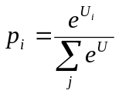

where
p_{i} = proportion of travellers selecting option i
U_{i} = utility of choice i (typically a linear function of the attributes of choice i)
j = list of all available options
e = base of natural logarithms (2.71828…)

This equation produces the familiar curve shown below:

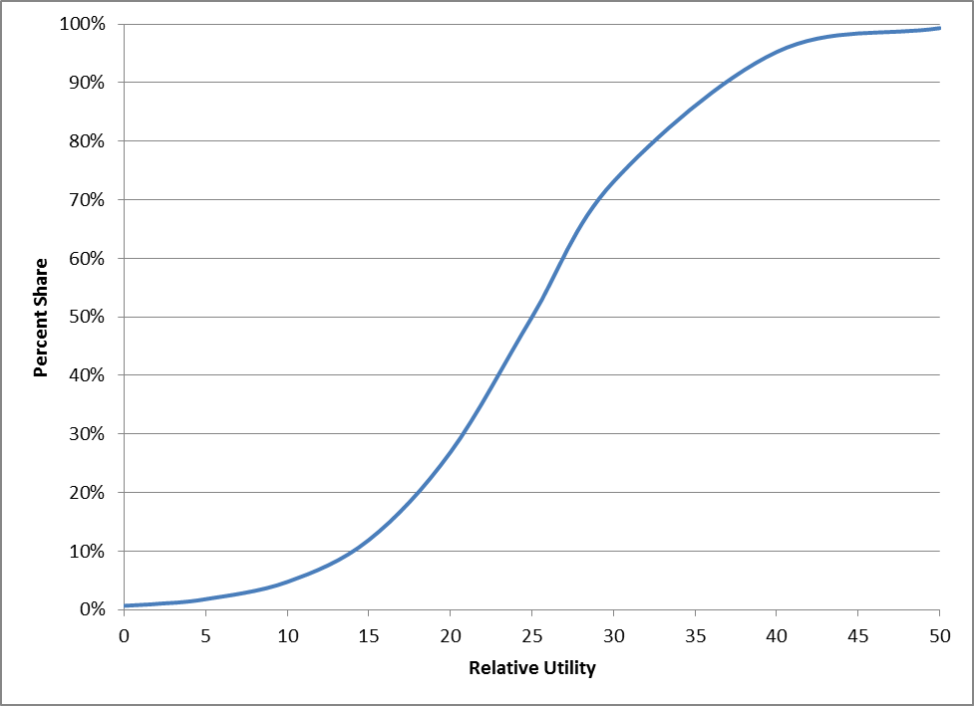

This function has been used in travel forecasting and consumer choice modelling in general since the 1960’s. It has several desirable attributes:

- No matter how many choices are being considered, the sum of the shares for all choices is always 1 (i.e., 100%).
- The function is most sensitive (the curve is the steepest) in the middle of the utility range. At the lower and upper ends, the curve is much flatter, meaning that in those utility ranges, it is relatively more difficult to change the shares of each option.
- The curve is specifically sensitive to changes in the absolute difference in utility, rather than the relative difference in utility.

The logit function is defined in terms of the utility function, U. This is a measure of the “goodness” of choice i. It is generally a linear function of various measurable attributes of choice i, each being factored by a coefficient that expresses the relative contribution of that variable to the choice’s utility. Typically, U also includes a bias constant, representing all of the unknown and un-measurable attributes. In some other applications, U is defined as disutility, a measure of the “badness” of choice i, in which case the equation is expressed as:

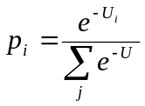

This function is used in every element of the model:

- Tour Frequency: the choices are whether the HH makes 0, 1, 2, … tours per day, by purpose. The utility is defined by the household characteristics, attributes of the household’s neighborhood, and other tours the HH makes.
- Tour Destination Choice: the choices are the traffic analysis zones to which a tour might go; thus, there are roughly 3,000 choices for each tour. The utility is defined by each zone’s distance from the HH zone, the activity level in each zone, and other characteristics of each zone.
- Intermediate Stops: the choices are whether the tour makes 0, 1, 2, … stops on the home-nonhome leg or the nonhome-home leg of the tour. The utility is defined by the detour time for each zone, the activity level in each zone, and other characteristics of each zone.
- Stop Location: the choices are limited to the zones in the general vicinity of the tour origin and destination. The utility is defined in a similar manner as for the Destination Choice model.
- Time of Day: this is the first time of day split (pre-mode choice), so the choices are peak and off-peak. The utility is defined in terms of the traveller characteristics and the attributes of the tour origin and destination zones.

A particularly useful feature of the logit function is that it can be applied either to aggregate or disaggregate data. The existing Metrolina mode choice model is an example of the former. The choices are the available travel modes and the model is applied to the aggregate number of person trips between two zones. The resulting p_{i} values are treated as shares of the person trips using each mode.

But disaggregate (discrete) modelling doesn’t deal with aggregate totals, it deals with individual trips (tours). In this context, p_{i} is treated as the probability that the tour will make a certain choice. The model is applied to individual tours using a technique known as Monte Carlo simulation, named after the famous casino in Monaco. In this method, the logit equation is used to calculate the probability of each available choice and then these probabilities are sorted low to high and used to create a cumulative probability table. A (pseudo-)random number between 0 and 1 is then generated and compared to each cumulative probability value in turn. The first choice whose cumulative probability exceeds the random number is then selected.

Another way to look at this is that the choices are placed on a “wheel of fortune” and the size of each choice’s wedge exactly reflects the choice’s probability of being selected. So a choice that had p_{i} = 0.50 would have a wedge that occupied 50% of the wheel. The wheel is spun and the wedge where it stops is the chosen option. It can be shown mathematically that if the wheel were spun a large number of times, the choice where
p_{i} = 0.50 would be selected almost exactly 50% of the time.

This is also illustrated in the following example. Consider the Tour Frequency model for Work travel. The model considers three choices for a HH: no tours, 1 tour, and 2+ tours. Assume that for a particular HH, the model estimates the following probabilities:

no tour 10%
1 tour 70%
2+ tours 20%

These are then sorted and the cumulative shares calculated:

p p(cum)
no tour 10% 10% (i.e., 0.10)
2+ tours 20% 30% (0.30)
1 tour 70% 100% (1.00)

A random number is generated; assume its value is 0.2736. This is compared to the cumulative probabilities and it is found that the cumulative probability for 2+ tours (0.30) is the first one that exceeds this random number. Thus, this HH is calculated to make 2 or more Work tours. In this case, since the highest number was selected (2+), an additional Monte Carlo process using fixed probabilities is used to determine the actual number of Work tours (as being 2, 3, 4, or 5), since the home interview survey determined that there could be as many as 5 Work tours by a HH. This involves generating another random number and using the fixed probabilities of 2, 3, 4, or 5 tours to determine which of those exact number of tours is selected.

Thus, developing a disaggregate tour-based model largely consists of establishing the options for each travel choice and then estimating the utility equations (variables and coefficients) for each option that best match the survey data. Throughout this document, the term model should be taken to mean the logit model (except where specifically described otherwise) and the principal specification of the model is the utility equations for each possible choice.

2 SURVEY ANALYSIS

CDOT hired the firm ETC Institute to conduct a conventional home interview travel survey. The survey was performed from December 2011 to May 2012, covering 4,231 HHs in the 11-county area covered by the Metrolina travel model and was documented in the report 2012 Metrolina Regional Household Travel Survey, by ETC Institute, July 2012. This survey was conducted in a similar manner as the previous Metrolina survey in 2002 and is similar to many other recent such surveys.

CDOT staff and the consultant spent some time performing quality control checks on this survey. Most of that work was also required in order to develop the trip-based model in 2013. This included:

- Development of expansion factors to ensure the survey was representative of the entire region with respect to HH size and income.
- Modify the purpose coding of work-related trips to clarify which trips were commute-to/from-work and which were made for other reasons (either work-related or personal).
- Link-out change mode trips. That is, if a person drove to a park-and-ride lot to take transit to work, this should be represented by one trip record, not two. An exception was made for school bus trips. In that case, the parent’s trip to drive the child to a school bus stop was treated separately from the child’s trip from the bus stop to school.
- Re-examine HHs that reported making only one (one-way) trip on the survey day, as well as other incomplete tours.
- Revise the destination and travel mode for people who walked or jogged within their neighborhood.
- Ensure that the origin zone of a trip was the same as the destination zone of the previous trip, for each person. Fix other similar geocoding problems.
- Impute missing data.
- Separate K-12 School from College/University trips.
- Re-compute coding of non-home-based sub-purposes (to/from work, at work, non-work; this was needed only for the trip-based model).

The survey trip records were converted to tour records. This was a complex process that required special software to construct round-trip tours from the trip records. The consultant wrote a Fortran program to perform this operation. The program groups trip segments into tours based on trip origin, destination, and time. This model assumes that the traveller’s home is the origin for all tours, except those that begin and end at the traveller’s workplace.

Although this project did not involve creating a tour-based mode choice model, the primary mode of the tour was established as follows:

- If any leg used transit, it was a Transit tour.
- Else, if any leg used school bus
  - If the leg is for school, it was a School Bus tour.
  - Else, it was a Carpool tour.
- Else, if the vehicle occupancy of any trip leg > 1, it was a Carpool tour.
- Else, if the vehicle occupancy of all legs = 1, it was a Drive Alone tour.
- Else, it was a Non-Motorized (walk/bike) tour.

The purpose of each tour was established based on this hierarchy:

- If the tour included going to School (K-12), it was a School tour.
- Else, if the tour included going to a College/University, it was a University tour.
- Else, if the tour included going to Work, it was a Work tour.
- Else, if the tour’s primary destination was to shop, it was a Shop tour.
- Else, the tour was Other.
- If the tour began/ended at work, it was an At Work tour.

For Work, School, and University tours, the location of the workplace, school, or university defined the primary tour destination. For Shop/Other/At Work tours, the primary tour destination was defined as the location where the traveller spent the most time. This is an important distinction, as the primary tour destination serves as the “anchor” for the tour and allows the definition of the tour’s two legs: the P/A leg (the home-nonhome or work-nonwork first half-tour) and the A/P leg (the nonhome-home or nonwork-work second half-tour). The result of this analysis was a set of tour records, identifying the tour main purpose, tour main destination, intermediate stop locations, and departure time for each leg. This was the primary source of model estimation data.

Table 2-1 shows the total weighted resident person tours by type and purpose. The survey contained 817,170 weighted HHs, so there are 3.56 RT tours per HH. Table 2-2 shows the tours by purpose and number of intermediate stops (in both directions). About 2/3 of tours are “simple” tours, with no intermediate stops.

Table 2-1 Tour Totals

 | I/I | I/X | Total
HBW | 647,038 | 21,389 | 668,427
SCH | 381,003 | 2,551 | 383,555
HBU | 35,024 | 2,493 | 37,516
HBS | 424,090 | 5,924 | 430,014
HBO | 1,297,139 | 29,194 | 1,326,333
ATW | 59,284 | 1,591 | 60,875
Total | 2,843,578 | 63,142 | 2,906,720

Table 2-2 Tours by Stops

Stops | HBW | SCH | HBU | HBS | HBO | ATW | Total
0 | 442,649 | 283,184 | 26,009 | 240,088 | 885,679 | 48,176 | 1,925,785
1 | 135,917 | 59,562 | 6,207 | 107,987 | 251,102 | 7,328 | 568,102
2 | 54,417 | 31,386 | 2,850 | 40,758 | 102,685 | 3,503 | 235,599
3 | 19,982 | 4,503 | 1,066 | 22,722 | 40,666 | 692 | 89,631
4 | 9,597 | 2,918 | 253 | 11,114 | 24,058 | 521 | 48,462
5 | 3,800 | 1,244 | 182 | 5,337 | 11,031 | 0 | 21,594
6 | 796 | 0 | 950 | 1,032 | 5,844 | 655 | 9,277
7 | 1,029 | 0 | 0 | 976 | 2,854 | 0 | 4,858
8 | 0 | 758 | 0 | 0 | 1,020 | 0 | 1,778
9 | 240 | 0 | 0 | 0 | 0 | 0 | 240
10+ | 0 | 0 | 0 | 0 | 1,394 | 0 | 1,394

3 HOUSEHOLD SYNTHESIS

3.1 Overview

Many aggregate four-step models (including Metrolina’s) begin with a step that splits the input total HHs in each zone by different socioeconomic characteristics. These are typically some combination of HH size, income group, vehicles available, HH lifecycle, and/or other similar attribute. The result is usually a 2- or 3-way table of fractional HHs by joint attributes in each zone.

In advanced ABMs, this process is replaced by a population synthesis step. This uses Census and survey data to create a synthetic list of people, along with their key individual and HH characteristics. It is a major challenge to create this file so that the individual and HH characteristics simultaneously match Census and other known data.

Rather than try to estimate the characteristics of individual households and people, the simplified tour-based process synthesizes only households. In this model, the household is the basic unit of travel activity; this is both consistent with the four-step model and it makes the tour-based model simpler and easier to understand. In fact, this model’s HH synthesis process uses exactly the same data and almost the same process as the current Metrolina four-step trip-based process. Therefore, some of the following discussion was excerpted from the trip-based model update report, Travel Model Recalibration 2013 (12 December 2013), updated as needed for the present work.

The HH stratification model estimates four key HH attributes:

- size (1-5+)
- income group (1-4)
- life cycle (1-3)
- workers (0-3+)

The income groups categorize regional households by their 2010 total household income, as follows:

1) Lowest 10% of the region (less than approximately $16,800) (“group 1”)
2) Low-middle 15% ($16,800 to $31,400) (“group 2”)
3) High-middle 25% ($31,400 to $55,900) (“group 3”)
4) High 50% (over $55,900) (“group 4”)

In some other models, the income groups are of equal size (25%/25%/25%/25%), but in this case, there was a desire to focus more on the lower income households. These categories were defined primarily by a previous analysis of mode choice tendencies by income. Because the entire model chain is stratified by income level, it seemed desirable to use a single definition of income groups for all parts of the model.

Life cycle is a relatively new concept in travel modelling, but one which has been gaining in popularity recently. It seems intuitively obvious that the stage of a family’s life should have a profound effect on tripmaking. However, this has not been commonly incorporated into trip generation models due to the difficulties of defining life cycle in a tractable manner and in forecasting it. The tour model uses a definition of life cycle that was developed originally for a model in Reading, PA and used successfully in other similar models (and in the Metrolina model since 2004). Households are stratified by three categories:

1) Retired: if the household has any retired people
2) Children: if the household has no retired people, but any children (age 18 or younger)
3) Other: if the household has no retired people and no children

Prior Metrolina analyses have shown that retirement status and the presence of children are extremely important influences on the extent and nature of the trips made by a household.

3.2 General Procedure

The challenge is to estimate the number of households jointly by these attributes, by traffic analysis zone. The trip-based model uses a set of socioeconomic submodels to perform this task. Those submodels have been adopted for use in the tour-based model. The size and income submodels use input zonal averages to stratify the households by size and income categories, respectively. The average size is calculated from two primary zonal inputs: households and persons living in households. The median household income (year 2010 dollars) is itself a primary zonal input.

Another submodel calculates the joint distribution of households by size and income, for 15 geographic subregions within Metrolina. The life cycle submodel uses another fixed set of percentages to estimate the households by life cycle category, for each size/income category. Finally, the worker submodel uses a fixed set of percentages to estimate the households by number of workers, for each size/income/life cycle category.

These submodels were originally developed in 2004, based on 2000 Census Public Use Microdata Sample (PUMS) and Census Transportation Planning Package (CTPP) data. In 2000, PUMS was a 5% sample of actual Census forms for the Metrolina region (containing 40,872 households, 103,535 persons in 2000). CTPP is a set of tabulations of the 1-in-12 households that received the Census “long form” with questions concerning travel to work. Those tabulations have been factored to represent the entire region.

As of 2010, the Census Bureau no longer collects CTPP data as part of the decennial census. The Bureau is assembling a CTPP-type transportation data base using its ACS data, but as of 2014, that data was not yet available for Metrolina. Further, it seemed reasonable to assume that most of the basic socioeconomic relationships did not change from 2000 to 2010. Thus, the consultant decided not to update the existing household size, income, worker, or life cycle submodels. The following discussion repeats the 2004 and 2013 documentation for these submodels. However, the joint size/income submodel was updated, as described in section 3.3.5.

3.3 Household Size Submodel

A number of other studies have documented that the distribution of households by size varies in a logical way as a function of the average household size. This relationship can be developed from Census data. Unless radical changes in average household size are projected, it is reasonable to assume that these relationships will continue to apply in future years. A comparison of the relationship between average household size and the percent distribution by size from the 1980 and 1990 Censuses for the Washington, DC area confirmed the validity of this assumption.

Figure 3-1 presents the household size distribution curves for the Metrolina region. These curves were developed from 2000 CTPP data for 1-4 persons/HH and supplemented with PUMS data for the 5+ persons/HH category. In 2000, the range of average household size was 1.1 to 3.9. These curves have been smoothed so as to represent a relatively continuous, coherent function and so that at any point on the X-axis, the sum of the five percentages is exactly 100% and the resulting calculated average size very closely equals the input average size.

Figure 3-1 Household Size Model
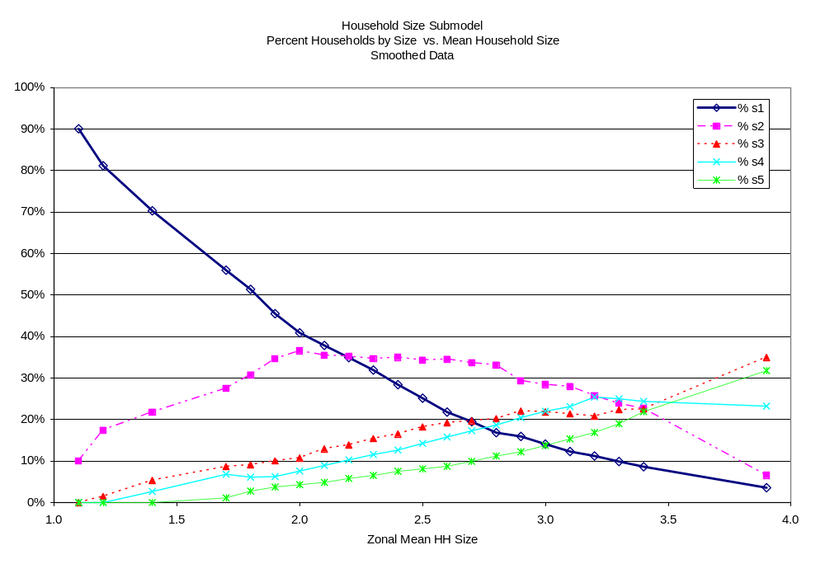

3.4 Income Submodel

The income submodel is developed in almost the same fashion as the size submodel. 2000 CTPP data were used to calculate the percent of households by income group, as a function of the income ratio. The income ratio is the zonal average household income divided by the regional average household income ($57,514 in 2000; $66,389 in 2010). In 2000, the observed range of this ratio was 0.3 to 3.7, but the curves were extrapolated downward to a ratio of 0.1 based on professional judgement. Figure 3-2 presents the household income distribution curves.

These curves have been smoothed to provide a continuous function and so that at any point on the X-axis, the sum of the four percentages is exactly 100%.

Figure 3-2 Household Income Model
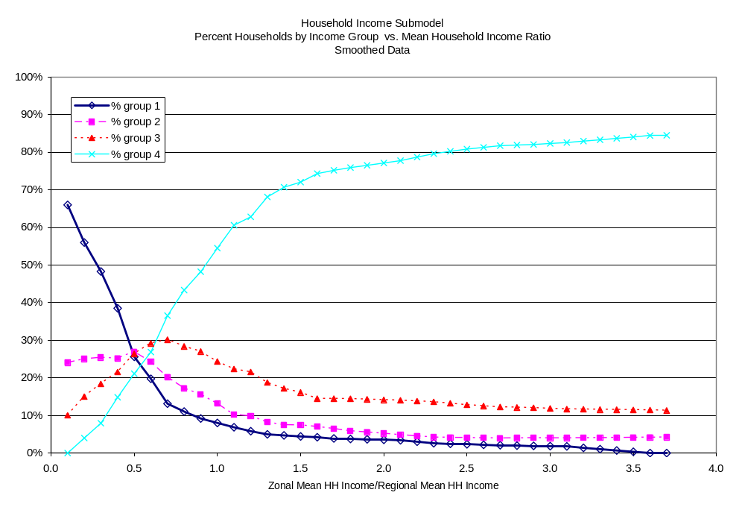

3.5 Joint Size/Income Submodel

This submodel estimates the joint distribution of households by size and income group. This is done by applying a matrix balancing procedure to the regional joint distribution by size/income, until the desired row and column totals are matched, for each zone. As noted above, this submodel was changed for 2010.

In the 2004 model, a single seed matrix was used to represent the regional joint distribution. In the 2013 trip model update, this was modified so as to use one of 15 seed tables, depending on the location of the zone. The 2005-09 ACS PUMS data was used to develop this submodel. The PUMS database identifies the PUM area (PUMA) and there are 15 PUMAs in the Metrolina area, as shown in Table 3-1. The consultant developed a file with the equivalency between zones and PUMAs and this is used as a new input.

Table 3-1 PUMA Numbering

Sequence | Census Code | Area
1 | 370400 | Cleveland, Rutherford, Polk, McDowell
2 | 370901 | SW Mecklenburg
3 | 370902 | NW Central Mecklenburg
4 | 370903 | NE Central Mecklenburg
5 | 370904 | E Mecklenburg
6 | 370905 | S Mecklenburg
7 | 371000 | N Mecklenburg
8 | 371100 | Gaston, Lincoln
9 | 371200 | Rowan
10 | 371300 | Cabarrus
11 | 371400 | Union
12 | 371500 | Iredell
13 | 372500 | Stanly, Montgomery, Anson
14 | 450500 (SC) | York
15 | 451300 (SC) | Lancaster, Chesterfield, Kershaw, Lee

Table 3-2 shows the regional joint distribution and the 15 PUMA joint distributions, as developed from Census data. The consultant believes that this geographic stratification produces greater accuracy in the household synthesis.

Table 3-2
Joint Size/Income Distribution by PUMA
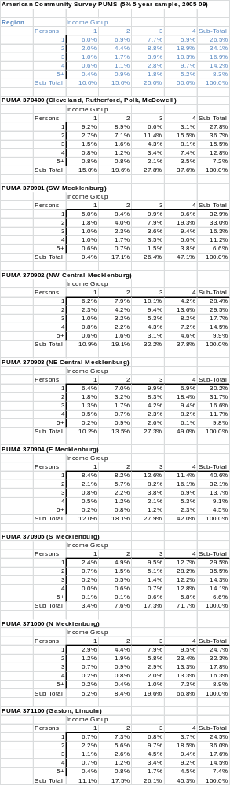

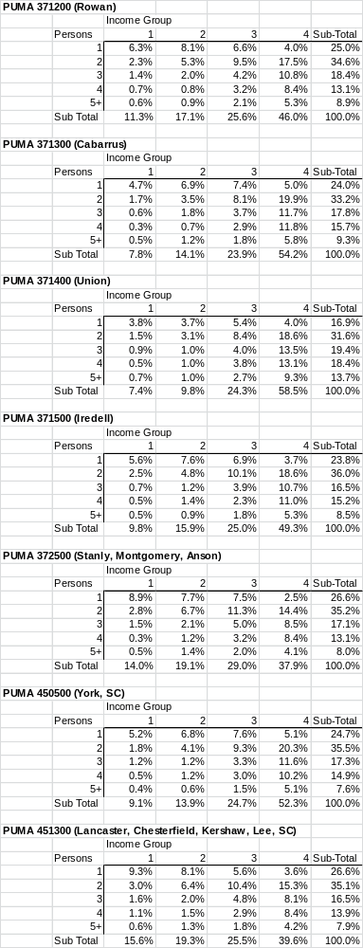

The distributions shown in Table 3-2 are used as the starting joint distribution for each zone. The curves in Figures 3-1 and 3-2 are used to estimate the distribution by size and by income for each zone. These become the new “desired” row and column totals for Table 3-2. The cells in Table 3-2 are then adjusted through a non-iterative proportional fitting procedure that matches the desired row and column totals for that zone. This procedure produces similar results as the Fratar process, except that it does not operate in an iterative fashion. The result is a table of 20 values, showing the estimated number of households in each category for that zone (fractional households are permitted at this point).

In application, it is possible that this procedure may produce a regional income distribution that differs slightly from the model’s income category definitions (10%/15%/25%/50%). Thus, a normalization step is included at the end to ensure that those percentage targets are met for the region. This is because the income categories are relative indicators of household affluence, regardless of the actual regional average income value.

3.6 Life Cycle Submodel

Perhaps the biggest impediment to using life cycle in a travel forecasting model is the difficulty in forecasting it. The life cycle submodel provides a simplified way to do that. It is based on a three-dimensional tabulation of PUMS data that provides a look-up table that determines the distribution of households by life cycle as a function of the household’s size and income (see Table 3-3). This is an easily applied but somewhat simplistic submodel.

As part of the 2013 trip-based analysis, the consultant investigated a more detailed process of forecasting households by life cycle. This involved a cohort-survival model of population by age (0 – 90 years) that accounted for birth rates by age, death rates by age, and domestic (U.S.) and foreign in- and out-migration. This model starts with a known base of population by age and then “ages” the population for each year. The rates were derived from Census data: 2000 PUMS, National Vital Statistics Report, Statistical Abstract of the U.S., and Domestic Net Migration in the United States. The process produces estimates of Metrolina population by each year of age for each year from 2010 to 2030. This showed that the share of regional population aged 18 and below will remain stable at 27% but the share of population aged 65 and over will increase from 11% to 18% by 2030. This information could be used to improve the estimation of households by life cycle. However, the process was judged to be too cumbersome and was not implemented at this time. It should be investigated again for use in the future.
Table 3-3 Life Cycle Table

 |  | Life Cycle
 | Income | 1 | 2 | 3
Size | Group | Retired | Kids | Other
1 | 1 | 53.8% | 0.0% | 46.2%
1 | 2 | 37.0% | 0.0% | 63.0%
1 | 3 | 13.4% | 0.0% | 86.6%
1 | 4 | 12.7% | 0.0% | 87.3%
2 | 1 | 32.9% | 31.7% | 35.4%
2 | 2 | 43.5% | 19.1% | 37.4%
2 | 3 | 30.8% | 13.3% | 55.9%
2 | 4 | 14.3% | 2.6% | 83.1%
3 | 1 | 6.3% | 86.3% | 7.4%
3 | 2 | 14.4% | 76.0% | 9.6%
3 | 3 | 12.0% | 73.8% | 14.2%
3 | 4 | 8.9% | 65.3% | 25.8%
4 | 1 | 4.8% | 89.8% | 5.4%
4 | 2 | 5.6% | 91.9% | 2.5%
4 | 3 | 4.2% | 92.3% | 3.5%
4 | 4 | 3.4% | 89.7% | 6.9%
5+ | 1 | 4.0% | 96.0% | 0.0%
5+ | 2 | 5.1% | 93.9% | 1.0%
5+ | 3 | 7.0% | 91.3% | 1.7%
5+ | 4 | 7.7% | 89.0% | 3.3%

Table 3-4 does suggest certain logical relationships. For example, 1-person households can have no children, but if they are lower income, they are more likely to have a retired person. Households with children are more prevalent with increasing household size.

Applying the percentages in Table 3-4 to the joint size/income distribution produces a three-way size/income/life cycle distribution for each zone.

In the 2013 trip-based project, the consultant also analyzed differences in life cycle distribution by geography. This initially focused on urban, suburban, and rural PUMAs. That analysis did not indicate significant differences by those geographic breakdowns, once differences in household size and income were accounted for.

However, that analysis did identify that households in the Charlotte “Uptown” area were noticeably different from other households, even after accounting for size and income. Thus, a set of adjustments was developed from the 2012 home interview survey, to modify the PUMS-derived life cycle estimates for households in Uptown. This is defined as zones 10001-10025,10106,10117,10118,10120,10139,10142,10143, 10149,10150,10174-10177,10184-10186,10188,10189,11025,11026. In these areas, “Kids” households are increased for income 1 but sharply decreased for the other incomes. “Other” households are increased for incomes 2-4. Table 3-4 shows the adjustment factors.

Table 3-4 Uptown Life Cycle Adjustment Factors

 | Life Cycle
Income | 1 | 2 | 3
Group | Retired | Kids | Other
1 | 0.89 | 1.82 | 0.81
2 | 1.02 | 0.00 | 1.36
3 | 0.73 | 0.00 | 1.58
4 | 0.74 | 0.30 | 1.53

3.7 Worker Submodel

The worker submodel operates in the same fashion as does the life cycle model. It is a straightforward look-up table, based on the household’s size, income, and life cycle status. It is based on a four-dimensional tabulation of PUMS data, as shown in Table 3-6.

For application in forecasting, this submodel includes an adjustment for future growth in employment. The data shown in Table 3-5 is household-based – that is, it computes households by the number of workers/HH. For 2010, this submodel estimated a regional total of about 1,067,600 workers. Since there were 1,220,700 jobs in the region in 2010, this results in a worker/job ratio of 0.8746 (i.e., Metrolina is a net importer of workers from outside the region). The difference is accounted for by non-resident workers and by workers who hold more than one job. This worker/job ratio is assumed to be constant over time. Therefore, the submodel attempts to balance the future number of workers (and thus households by workers) with the future number of jobs.

For example, if jobs were estimated to increase by 20% for a forecast year and households were estimated to increase by 10%, the worker submodel would not initially generate enough workers to fill those jobs. So, this submodel includes an adjustment that automatically adjusts the number of workers (and households by number of workers) accordingly.

The adjustment process works as follows:

Compute the initial number of workers/HH by zone for all zones (from application of Table 3-5).
- Sum the regional number of workers and workers/HH.
- Compute the revised regional number of workers and workers/HH by applying the worker/job ratio to the number of jobs.
- Use the curves in Figure 3-3 to compute the initial and revised regional number of households by workers.
- Divide the revised numbers of households by workers by the initial numbers to get an adjustment factor by number of workers.
- Apply that adjustment factor to the households by workers in each zone.

Figure 3-3 Worker Adjustment Submodel
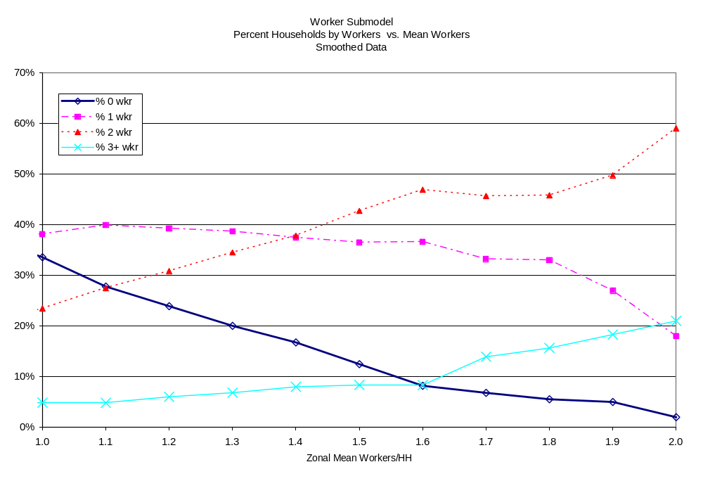

Table 3-5 Worker Submodel Table

 | Income | Life | Workers
Size | Group | Cycle | 0 | 1 | 2 | 3+
1 | 1 | 1 | 100.0% | 0.0% | 0.0% | 0.0%
1 | 1 | 2 | 62.1% | 37.9% | 0.0% | 0.0%
1 | 1 | 3 | 59.8% | 40.2% | 0.0% | 0.0%
1 | 2 | 1 | 100.0% | 0.0% | 0.0% | 0.0%
1 | 2 | 2 | 23.0% | 77.0% | 0.0% | 0.0%
1 | 2 | 3 | 17.0% | 83.0% | 0.0% | 0.0%
1 | 3 | 1 | 100.0% | 0.0% | 0.0% | 0.0%
1 | 3 | 2 | 74.5% | 25.5% | 0.0% | 0.0%
1 | 3 | 3 | 9.7% | 90.3% | 0.0% | 0.0%
1 | 4 | 1 | 100.0% | 0.0% | 0.0% | 0.0%
1 | 4 | 2 | 10.0% | 90.0% | 0.0% | 0.0%
1 | 4 | 3 | 8.1% | 91.9% | 0.0% | 0.0%
2 | 1 | 1 | 87.1% | 12.9% | 0.0% | 0.0%
2 | 1 | 2 | 50.3% | 47.2% | 2.5% | 0.0%
2 | 1 | 3 | 48.0% | 36.5% | 15.5% | 0.0%
2 | 2 | 1 | 84.8% | 15.2% | 0.0% | 0.0%
2 | 2 | 2 | 16.9% | 77.2% | 5.9% | 0.0%
2 | 2 | 3 | 24.1% | 50.0% | 25.9% | 0.0%
2 | 3 | 1 | 64.2% | 35.8% | 0.0% | 0.0%
2 | 3 | 2 | 7.0% | 80.0% | 13.0% | 0.0%
2 | 3 | 3 | 8.7% | 39.0% | 52.3% | 0.0%
2 | 4 | 1 | 58.1% | 41.9% | 0.0% | 0.0%
2 | 4 | 2 | 3.9% | 78.1% | 18.0% | 0.0%
2 | 4 | 3 | 3.6% | 20.5% | 75.9% | 0.0%
3 | 1 | 1 | 73.4% | 26.6% | 0.0% | 0.0%
3 | 1 | 2 | 47.8% | 44.9% | 7.0% | 0.3%
3 | 1 | 3 | 30.4% | 35.3% | 29.7% | 4.6%
3 | 2 | 1 | 46.9% | 45.6% | 7.5% | 0.0%
3 | 2 | 2 | 18.1% | 65.0% | 16.1% | 0.8%
3 | 2 | 3 | 17.0% | 39.7% | 39.1% | 4.2%
3 | 3 | 1 | 37.0% | 52.4% | 10.6% | 0.0%
3 | 3 | 2 | 6.7% | 46.2% | 44.3% | 2.8%
3 | 3 | 3 | 5.8% | 24.6% | 47.1% | 22.5%
3 | 4 | 1 | 12.7% | 44.4% | 42.9% | 0.0%
3 | 4 | 2 | 2.5% | 24.2% | 65.7% | 7.6%
3 | 4 | 3 | 1.4% | 8.0% | 31.1% | 59.5%
Table 3-5 (continued) Worker Submodel Table

 | Income | Life | Workers
Size | Group | Cycle | 0 | 1 | 2 | 3+
4 | 1 | 1 | 83.0% | 17.0% | 0.0% | 0.0%
4 | 1 | 2 | 46.7% | 40.2% | 12.5% | 0.6%
4 | 1 | 3 | 19.2% | 57.6% | 13.8% | 9.4%
4 | 2 | 1 | 52.9% | 40.0% | 7.1% | 0.0%
4 | 2 | 2 | 15.0% | 59.9% | 22.6% | 2.5%
4 | 2 | 3 | 23.1% | 40.2% | 6.8% | 29.9%
4 | 3 | 1 | 11.2% | 58.4% | 21.3% | 9.1%
4 | 3 | 2 | 4.3% | 41.9% | 47.4% | 6.4%
4 | 3 | 3 | 5.3% | 11.9% | 36.6% | 46.2%
4 | 4 | 1 | 7.8% | 25.7% | 50.6% | 15.9%
4 | 4 | 2 | 1.6% | 23.7% | 59.6% | 15.1%
4 | 4 | 3 | 1.3% | 2.8% | 11.4% | 84.5%
5+ | 1 | 1 | 55.0% | 28.9% | 16.1% | 0.0%
5+ | 1 | 2 | 42.7% | 40.1% | 15.4% | 1.8%
5+ | 1 | 3 | 90.0% | 10.0% | 0.0% | 0.0%
5+ | 2 | 1 | 27.2% | 53.5% | 15.6% | 3.7%
5+ | 2 | 2 | 20.1% | 51.7% | 23.0% | 5.2%
5+ | 2 | 3 | 87.5% | 12.5% | 0.0% | 0.0%
5+ | 3 | 1 | 17.0% | 37.3% | 36.2% | 9.5%
5+ | 3 | 2 | 5.2% | 38.3% | 44.3% | 12.2%
5+ | 3 | 3 | 0.0% | 11.1% | 42.1% | 46.8%
5+ | 4 | 1 | 2.2% | 22.5% | 37.3% | 38.0%
5+ | 4 | 2 | 1.5% | 22.9% | 45.7% | 29.9%
5+ | 4 | 3 | 1.6% | 0.0% | 7.6% | 90.8%

Up to this point, the tour-based HH synthesis model is identical to the trip-based HH submodel. However, the tour-based process deals only with integer data and so the four-way table for each zone is bucket-rounded, with an additional check to ensure that the input HHs for this zone is matched. The model then outputs a list of individual households, containing a separate ID for each HH, the zone of residence, HH size, income group, lifecycle code, and number of workers. For 2010, this consisted of 833,570 plain text (ASCII) records (based on the zone system in effect in 2012). When summarized for the region, this data matches the aggregate sub-totals as estimated by the trip-based model for 2010.
4 TOUR FREQUENCY

4.1 Overview

Tour Frequency is the disaggregate analog of the four-step model’s Trip Generation step. As noted above, instead of estimating aggregate productions and attractions by zone, this step estimates the number of round-trip tours by each household for each purpose. In order to maintain consistency with the existing model, the tour-based model uses similar purposes for person travel: HBW (work), SCH (K-12 school), HBU (college/university), HBS (shop), HBO (other), and ATW (at-work). External travel is represented as I/X (residents leaving the area), XIW (non-resident commuters), XIN (non-resident non-work travel), and X/X (through). Commercial travel is stratified by COM (light-duty commercial), MTK (medium truck), and HTK (heavy truck).

For the person travel purposes, all travel (except ATW) is assumed to begin and end at the traveller’s home. ATW tours begin and end at the traveller’s workplace. The non-home-based purpose is not used at this point. Most trips that are NHB in the trip-based model are modelled as stops made as part of a tour.

The basic premise of the Tour Frequency (TF) model is to estimate the probability of a household’s making 0, 1, 2, … round-trip tours by purpose on a typical weekday. This uses a multinomial logit model and the utility is a function of the household characteristics, the home zone’s attributes, and the number of tours estimated for certain purposes. In this model, the purposes are assigned a priority from high to low, as follows: SCH, HBU, HBW, HBS, HBO, ATW. Higher priority tours are assumed to be more important and lower priority tours are assumed to be conditioned on whether (and how many) higher priority tours are estimated. This is a common feature of advanced tour-based models. The consultant is not aware of any research that proves that this particular priority is correct or optimal, but it is similar to the priority used in other models and seems to make sense.

4.2 Choices

The most basic aspect of the model is to determine the number of choices (tours) to be modelled for each purpose. Modelling every potential choice is unwise, because above a certain number of tours, the probabilities become very low, making them more difficult to estimate accurately and making the consequences of estimation error much less important. The consultant tabulated the number of tours per HH by purpose from the survey and based on those results, decided which choices should be estimated (throughout the rest of this document, tour will always refer to a round-trip tour from the home or workplace). Table 4-1 shows the result.

Table 4-1 Tour Choices

tours | sch | hbu | hbw | hbs | hbo | atw
0 | 0.757 | 0.963 | 0.519 | 0.677 | 0.354 | 0.941
1 | 0.117 | 0.032 | 0.292 | 0.220 | 0.266 | 0.053
2 | 0.091 | 0.004 | 0.150 | 0.077 | 0.197 | 0.006
3 | 0.028 | 0.001 | 0.031 | 0.019 | 0.081
4 | 0.006 |  | 0.007 | 0.005 | 0.049
5 | 0.001 |  | 0.001 | 0.001 | 0.022
6 |  |  |  | 0.001 | 0.017
7 |  |  |  |  | 0.006
8 |  |  |  |  | 0.005
9 |  |  |  |  | 0.002
10 |  |  |  |  | 0.001
 | 1.000 | 1.000 | 1.000 | 1.000 | 1.000 | 1.000

The number of tours shown in red italics are those that are modelled directly. For example, for HBW, the model includes the choices 0 tours, 1 tour, and 2+ tours. For choices above 2 tours, the fixed survey percentages implied by Table 4-1 are used, as shown in Table 4-2.

Table 4-2 Non-Modelled Tour Choices

tours | sch | hbu | hbw | hbs | hbo | atw
0
1 |  | 0.865 |  |  |  | 0.898
2 | 0.722 | 0.108 | 0.794 | 0.747 |  | 0.102
3 | 0.222 | 0.027 | 0.164 | 0.184
4 | 0.048 |  | 0.037 | 0.049 | 0.479
5 | 0.008 |  | 0.005 | 0.010 | 0.216
6 |  |  |  | 0.010 | 0.167
7 |  |  |  |  | 0.059
8 |  |  |  |  | 0.049
9 |  |  |  |  | 0.020
10 |  |  |  |  | 0.010
 | 1.000 | 1.000 | 1.000 | 1.000 | 1.000 | 1.000

Table 4-2 represents the highest choices observed in the survey. For example, no HH was observed to make more than 5 HBW tours. For the highest modelled choice, the fractions in Table 4-2 are used. For example, if the model estimated that a HH made 2+ HBW tours, the fractions in Table 4-2 would be used to indicate that the probability that it made exactly 2 tours was 0.794, 3 tours 0.164, 4 tours 0.037, and 5 tours 0.005.

4.3 Calibration

The next step in estimating the model was to prepare a calibration file. This is a set of HH records that describe the choices actually made for each HH and the measurable data that might logically influence those choices. This file includes a wide range of objective statistics, from which a smaller set is chosen to calculate the utility of each choice. Table 4-3 lists the candidate variables.

In general, calibrating a logit model mainly consists of identifying the available choices, hypothesizing a set of variables for the utility equations, and specifying conditions for optimization. The estimation software (ALOGIT) calculates the coefficients for each variable that maximizes the likelihood function. The likelihood function is the sum across all records of the probability that the actual choice would be chosen. (In practice, the natural log of the likelihood is used, since it is easier to compute.) This produces the coefficients that allow the selected utility equations to best predict the actual choices overall. However, it is very important to understand that ALOGIT does not indicate what the “best” variables would be. It only calculates the best coefficients for the variables (and alternatives) that the analyst has chosen to test.

ALOGIT produces a variety of statistics indicating goodness-of-fit, including:
- ρ²(0)
This is the ratio of the final likelihood to the likelihood of a model with zero coefficients (i.e., for each observation, all the available choices have equal probabilities).
- ρ²(C)
This is the ratio of the final likelihood to the likelihood of a model in which all of the choices except one have alternative-specific constants.
- t ratio
This is the ratio of each coefficient’s value to its standard error.

Generally, the higher the ρ² values (closer to 1.0), the better; this statistic is roughly analogous to the more familiar r² value in statistics, although it is calculated much differently and acceptable ρ² values are lower. The t ratio indicates, for each coefficient, the probability that the coefficient is significantly different from zero. An absolute t ratio above 1.96 means that there is a 95% chance that the coefficient is statistically significant. Higher values indicate a stronger relationship. The analyst must also look for logical signs on the coefficients: a positive sign means that higher values of that variable are associated with a higher choice of that alternative. Coefficient signs that are clearly illogical should be avoided.
Table 4-3 TF Candidate Variables

Accessibility to HH within 15 min of highway time (method 1)
Accessibility to HH within 15 min of transit time (method 1)
Accessibility to HH within 15 min of composite time (method 1)
Accessibility to HH within 45 min of highway time (method 2)
Accessibility to HH within 45 min of transit time (method 2)
Accessibility to HH within 45 min of composite time (method 2)
Accessibility to employment within 15 min of highway time (method 1)
Accessibility to employment within 15 min of transit time (method 1)
Accessibility to employment within 15 min of composite time (method 1)
Accessibility to employment within 45 min of highway time (method 2)
Accessibility to employment within 45 min of transit time (method 2)
Accessibility to employment within 45 min of composite time (method 2)
Accessibility to HH by highway time (method 3)
Accessibility to HH by transit time (method 3)
Accessibility to HH by composite time (method 3)
Accessibility to employment by highway time (method 3)
Accessibility to employment by transit time (method 3)
Accessibility to employment by composite time (method 3)
Accessibility to HH by highway time (method 4)
Accessibility to HH by transit time (method 4)
Accessibility to HH by composite time (method 4)
Accessibility to employment by highway time (method 4)
Accessibility to employment by transit time (method 4)
Accessibility to employment by composite time (method 4)
Accessibility to income 1 HH by highway time (method 3)
Accessibility to income 1 HH by transit time (method 3)
Accessibility to income 1 HH by composite time (method 3)
Accessibility to income 4 HH by highway time (method 3)
Accessibility to income 4 HH by transit time (method 3)
Accessibility to income 4 HH by composite time (method 3)
Distance to the CBD (TAZ 10002) (miles)
Distance to the nearest external station (miles)
HH/sq mi
employment/sq mi
composite density [(300*emp + 2000*HH)/sq mi]
state code
county code
median HH income
percent of employment that is retail (RTL + HWY)
percent of employment that is office (OFFGOV + EDUC)
Number of enrolled students (K-12 + coll/univ)
Dorm zone flag
Percent of HHs by income (1-4)
Area type (1-5)
Number of tours actually made, by purpose
Note: Different accessibility variables were created for peak and off-peak travel times. Four different methods were used to calculate accessibility:
- how much land use is in zones that are located within 15 min of the subject zone
- how much land use is in zones that are located within 45 min of the subject zone
- the sum of the term data_{j}/TT_{ij}² across all zones j
- the sum of the term data_{j}/TT_{ij}³ across all zones j
For composite time, the average across all incomes was generally used.
Data represents 2010 model data as of 2013, with 2934 internal zones.
Calibration of a model is as much art as science. It depends on the analyst’s ability to select rational utility equations and variables for testing and on the final selection of variables whose coefficients achieve a good balance between statistical validity and common sense relationships. In all of the TF models, the utility of making no tours is defined as zero. This is a common convention that is necessary to avoid over-specifying the model.

A separate model was estimated for each trip purpose. The consultant hypothesized numerous utility functions for each purpose, as listed in Appendix A. The final models are shown in Table 4-4 and the variables are listed in Table 4-5. Some of the final model variables involve transformations of the basic input variables shown in Table 4-3.

Table 4-4 TF Models

Purpose | Tours | Utility Equation
SCH | 0 | 0
 | 1 | -7.367 + 5.345*LC2DUM + 0.8065*SIZE34DUM – 0.5759*WKR3DUM + 0.7053*AVGSIZE
 | 2+ | -9.295 + 5.796*LC2DUM + 2.915*SIZE45DUM – 1.556*WKR3DUM + 0.7053*AVGSIZE
HBU | 0 | 0
 | 1+ | -6.056 + 1.040*SIZE – 0.7481*SCHTOURS
HBW | 0 | 0
 | 1 | -2.781 – 0.6602*LC1DUM – 0.3886*INC1DUM + 2.543*WORKERS + 0.1779*SIZE345DUM[1] + 0.1346*SCHTOURS[2]
 | 2+ | -7.242 – 0.6602*LC1DUM – 0.3886*INC1DUM + 4.809*WORKERS + 0.1779*SIZE345DUM[1] + 0.1346*SCHTOURS[2]
HBS | 0 | 0
 | 1 | -1.584 + 0.3866*SIZE – 0.5960*LC2DUM + 0.5474*SUBURB – 0.2518*EDTOURS  - 0.5492*HBWTOURS
 | 2+ | -1.584 + 0.3866*SIZE – 0.5960*LC2DUM + 0.5474*SUBURB – 0.2518*EDTOURS  – 0.5492*HBWTOURS
HBO | 0 | 0
 | 1 | -0.1911 + 0.8086*SIZE + 0.3765*LC2DUM – 0.2502*WORKERS – 0.05369*ATYPE + 0.000005842*MED_INC – 0.6965*EDTOURS – 1.035*HBWTOURS – 0.8163*HBSTOURS + 0.3254*INC4DUM
 | 2 | -0.5274 + 0.8086*SIZE + 0.3765*LC2DUM – 0.2502*WORKERS – 0.05369*ATYPE + 0.000005842*MED_INC – 0.6965*EDTOURS – 1.035*HBWTOURS – 0.8163*HBSTOURS + 0.3254*INC4DUM
 | 3 | -2.8800 + 1.421*SIZE + 0.3765*LC2DUM – 0.5127*WORKERS – 0.05369*ATYPE + 0.000005842*MED_INC – 0.6965*EDTOURS – 1.035*HBWTOURS – 0.8163*HBSTOURS + 0.6236*INC4DUM – 0.6706*INC1DUM
 | 4+ | -4.2020 + 1.859*SIZE + 0.3765*LC2DUM – 0.5127*WORKERS – 0.05369*ATYPE + 0.000005842*MED_INC – 0.6965*EDTOURS – 1.035*HBWTOURS – 0.8163*HBSTOURS + 0.6085*INC4DUM – 0.7486*INC1DUM
ATW | 0 | 0
 | 1+ | -2.659 – 0.3166*WORKERS + 0.000003801*MED_INC[3] + 0.7615*INC4DUM  + 0.03204*HHDENS
Note: All coefficients have absolute t values over 2.0, except as follows:
[1] t=1.4 [3] t=1.9
[2] t=1.9
Table 4-5 TF Variables

Variable | Definition
ATYPE | Area type of the home zone (1-5)
AVGSIZE | Average HH size of the home zone
EDTOURS | Sum of estimated SCHTOURS + HBUTOURS
HBSTOURS | Estimated HBS tours
HBWTOURS | Estimated HBW tours
HHDENS | HH/acre of the work zone
INC1DUM | 1 if HH is income 1, else 0
INC4DUM | 1 if HH is income 4, else 0
LC1DUM | 1 if HH is life cycle 1 (retired), else 0
LC2DUM | 1 if HH is life cycle 2 (children), else 0
MED_INC | median HH income of home zone, dollars
SCHTOURS | Estimated SCH tours
SIZE | HH size (1-5)
SIZE345DUM | 1 if HH has 3-5 persons, else 0
SIZE34DUM | 1 if HH has 3-4 persons, else 0
SIZE45DUM | 1 if HH has 4-5 persons, else 0
SUBURB | 1 if area type is 3-4, else 0
WKR3DUM | 1 if HH has 3+ workers, else 0
WORKERS | Number of workers in HH (0-3)

A logical interpretation of these equations is as follows:

- SCH
The LC2DUM (HH with children) coefficient is very large and positive, which is very logical. The 3-worker dummy coefficient is negative, meaning that if the HH has 3+ workers, SCH travel is less likely, which makes sense. If the home zone has a higher average HH size, more SCH tours are likely. This generally indicates more apartments and may be a surrogate for density. However, it’s not obvious that it should relate to more SCH tripmaking. The size of this HH became important only as dummy variables: 3-4 persons for 1 tour, 4-5 persons for 2+ tours.
- HBU
This was difficult to estimate because of the lack of forecastable variables that relate to college/university travel. The most significant variable was HH size, with an appropriate positive coefficient. SCH tours has a negative coefficient, meaning that if the HH made any SCH tours, it was less likely to make an HBU tour, which seems logical. The “SCH tours” variable is available to the HBU model because the SCH model is applied first and so by the time the HBU model is applied, the number of estimated SCH tours is known. This interdependency of tourmaking by purpose is an important and unique feature of disaggregate tour-based models.
- HBW
The number of workers is the most important variable, as it should be. Having different coefficients on 1 tour vs. 2+ tours suggests that additional work tours are more likely to be part-time jobs, which makes sense. Life cycle 1 (retired) has a negative coefficient, meaning that such HHs are less likely to make HBW tours, which is logical. SCH tours has a positive coefficient: if the HH makes SCH tours, it’s more likely to make HBW tours. Income 1 HHs are less likely to make HBW tours – also logical. If the HH has 3+ persons, it’s more likely to make HBW tours, aside from the number of workers, probably because there are more family members to support.
- HBS
HH size is the most important variable, which is to be expected. Its sign is positive and the t score is good. There is a higher coefficient on 2+ tours, meaning that greater HH size has a disproportionate effect on Shop tourmaking, which seems logical. The coefficients on HBW tours and the sum of SCH+HBU tours are both negative: if the HH makes more Work or School tours, it makes fewer Shop tours. This is because there’s less time and because shopping can be accomplished as an intermediate stop on an HBW, HBU, or (less likely) SCH tour. Life cycle 2 (children) has a negative coefficient, which seems counterintuitive. It probably means that if the HH has children, it doesn’t have time to make “pure” Shop tours. Shopping is accomplished mainly as an intermediate stop on some other tour. If the HH is in the suburbs (area type = 3,4), it’s more likely to make HBS tours, which fits the stereotype of the suburban HH.
- HBO
The HH is more likely to make an HBO tour with increasing HH size, and the effect is greater for 3 and 4+ tours, probably reflecting child travel. There are more tours if the HH is income 4, and the effect is greater for 3 and 4+ tours, and a lower chance of making 3+ tours if the HH is income 1. In addition, there are more tours if the HH is in a zone with a higher median income. These all seem logical. If the HH is life cycle 2 (children), there are more tours, which again reflects the influence of children. HBO travel decreases with an increasing number of workers, probably because the workers are instead making stops on their work tours. If the HH makes more tours of any other purpose, it makes fewer HBO tours. This is almost certainly because making the other tours both takes time away from the HH and also provides more opportunities for intermediate stops to accomplish HBO tasks. HBO tours are also more likely if the home zone is more urban. This relationship uses the categorical variable Area Type, which varies from 1 (CBD) to 5 (rural); this is somewhat problematic in a strict mathematical sense. However, the results aren’t illogical and are statistically valid, so the variable was retained.
- ATW
ATW tours are different from the others. They are treated as round-trip tours made from and to the workplace, by workers who made a work tour (i.e., who actually went to work). The frequency of these tours is influenced by the characteristics of the HH, the home zone, and the workplace zone. ATW tours increase if the HH is high income (income 4) and with increasing median income in the home zone, which is logical. However, they decrease with a higher number of workers in the HH and increase with increasing HH/acre in the workplace zone and it is less clear if these relationships are logical.

4.4 Validation

When the models were applied to the 2010 synthesized HHs, some adjustments were necessary to the ALOGIT bias constants initially estimated by ALOGIT in order to better match the shares of tours observed in the survey. The bias constants in Table 4-4 already reflect those adjustments. The resulting observed and estimated shares of tours by purpose, stratified by various HH variables are shown in Table 4-6. This shows the observed and estimated percentage of tours made by HHs, by attribute.
For example, the survey said that 6.0% of the HBW tours were made by HHs with 1 person, while the model estimated that 9.3% of HBW tours were made by such HHs. The model’s estimated shares are very close to the survey’s observed shares, suggesting there is little bias in the estimates.

Table 4-7 shows the observed and estimated number of tours by purpose.

Table 4-6 Share of Tours by HH Attributes

 | HBW |  | SCH |  | HBU |  | HBS |  | HBO |  | ATW
Size
survey
1 | 6.0% |  | 0.1% |  | 2.2% |  | 15.8% |  | 12.3% |  | 8.9%
2 | 24.1% |  | 1.3% |  | 6.7% |  | 33.2% |  | 26.5% |  | 29.6%
3 | 30.3% |  | 20.1% |  | 37.8% |  | 21.9% |  | 20.7% |  | 23.0%
4 | 25.3% |  | 40.4% |  | 32.8% |  | 17.8% |  | 23.7% |  | 27.2%
5 | 14.3% |  | 38.0% |  | 20.6% |  | 11.4% |  | 16.9% |  | 11.3%
model
1 | 9.3% |  | 0.0% |  | 24.9% |  | 17.2% |  | 11.2% |  | 8.4%
2 | 29.8% |  | 5.4% |  | 33.8% |  | 30.5% |  | 22.9% |  | 30.9%
3 | 24.0% |  | 20.4% |  | 17.9% |  | 16.5% |  | 18.3% |  | 23.5%
4 | 23.0% |  | 45.1% |  | 15.1% |  | 17.8% |  | 23.5% |  | 23.6%
5 | 13.9% |  | 29.1% |  | 8.3% |  | 18.0% |  | 24.1% |  | 13.6%
Income
survey
1 | 4.3% |  | 9.5% |  | 9.4% |  | 11.9% |  | 9.6% |  | 2.3%
2 | 9.4% |  | 13.5% |  | 13.3% |  | 17.4% |  | 14.5% |  | 3.9%
3 | 19.9% |  | 17.5% |  | 21.1% |  | 22.4% |  | 19.2% |  | 14.4%
4 | 66.5% |  | 59.5% |  | 56.1% |  | 48.4% |  | 56.7% |  | 79.4%
model
1 | 2.5% |  | 9.0% |  | 10.3% |  | 12.1% |  | 8.6% |  | 1.5%
2 | 7.5% |  | 11.7% |  | 15.5% |  | 16.4% |  | 13.8% |  | 4.4%
3 | 20.9% |  | 21.3% |  | 25.4% |  | 25.3% |  | 21.6% |  | 12.6%
4 | 69.1% |  | 58.0% |  | 48.8% |  | 46.2% |  | 56.0% |  | 81.5%
Life Cycle
survey
1 | 3.9% |  | 1.6% |  | 3.9% |  | 21.2% |  | 14.3% |  | 4.7%
2 | 47.5% |  | 98.3% |  | 49.4% |  | 31.0% |  | 47.7% |  | 42.0%
3 | 48.6% |  | 0.1% |  | 46.7% |  | 47.8% |  | 38.0% |  | 53.3%
model
1 | 4.3% |  | 0.4% |  | 19.8% |  | 25.2% |  | 19.2% |  | 4.3%
2 | 49.8% |  | 99.6% |  | 36.1% |  | 40.3% |  | 56.4% |  | 49.8%
3 | 45.9% |  | 0.0% |  | 44.1% |  | 34.5% |  | 24.4% |  | 45.9%
Workers
survey
0 | 0.0% |  | 9.4% |  | 18.3% |  | 46.1% |  | 33.9% |  | 0.0%
1 | 31.7% |  | 40.7% |  | 26.1% |  | 30.9% |  | 34.3% |  | 35.0%
2 | 50.1% |  | 43.5% |  | 36.1% |  | 17.0% |  | 26.3% |  | 52.1%
3 | 18.2% |  | 6.4% |  | 19.4% |  | 5.9% |  | 5.5% |  | 12.8%
model
0 | 0.0% |  | 9.5% |  | 25.6% |  | 32.3% |  | 24.5% |  | 0.0%
1 | 29.5% |  | 39.7% |  | 40.7% |  | 41.1% |  | 41.2% |  | 28.4%
2 | 56.4% |  | 43.9% |  | 28.8% |  | 22.1% |  | 27.6% |  | 59.6%
3 | 14.1% |  | 6.9% |  | 4.9% |  | 4.5% |  | 6.6% |  | 12.0%

Table 4-7 Tours by Purpose

 | Estimated | Observed
Purpose | Tours | Tours | Difference
HBW | 667,730 | 668,427 | -0.1%
SCH | 383,121 | 383,554 | -0.1%
HBU | 37,743 | 37,517 | 0.6%
HBS | 429,588 | 430,014 | -0.1%
HBO | 1,329,758 | 1,326,333 | 0.3%
ATW | 60,662 | 60,875 | -0.3%

When the TF model is applied, some special rules come into play:
- If the HH has only 1 person or is life cycle 3 (no retirees or kids), no School tours are estimated.
- If the HH has no workers, no Work tours are estimated.
- If the HH is estimated to have fewer Work tours than workers, this implies that one or more workers didn’t go to work. This could be due to vacation, unemployment, part-time work, or working at a location other than the normal workplace. No At-Work tours are estimated for such workers.

5 TOUR DESTINATION CHOICE

5.1 Overview

Once the number of tours and the locations where they are produced (originate) are known, the next model step is determining where they go (are attracted to). In a four-step aggregate model, this is known as trip distribution, but in this model, this step is called Destination Choice and it is applied to each tour, individually. The location being modelled is the tour’s main or “anchor” destination, representing the principal purpose of the tour. Certain destinations are considered to define a tour’s main purpose. In this model, the priority is as follows: School, University, and Work. That is, if any leg of the tour is for School, that becomes the tour’s main purpose and destination. For Shop, Other, and At-Work tours, the anchor location is defined as the place where the traveller spent the most time, as determined from the survey.

The most common type of Destination Choice model is a logit model estimated from home interview travel survey data. This model identifies the attributes that affect a tripmaker’s selection of a destination zone. Typically, these attributes include the traveller’s HH attributes, travel time to the other zones, and the number of jobs and other attractions in the other zones. The logit model was used for this study.

An unusual feature of this Destination Choice (DC) model is that it is doubly-constrained. Most such models elsewhere are singly-constrained. This means that the start points of the tours are based on (constrained by) the HH locations and the end points are allocated to the destination zones, but no separate check is made to ensure that the total number of allocated tour destinations is reasonably related to the land use activity in the zone. In this model, a destination zone constraint is added as described in section 5.3.

5.2 Choices

Although both the DC and TF models use the multinomial logit function, they are different in the consideration of alternatives. The TF model has a very limited set of choices: 0, 1, 2, 3, and 4+ tours in the case of the HBO purpose. But the DC model has as many as 3,000 choices; that is, almost every internal zone. Both in calibration and application, it is necessary as a practical matter to restrict the choice of destination to zones that travellers would logically consider as a true candidate destination zone. This is discussed further below.

5.3 Double Constraint

As noted above, this DC model is unusual among tour-based models in that it includes a constraint on the destination end. This was added during development of the model application process. Initially, no destination constraint was applied. The unconstrained allocated work tour destinations were compared to these attractions by zone. This comparison indicated that the difference in attractions was as high as 700% and averaged 6.4% across all zones with an RMSE of 300 and zone-level correlation of 0.826. Work tours to the CBD were overestimated by 4.4%. The consultant reviewed these results with CDOT and concluded that these results were unacceptable. Although most of the proponents of ABMs would argue that there should be some variation in attractions per zone due to the different accessibilities by zone, it is unclear what constitutes an acceptable variation. In the consultant’s opinion, zonal accessibility is a smaller influence on zonal attractiveness than land use. This suggests that a destination constraint process would be needed.

The first question is then how to estimate zonal tour attractions. The Metrolina trip-based model includes a conventional trip attraction model. Based on the home interview survey, the observed trip attractions by purpose were summarized to districts and a set of linear regression models were fitted to estimate attractions as a function of the available socioeconomic variables. Separate adjustments by area type are also included. These equations were adopted for the tour-based DC model and adjusted so as to estimate the correct number of tours by purpose. Table 5-1 shows the resulting model.

The next question is how to constrain the tour destinations to be relatively close to the estimated attractions. Initially, a traditional process was tested, similar to what is used in almost all gravity models. The DC model is applied, the resulting destinations summed by zone and compared with the desired attractions, a zonal adjustment factor is developed, and the DC model is re-applied. This did not produce acceptable results and had a very long run time. Part of the problem is that there is a random component to the choice of destination. This complicates the comparison of estimated attractions to desired attractions because on each iteration, the trip pattern changes slightly.

The next test used a non-iterative approach developed by Gordon Schultz many years ago. It starts by creating a list of desired tour attractions by zone. Each time the DC model estimates a tour to zone X, it subtracts 1 from the list of desired attractions for zone X. The exp(U) function in the main DC model is factored by the ratio Attractions Remaining/Total Attractions. As a zone “fills up” with attractions, it gradually becomes less and less “attractive” until at some point the model says no one can go there and the remaining tours are sent to other zones.

Table 5-1 Tour Attraction Model

variable | HBW | SCH | HBU | HBS | HBO | ATW
HH | 0 | 0 | 0 | 0.472 | 1.687 | 0
POP_HHS | 0 | 0 | 0 | 0 | 0 | 0
LOIND | 0.71 | 0 | 0 | 0 | 0 | 0
HIIND | 0.71 | 0 | 0 | 0 | 0 | 0
RTL | 1.591 | 0 | 0 | 2.469 | 2.731 | 0.553
HWY | 1.591 | 0 | 0 | 3.607 | 2.731 | 0
LOSVC | 0.597 | 0 | 0 | 0 | 0 | 0.542
HISVC | 1.035 | 0 | 0 | 1.116 | 2.592 | 0
OFFGOV | 0.597 | 0 | 0 | 0 | 0 | 0.129
EDUC | 1.035 | 0 | 0 | 0 | 0 | 0
STUK8 | 0 | 1.62 | 0 | 0 | 0 | 0
STUHS | 0 | 1.85 | 0 | 0 | 0 | 0
STUCU | 0 | 0 | 0.442 | 0 | 0 | 0
dens | 0 | 0 | 0 | 0 | 0.093 | 0
med_inc | 0 | 0 | 0 | 0 | 0.0004 | 0
cbd dummy | 649 | 0 | 0 | -726 | 0 | 0
AT factor | HBW | SCH | HBU | HBS | HBO | ATW
1 | 1.02 | 1.16 | 0.66 | 0.90 | 1.17 | 1.10
2 | 1.00 | 1.06 | 0.76 | 0.93 | 1.07 | 1.00
3 | 0.99 | 1.06 | 0.86 | 1.03 | 1.13 | 0.90
4 | 1.00 | 0.98 | 0.84 | 1.00 | 0.93 | 0.80
5 | 1.02 | 0.92 | 0.94 | 0.90 | 0.83 | 0.70
 | tour/trip
purpose | factor
hbw | 0.5749
sch | 0.5800
hbu | 0.6264
hbs | 0.3682
hbo | 0.4548
atw | 0.4155

In this application, the input tour records are already sorted by origin (home) zone. But in order to implement the new method properly, the tour records must be re-sorted in random order by origin zone. Otherwise, the results would be biased. The lower-numbered zones would get to go anywhere they wanted, while the higher-numbered zones would have an increasingly limited choice of destinations. This is especially critical in Metrolina, since the busiest zones are in Mecklenburg Co., which happens to be at the high end of the zone number range. Random re-sorting solves that problem. Because this method is non-iterative, it saves a lot of model run time and is only slightly slower than the original singly-constrained method.

Application of this method for work tours produced the following statistics: average error was -0.8% across all zones with an RMSE of 27 and zone-level correlation of 0.999. Work tours to the CBD were overestimated by 2.0%. Correlation of the estimated county-county tour table with the observed table improved slightly. This was judged to be acceptable.

The double-constraint process represents a trade-off. It does change the trip patterns and it may be that this disrupts the theoretical underpinnings of the DC model. However, for certain trip purposes, such as HBW, SCH, HBU, and HBS, that are logically closely related to certain socioeconomic variables, it would seem that the zonal tour destinations should be fairly closely related to those variables. This also means that the tour attraction model must be reasonable and that the socioeconomic data must be of high quality. Here, the tour attraction model is a variation on the trip-based attraction model that has been around for a while, which provides some reassurance. For the other purposes -- HBO, ATW -- that are a largely unknown mixture of trip purposes, the value of the double-constraining process might not be as significant.

5.4 Calibration

The standard network highway and transit travel times were used to create the calibration file. Following common industry practice (and the trip-based model), peak period travel times are used for work trips and off-peak times are used for the other purposes. The off-peak speeds used for the other purposes are not updated via speed feedback and are assumed to be relatively insensitive to the volume of traffic. Since most non-work trips occur outside the peak periods, this seems reasonable. The highway travel times include intrazonal times and terminal times, as per standard Metrolina model practice.

Preparing the calibration file was done in a similar manner as for the TF model. Observed tour records were extracted from the survey and a set of candidate independent variables was added, reflecting measurable attributes that the consultant considered would likely (and logically) affect destination choice.

However, the DC calibration file differed significantly in one respect. It is not feasible in ALOGIT (or any other logit calibration program) to consider every possible choice (i.e., all of the roughly 3,000 possible zones). Fortunately, considerable prior research on this topic has suggested that including a limited set of alternatives in model calibration is sufficient to develop reasonable model coefficients. In general, it is considered sufficient to consider between 10 and 30 alternatives for each tour. In this study, the consultant decided to use 20 total alternatives: the actual destination zone plus 19 other zones.

The next issue is how to select the 19 other zones. Early logit DC models selected this sample at random. However, recent research has suggested that it might be better to “inform” this selection process, so as to specifically select alternative zones that have a more realistic chance of being picked by the traveller. The consultant tried this process first. For each origin zone, an “importance weight” was computed for each destination zone, as the ratio of the estimated attractions in that zone divided by the square of the O/D travel time. This was intended to mimic the effects of a conventional gravity model. Destinations that were more than 120 minutes away were excluded. For each origin zone i, the ATTR_{j}/TT_{ij}² values were summed for all destination zones j and the statistic for zone j was divided by the row sum to get a new statistic that reflects the probability of going to zone j. This was then used in a Monte Carlo process to select the 19 other zones.

This method produced acceptable results for the SCH and HBU models, but proved unworkable for the HBW model and less than satisfactory for the HBS model. The reasons for this are not clear, but it is likely that the process of pre-selecting the candidate alternative destination zones did not provide sufficient variation among the candidate destination zones. That is, the 19 selected alternatives may have been too similar to the chosen zone. Because of this, the consultant switched to the more traditional method of selecting the 19 alternatives completely at random from the 2,900+ internal zones. This technique provided greater variation between the selected and non-selected zones. Interestingly, it also resulted in higher (better) ρ² scores for all purposes.

From that point, the calibration file was created in the standard manner: several candidate variables were selected that should influence the choice of destination and these were output on a calibration file for the selected zone and each of the 19 candidate zones. Table 5-2 lists these variables.

These variables were used to estimate a logit model for each trip purpose, in a manner similar to that described in section 4.3. The tested utility functions are listed in Appendix A. The final models are shown in Table 5-3 and the variables are listed in Table 5-4. Some of the final model variables involve transformations of the basic input variables shown in Table 5-2.

These models are also different in that they include different types of variables:
- Travel time, which measures the separation between zones.
- Descriptors of the destination zones.
- “Size” variables: these are variables that represent the magnitude of the destination zones, such as households or employment. By convention, these are entered in the utility equation in logarithmic form.

Table 5-2 DC Candidate Variables

Auto time (incl. terminal time)
Transit time (total)
Composite time
Total employment (j)
Total population (j)
Accessibility to employment within 15 min by composite time (j)
Accessibility to employment within 45 min by composite time (j)
Accessibility to HH within 15 min by composite time (j)
Accessibility to HH within 45 min by composite time (j)
Accessibility to employment by composite time (method 3) (j)
Accessibility to HH by composite time (method 3) (j)
Distance to the cordon (mi) (j)
Distance to the CBD (mi) (j)
Area type (j)
Area (j)
Percent of income 1 HHs (j)
Percent of income 4 HHs (j)
Retail employment (j)
K-12 enrollment (j)
College/university enrollment (j)
County code (j)
CBD dummy (j)
Note: The travel time variables reflect the network-estimated travel time from the tour’s origin to each of 20 destination zones. The other variables (designated by (j)) are calculated for each of 20 destination zones. Accessibility method 3 is the sum of the term data_{j}/TT_{ij}² across all zones j. For composite time, the average across all incomes was generally used. Data represents 2010 model data as of 2013, with 2934 internal zones.

Table 5-3 DC Models

Purpose | Income | Utility Equation
HBW | 1-3 | -0.08588*HTIME + 0.7249*INTRACO + 0.4477*CBDDUM  - 0.00000001147*ACCE15C + ln(EMP)
 | 4 | -0.07185*HTIME + 0.9613*INTRACO + 1.102*CBDDUM  - 0.00000001031*ACCE15C + ln(RET + 1.8556*NRET)
SCH | all | -0.2918*HTIME + 1.681*INTRACO + ln(K12ENR)
HBU | all | -0.1735*HTIME + ln(CUENR)
HBS | 1-3 | -0.3282*HTIME – 0.1907*ATYPE[1] – 1.2877*CBDDUM + ln(RET + 0.003874*POP)
 | 4 | -0.2675*HTIME – 0.2576*ATYPE – 0.7588*CBDDUM[2] + 0.0000000468*ACCH15C + ln(RET + 0.003135*POP)
HBO | 1-3 | -0.2301*HTIME - 0.4972*ATYPE + 0.1709*SAMEAT + 0.03015*DISTCBD  - 0.00000002033*ACCE15C + 0.4836*PCT4 + ln(EMP + 0.192242*POP)
 | 4 | -0.2353*HTIME - 0.4178*ATYPE + 0.2998*SAMEAT + 0.02397*DISTCBD  - 0.000000015*ACCE15C + 1.128*PCT4 + ln(EMP + 0.109481*POP)
ATW | all | -0.2718*HTIME - 0.3274*ATYPE - 0.00000001045*ACCE15C + ln(NRET + 4.5676*RET + 0.1475*POP)
I/X | all | -0.08577*HTIME + ln(STAVOL)
Note: All coefficients have absolute t values over 2.0, except as follows:
[1] t=1.8
[2] t=1.4
Variables shown in logarithmic form [ln()] are “Size” variables. The coefficients shown have already been transformed by taking the exponential of the value estimated by ALOGIT.

These models are subject to the following conditions:
- For HBW, no tours are allocated to zones with no employment.
- For SCH, no tours are allocated to zones with no K-12 enrollment.
- For HBU, no tours are allocated to zones with no college/university enrollment.
- For HBS, no tours are allocated to zones with no retail employment.

As Table 5-3 shows, the HBW, HBS, and HBO models were estimated separately for lower (INC = 1-3) and higher (INC = 4) income groups. Since income groups 1-3 are the lower 50% of all HHs, this division roughly splits the travel market in half. There were insufficient survey samples to use any finer stratifications. Analysis of the survey data indicated that higher income travellers generally made longer tours.

The DC model is applied to all person tours made by Metrolina residents. The model includes a separate component to split I/I from I/X tours, as discussed in Chapter 10.

Table 5-4 DC Variables

Variable | Definition
ACCE15C | Accessibility to employment within 15 min of composite time
ACCH15C | Accessibility to HH within 15 min of composite time
ATYPE | Area type (1-5)
CBDDUM | 1 if destination is in the CBD*, else 0
CUENR | College/university enrollment
DISTCBD | Distance to CBD (TAZ 10002), mi.
EMP | Total employment
HTIME | Auto travel time, O/D (incl. terminal time)
INTRACO | 1 if origin and destination are in the same county, else 0
K12ENR | K-12 enrollment (STU_K8 + STU_HS)
NRET | Total non-retail employment (TOT – RET)
PCT4 | Fraction of income 4 HHs (0.0 – 1.0)
POP | Total population
RET | Total retail employment (RTL + HWY)
SAMEAT | 1 if origin and destination zones have the same area type, else 0
STAVOL | External station volume (daily vehicle count)
* CBD zones: 10001-10003,10005-10025,10039,10059,10103,10104,10106,10112,10115,
10117-10120,10139-10144,10152,10174,10177,11025 (using system of 2,934 internal zones as of 2013).

A logical interpretation of these equations is as follows:

- HBW
This was split by income and the lower income model is more sensitive to travel time, which is appropriate. Auto time worked better than composite time. The intra-county dummy was fairly important, indicating that people tend to work in the county of their residence. The positive CBD dummy was much more important for higher income than lower income, which makes sense, since most of the higher income jobs are in the CBD. The negative coefficient on accessibility represents the “competition” effect: if a group of zones has high accessibility, the chance of selecting any particular one goes down, because they’re all competing with each other. Non-retail employment is more important than retail employment, as the Size variable.
- SCH
The intra-county dummy is fairly important here, which makes sense, since most children attend school in their home jurisdiction. K-12 enrollment is the only Size variable that makes sense.
- HBU
The limited number of observations for this purpose and the limited number of possible destination zones both restrict how adventurous the model calibration can be. The only logical Size variable is college/university enrollment and the only statistically significant variable is auto time.
- HBS
Auto time is very important, as it should be. ATYPE and CBD dummy are both negative, meaning that people prefer not to shop in less developed areas or the heart of downtown. The HH accessibility term on higher income is positive, reflecting an “agglomeration” effect: being close to a lot of HHs makes a zone look more attractive as a shop destination, which makes sense, since retailers try to locate near housing. Population has a small impact on the Size variable, which reflects the same thing.
- HBO
The model is split by income, but both incomes use the same variables. Auto time is significant. ATYPE is negative: people prefer not going to less developed zones. Accessibility to employment is negative, reflecting the “competitive” effect. Same area type dummy and CBD dummy were both positive, so that people prefer travelling to the same ATYPE and to the CBD. The Size variable is a combination of employment and population.
- ATW
Auto time is significant. There were too few records to subdivide by income. ATYPE is negative: people prefer not going to less developed zones. Accessibility to employment is negative, reflecting the “competitive” effect. The Size variable is a mixture of retail and non-retail employment and population, with retail having the highest weight.
- I/X
The only logical Size variable is the volume at each external station and the only other variable is auto time, which is statistically significant, but fairly small.

In these models, the accessibility calculation is based on composite time. This combines auto and transit time, using a weight on transit time averaged across all incomes. This brings transit time into the DC model, but in a fairly small way, which in Charlotte is reasonable.

5.5 Validation

A variety of statistics can be used to validate the DC models. Traditional metrics include the average tour length, percent intrazonal, and percent external. Table 5-5 compares the survey and model results, which shows a reasonably good comparison. Figures 5-1 through 5-7 show the observed and estimated tour length frequency distributions. Except for ATW and I/X (which have very low sample sizes), these graphs are very close.

Table 5-5 DC Validation

 | Average Tour
 | O/D Direct Time |  |  | Percent Intrazonal |  | Percent I/X
Purpose | Survey | Model | Diff | Survey | Model | Survey | Model
HBW | 29.88 | 31.27 | 4.7% | 2.2% | 1.3% | 3.2% | 3.2%
SCH | 12.18 | 12.98 | 6.6% | 6.4% | 8.9% | 0.7% | 0.7%
HBU | 21.27 | 21.72 | 2.1% | 0.0% | 0.5% | 6.6% | 6.8%
HBS | 13.74 | 13.61 | -0.9% | 5.6% | 10.8% | 1.4% | 1.4%
HBO | 14.98 | 15.04 | 0.4% | 6.4% | 8.3% | 2.2% | 2.2%
ATW | 13.13 | 13.48 | 2.7% | 10.1% | 11.3% | 2.6% | 2.7%
I/X | 28.41 | 28.27 | -0.5%

Figure 5-1 HBW TLFD

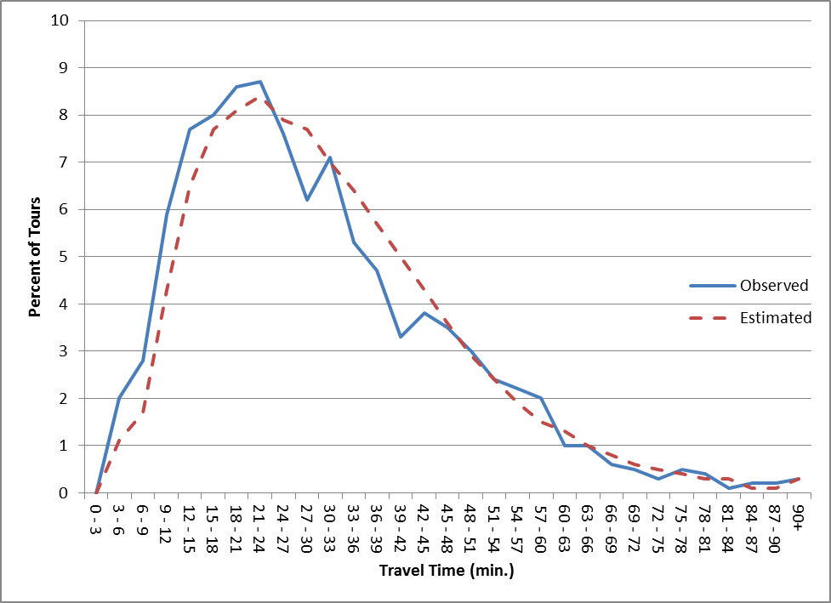

Figure 5-2 SCH TLFD

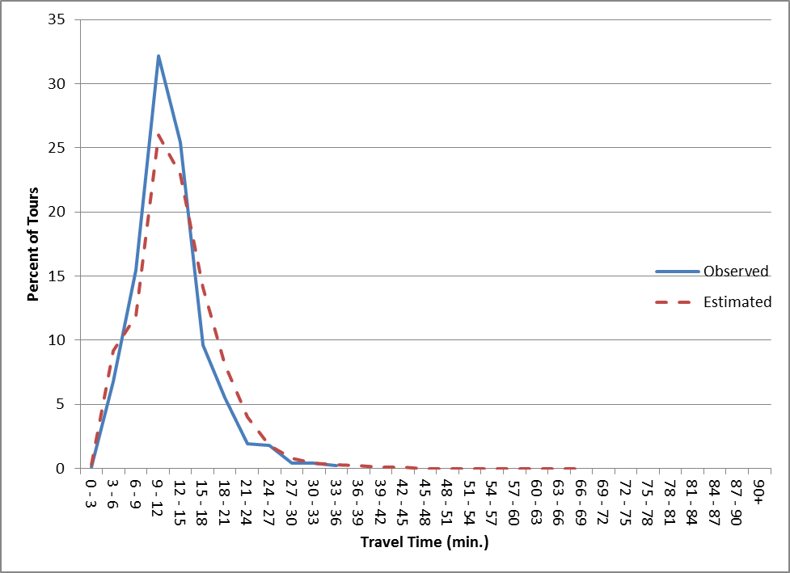

Figure 5-3 HBU TLFD

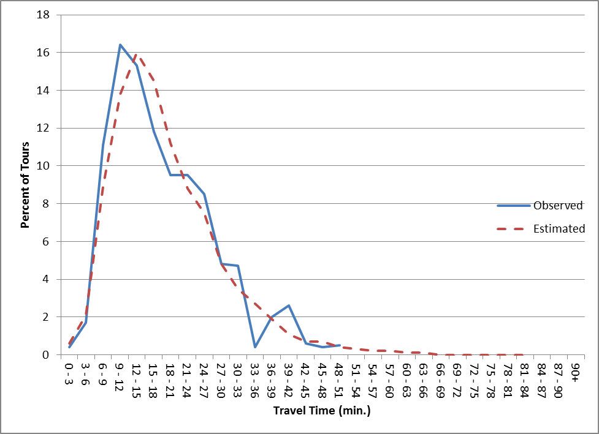

Figure 5-4 HBS TLFD

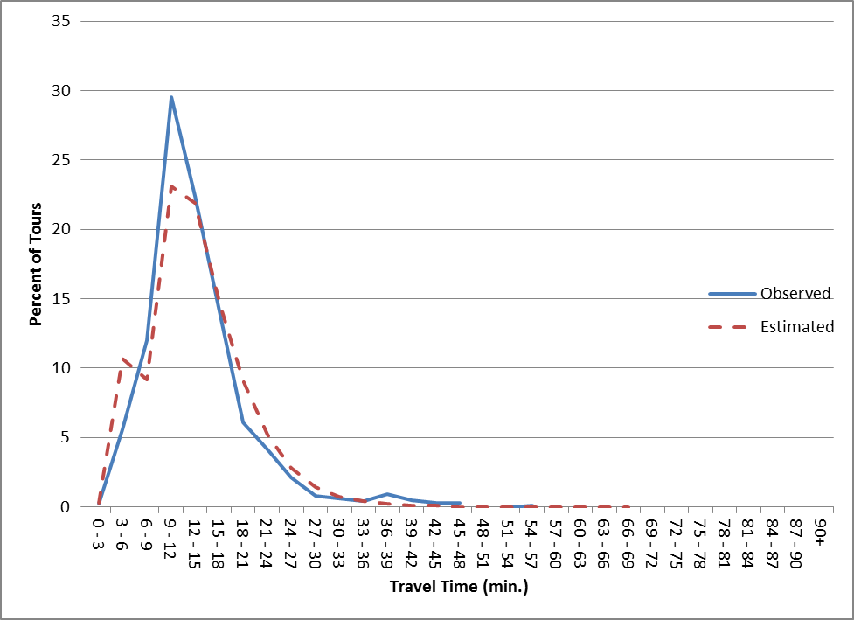

Figure 5-5 HBO TLFD

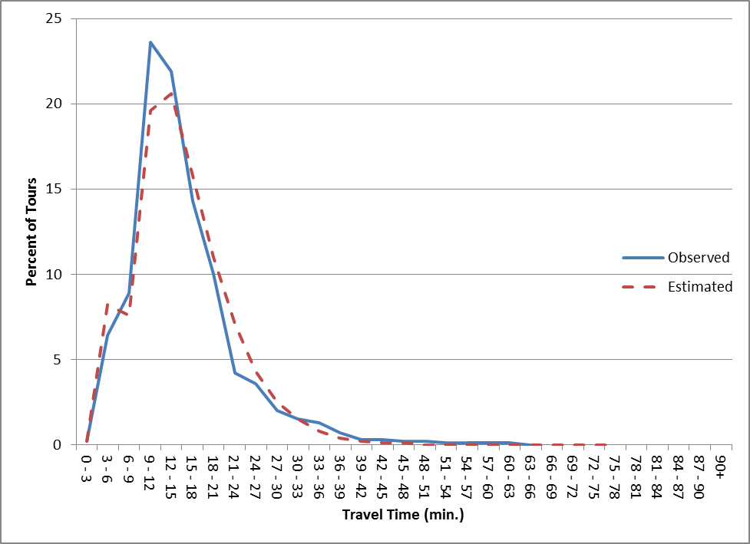

Figure 5-6 ATW TLFD

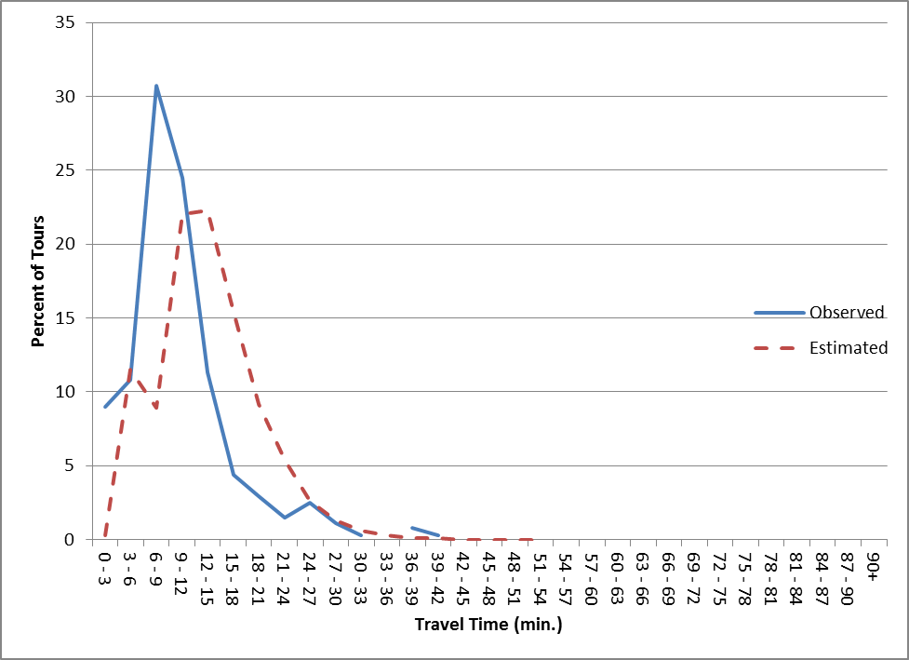

Figure 5-7 I/X TLFD

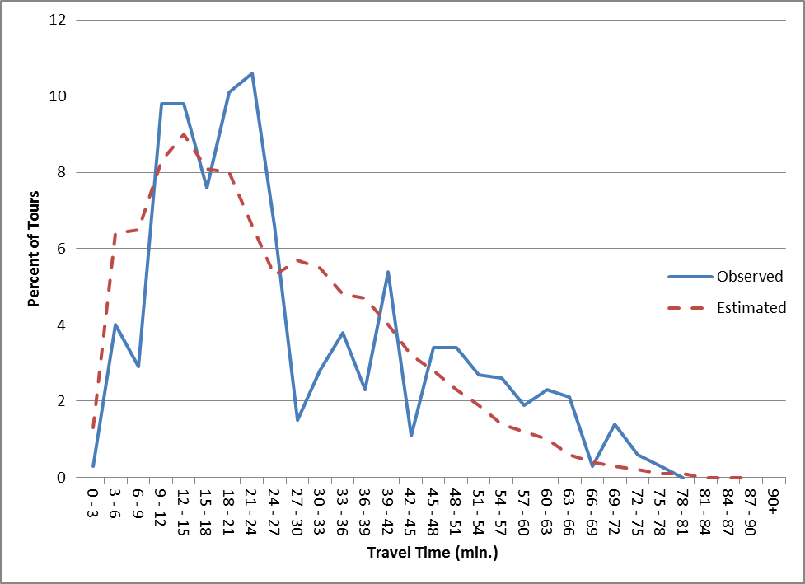

Another relevant statistic is the correspondence of trip patterns, as indicated by a county-county tour table. Tables 5-6 and 5-7 show the observed and estimated resident person tour tables. The county-to-county-level r² is 0.992, indicating close correspondence.

Table 5-6 Observed Person Tours

Destination District

| 1 2 3 4 5 6 7 8 9 10 11 12 13 | Total
---------------+---------------------------------------------------------------------------------------------------------+----------
O 1 Cabarrus | 167515 13417 466 908 0 1237 0 0 2162 2360 20801 30105 2958 | 241929
r 2 Rowan | 21156 138489 0 0 0 1319 0 108 1630 0 2813 7314 8230 | 181059
i 3 Gaston | 392 0 223966 3749 9636 240 6140 240 148 295 7758 19860 2637 | 275061
g 4 York | 9 0 6224 239047 958 907 0 4465 0 712 1317 30452 7022 | 291113
i 5 Clevland | 0 0 4622 0 59193 0 1142 0 0 0 492 1506 6986 | 73941
n 6 Iredell | 909 1432 119 0 0 70315 230 0 0 0 9055 4746 5488 | 92294
7 Lincoln | 201 200 10536 244 1006 1395 69257 0 0 280 5188 5810 8274 | 102391
D 8 Lancastr | 0 0 0 2288 0 0 0 7260 0 568 88 7013 494 | 17711
i 9 Stanly | 6231 1126 0 0 0 0 357 0 64331 1480 241 4154 2725 | 80645
s 10 Union | 2269 0 810 1567 0 401 0 2336 2455 162848 4110 80541 7366 | 264703
t 11 N Meck | 7560 821 7663 361 0 7563 1680 0 0 323 180450 76252 1901 | 284574
r 12 S Meck | 13315 1095 5406 11468 194 580 759 2096 657 18658 36234 899910 7798 | 998170
i 13 External | 0 0 0 0 0 0 0 0 0 0 0 0 1250 | 1250
---------------+---------------------------------------------------------------------------------------------------------+----------
Total 219557 259812 70987 79565 71383 268547 63129 | 2904841
| 156580 259632 83957 16505 187524 1167663 |

Table 5-7 Estimated Person Tours

Destination District

| 1 2 3 4 5 6 7 8 9 10 11 12 13 | Total
---------------+---------------------------------------------------------------------------------------------------------+----------
O 1 Cabarrus | 171858 9327 761 537 83 1405 148 121 3371 2210 15999 30597 2259 | 238676
r 2 Rowan | 24585 131075 178 134 20 3871 64 19 1761 191 4180 5016 6613 | 177707
i 3 Gaston | 994 90 199938 5988 10666 180 6868 139 31 357 13276 30160 3784 | 272471
g 4 York | 416 46 9580 230216 1646 50 190 2394 23 1335 1971 40702 9208 | 297777
i 5 Clevland | 54 6 8667 1361 74951 15 840 12 3 27 594 2001 7177 | 95708
n 6 Iredell | 4238 4618 309 151 33 65790 684 12 56 70 13396 4081 5371 | 98809
7 Lincoln | 410 91 12484 611 2749 1244 63737 41 7 85 8368 5835 6946 | 102608
D 8 Lancastr | 108 8 148 3211 14 7 11 9832 8 3042 196 9900 738 | 27223
i 9 Stanly | 5620 1195 60 110 8 40 11 50 59753 2947 663 3677 3596 | 77730
s 10 Union | 3205 214 614 3968 84 54 49 4863 1867 173322 2263 70842 7755 | 269100
t 11 N Meck | 18349 968 7837 1720 225 5656 2152 114 85 695 185179 114987 3450 | 341417
r 12 S Meck | 20138 687 6090 18470 351 394 331 3475 499 20628 54794 781712 7840 | 915409
i 13 External | 0 0 0 0 0 0 0 0 0 0 0 0 0 | 0
---------------+---------------------------------------------------------------------------------------------------------+----------
Total 249975 246666 90830 75085 67464 300879 64737 | 2914635
| 148325 266477 78706 21072 204909 1099510 |

6 INTERMEDIATE STOPS

6.1 Overview

The Tour Frequency and tour Destination Choice steps estimate the start and end locations for each round-trip tour. The next step is to determine for each individual tour, how many stops are made from origin to destination and from destination to origin. No separate estimate is made of the purpose of those intermediate stops; it is assumed that they are all for shopping or other such purposes (personal business, social, recreational, etc.). In the context of this model, the specific purpose of those stops is not important. Roughly 10-30% of tours have at least one intermediate stop, depending on purpose.

The Intermediate Stop (IS) model is stratified by purpose and direction (first half-tour, or PA direction vs. second half-tour, or AP direction). The model considers up to seven stops in each direction, since the survey said that only a very few tours made more stops than that. The IS model uses the standard multinomial logit process, based on the premise that the number of stops is related to the characteristics of the traveller, of the origin and destination zones, and of the area surrounding those zones.

6.2 Choices

As noted above, the maximum number of stops to be modelled is seven. For most purposes, the survey showed fewer than that, as Table 6-1 shows. The figures in this table represent the proportion of tours that have the number of stops shown, by purpose and direction. Stops are modelled separately by half-tour, as the survey and prior research shows that the number of stops made on the second half-tour is related to the number of stops made on the first half-tour.

Similar to the Tour Frequency model, the IS logit model includes a certain number of stops and then fixed percentages are used to estimate the number of stops above that figure. In Table 6-1, the number of stops shown in red italics are those that are modelled directly. This table also includes the average number of stops per tour. For example, for HBW, the model includes the choices no stops, 1 stop, and 2+ stops. For choices above 2 stops, the surveyed percentages implied by Table 6-1 are used, as shown in Table 6-2.
Table 6-1 Stop Choices

stops | HBW | SCH | HBU | HBS | HBO | ATW | I/X
P-A
0 | 0.856 | 0.902 | 0.918 | 0.718 | 0.845 | 0.891 | 0.773
1 | 0.112 | 0.087 | 0.063 | 0.185 | 0.108 | 0.085 | 0.135
2 | 0.022 | 0.010 | 0.019 | 0.062 | 0.029 | 0.010 | 0.049
3 | 0.006 | 0.001 |  | 0.026 | 0.009 | 0.003 | 0.018
4 | 0.003 |  |  | 0.007 | 0.005 | 0.011 | 0.019
5 | 0.001 |  |  | 0.001 | 0.002 |  | 0.006
6 |  |  |  | 0.001 | 0.001
7 |  |  |  |  | 0.001
avg. | 0.19 | 0.11 | 0.10 | 0.43 | 0.24 | 0.16 | 0.39
A-P
0 | 0.744 | 0.792 | 0.741 | 0.743 | 0.770 | 0.862 | 0.691
1 | 0.176 | 0.143 | 0.171 | 0.185 | 0.153 | 0.086 | 0.185
2 | 0.056 | 0.048 | 0.056 | 0.047 | 0.045 | 0.035 | 0.085
3 | 0.015 | 0.013 | 0.027 | 0.016 | 0.019 | 0.014 | 0.020
4 | 0.004 | 0.001 | 0.005 | 0.007 | 0.008 | 0.003 | 0.010
5 | 0.003 | 0.002 |  | 0.001 | 0.003 |  | 0.002
6 | 0.001 | 0.001 |  | 0.001 | 0.001 |  | 0.007
7 | 0.001 |  |  |  | 0.001
avg. | 0.38 | 0.30 | 0.38 | 0.37 | 0.36 | 0.21 | 0.51

Table 6-2 Non-Modelled Stop Choices

stops | HBW | SCH | HBU | HBS | HBO | ATW | I/X
P-A
0
1 |  |  |  |  |  | 0.779
2 | 0.687 | 0.909 |  |  |  | 0.092 | 0.532
3 | 0.188 | 0.091 |  | 0.742 | 0.500 | 0.028 | 0.196
4 | 0.094 |  |  | 0.200 | 0.277 | 0.101 | 0.207
5 | 0.031 |  |  | 0.029 | 0.111 |  | 0.065
6 |  |  |  | 0.029 | 0.056
7 |  |  |  |  | 0.056
A-P
0
1 |  |  |  |  |  | 0.623
2 | 0.698 | 0.739 | 0.636 |  |  | 0.254 | 0.686
3 | 0.188 | 0.200 | 0.307 | 0.640 | 0.594 | 0.101 | 0.161
4 | 0.050 | 0.015 | 0.057 | 0.280 | 0.250 | 0.022 | 0.081
5 | 0.038 | 0.031 | 0.000 | 0.040 | 0.094 |  | 0.016
6 | 0.013 | 0.015 |  | 0.040 | 0.031 |  | 0.056
7 | 0.013 |  |  |  | 0.031

6.3 Calibration

The next step in estimating the model was to prepare a calibration file. This is a set of records that describe the choices actually made by each traveller and the measurable data that might logically influence those choices. This file includes a wide range of objective statistics, from which a smaller set is chosen to calculate the utility of each choice. Table 6-3 lists the candidate variables. Separate calibration files were developed by tour direction, and for I/I tours by purpose and I/X tours in total. Preparing the calibration file was done in a similar manner as for the TF model. Observed tour records were extracted from the survey and a set of candidate independent variables was added, reflecting measurable attributes that the consultant considered would likely (and logically) affect the number of stops.

Table 6-3 IS Candidate Variables

Tour origin and destination zones
HH income code (1-4)
HH size (1-5)
HH life cycle (1-3)
HH workers (0-3)
Origin and destination county codes
Origin area type (1-5)
Destination area type (1-5)
Origin CBD dummy (1 if origin zone in CBD, else 0)
Destination CBD dummy (1 if destination zone in CBD, else 0)
Actual number of PA stops
Actual number of AP stops
O/D travel time
Retail employment within 0.5 mi of origin centroid
Retail employment within 1.0 mi of origin centroid
Retail employment within 2.0 mi of origin centroid
Retail employment within 3.0 mi of origin centroid
Total employment within 0.5 mi of origin centroid
Total employment within 1.0 mi of origin centroid
Total employment within 2.0 mi of origin centroid
Total employment within 3.0 mi of origin centroid
Total population within 0.5 mi of origin centroid
Total population within 1.0 mi of origin centroid
Total population within 2.0 mi of origin centroid
Total population within 3.0 mi of origin centroid
Retail employment within 0.5 mi of destination centroid
Retail employment within 1.0 mi of destination centroid
Retail employment within 2.0 mi of destination centroid
Retail employment within 3.0 mi of destination centroid
Total employment within 0.5 mi of destination centroid
Total employment within 1.0 mi of destination centroid
Total employment within 2.0 mi of destination centroid
Total employment within 3.0 mi of destination centroid
Total population within 0.5 mi of destination centroid
Total population within 1.0 mi of destination centroid
Total population within 2.0 mi of destination centroid
Total population within 3.0 mi of destination centroid
Retail employment within the O/D circle
Total employment within the O/D circle
Population within the O/D circle
K-12 enrollment within the O/D circle
Retail employment within the O/D box
Total employment within the O/D box
Population within the O/D box
K-12 enrollment within the O/D box
Retail employment in the origin zone
Total employment in the origin zone
Population in the origin zone
Retail employment in the destination zone
Total employment in the destination zone
Population in the destination zone
Area in the origin zone
Area in the destination zone
A key set of IS variables is related to the geometry of the origin and destination zones. This is defined by the land use in those zones whose centroids are various straight-line distances from the origin and destination zones. For example, the variable “retail employment within 0.5 mi of origin” is defined for a tour origin zone as the retail employment (RTL + HWY) in all zones whose centroids lie with 0.5 mi straight line distance of the subject zone. A similar construct is used for the “box” variables: these are the land use in all zones whose centroid lies within a rectangle centered on the O-D straight line axis, whose length is the O-D straight line distance and whose width is 30% of that distance. The “circle” variables are the land use in all zones whose centroid lies within a circle centered on the O-D straight line midpoint, with a diameter equal to the O-D straight line distance (i.e., a circle with the origin centroid on one side and the destination centroid on the other side). See Figure 6-1.

Figure 6-1 Box and Circle Definitions

x
0.3x
“box”
“circle”
dest
orig
dest
orig
The consultant hypothesized numerous utility functions for each purpose, as listed in Appendix A. The utility of making no stops was defined as zero. The candidate models are listed in Appendix A and the final models are shown in Table 6-4 and the variables are listed in Table 6-5. Some of the final model variables involve transformations of the basic input variables shown in Table 6-3.

Table 6-4 IS Models

Purpose | Direction | Stops | Utility Equation
HBW | PA | 0 | 0
 |  | 1 | -2.632 + 0.2392*INC4DUM + 0.9609*LC2DUM + 0.00004341*RET30P  + 0.00001594*RET30A[1] - 0.2317*TOURS
 |  | 2+ | -4.062 + 0.2392*INC4DUM + 0.9609*LC2DUM + 0.00004341*RET30P  + 0.00001594*RET30A[1] - 0.2317*TOURS
 | AP | 0 | 0
 |  | 1 | -1.914 + 0.4851*PASTOPS + 0.3553*INC4DUM + 0.00003103*RET30P
 |  | 2+ | -2.714 + 0.4851*PASTOPS + 0.3553*INC4DUM + 0.00003103*RET30P
SCH | PA | 0 | 0
 |  | 1 | -4.085 + 0.0473*HTIME + 0.4372*DESTRUR[2] + 0.0000429*RET30P  + 0.1217*TOURS
 |  | 2+ | -6.080 + 0.0473*HTIME + 0.4372*DESTRUR[2] + 0.0000429*RET30P  + 0.1217*TOURS
 | AP | 0 | 0
 |  | 1 | -2.936 + 0.9709*PASTOPS + 0.02792*HTIME - 0.1922*SIZE  + 0.2126*ORIGAT[6] + 0.00006084*RET30P + 0.08723*TOURS
 |  | 2+ | -3.786 + 0.9709*PASTOPS + 0.02792*HTIME - 0.1922*SIZE  + 0.2126*ORIGAT[6] + 0.00006084*RET30P + 0.08723*TOURS
HBU | PA | 0 | 0
 |  | 1 | -2.700 - 1.154*INC4DUM[3] + 0.1311*TOURS[4]
 |  | 2+ | -4.885 - 1.154*INC4DUM[3] + 0.1311*TOURS[4]
 | AP | 0 | 0
 |  | 1 | -1.170 + 0.5613*PASTOPS[7] + 0.00004232*RET30A[4]  - 0.1311*TOURS[1]
 |  | 2+ | -1.909 + 0.5613*PASTOPS[7] + 0.00004232*RET30A[4]  - 0.1311*TOURS[1]
HBS | PA | 0 | 0
 |  | 1 | -1.805 + 0.03799*HTIME - 0.6524*INC1DUM + 0.0000362*DDENSP  - 0.0939*TOURS
 |  | 2 | -2.872 + 0.03799*HTIME - 0.6524*INC1DUM + 0.0000362*DDENSP  - 0.0939*TOURS
 |  | 3+ | -3.491 + 0.03799*HTIME - 0.6524*INC1DUM + 0.0000362*DDENSP  - 0.0939*TOURS
 | AP | 0 | 0
 |  | 1 | -1.748 + 0.2972*PASTOPS + 0.01944*HTIME - 0.5592*INC1DUM  + 0.00004218*RET30A - 0.1683*TOURS
 |  | 2 | -3.045 + 0.2972*PASTOPS + 0.01944*HTIME - 0.5592*INC1DUM  + 0.00004218*RET30A - 0.1683*TOURS
 |  | 3+ | -3.685 + 0.2972*PASTOPS + 0.01944*HTIME - 0.5592*INC1DUM  + 0.00004218*RET30A - 0.1683*TOURS
HBO | PA | 0 | 0
 |  | 1 | -2.697 + 0.03097*HTIME - 0.62*INTRAZ - 0.7354*DESTCBD  + 0.2526*DESTRUR[2] + 0.00003275*RET30P
 |  | 2 | -3.999 + 0.03097*HTIME - 0.62*INTRAZ - 0.7354*DESTCBD  + 0.2526*DESTRUR[2] + 0.00003275*RET30P
 |  | 3+ | -4.435 + 0.03097*HTIME - 0.62*INTRAZ - 0.7354*DESTCBD  + 0.2526*DESTRUR[2] + 0.00003275*RET30P
 | AP | 0 | 0
 |  | 1 | -1.635 + 0.3102*PASTOPS + 0.02345*HTIME - 0.4550*INTRAZ  - 0.3154*INC1DUM - 0.2879*ORIGRUR - 0.06909*TOURS
 |  | 2 | -2.815 + 0.3102*PASTOPS + 0.02345*HTIME - 0.4550*INTRAZ  - 0.3154*INC1DUM - 0.2879*ORIGRUR - 0.06909*TOURS
 |  | 3+ | -3.224 + 0.3102*PASTOPS + 0.02345*HTIME - 0.4550*INTRAZ  - 0.3154*INC1DUM - 0.2879*ORIGRUR - 0.06909*TOURS
ATW | PA | 0 | 0
 |  | 1+ | -3.766 + 0.05033*HTIME[3] + 1.559*DESTRUR[3] + 0.1313*TOURS[5]
 | AP | 0 | 0
 |  | 1+ | -2.439 + 1.161*PASTOPS + 0.05672*HTIME + 1.025*DESTCBD[1]  - 0.00008081*RET30P[2]
I/X | PA | 0 | 0
 |  | 1 | -3.594 + 1.250*NWDUMMY + 0.9095*INC4DUM - 2.263*ORIGRUR  + 0.3864*LC2DUM[4] + 0.0001245*RET30P
 |  | 2+ | -4.136 + 1.250*NWDUMMY + 0.9095*INC4DUM - 2.263*ORIGRUR  + 0.3864*LC2DUM[4] + 0.0001245*RET30P
 | AP | 0 | 0
 |  | 1 | -2.141 + 0.6979*PASTOPS + 0.0125*HTIME[3] + 0.3412*ORIGRUR[4]
 |  | 2+ | -2.495 + 0.6979*PASTOPS + 0.0125*HTIME[3] + 0.3412*ORIGRUR[4]
Note: All coefficients have absolute t values over 2.0, except as follows:
[1] t=1.5 [5] t=1.6
[2] t=1.9 [6] t=1.7
[3] t=1.8 [7] t=1.2
[4] t=1.3

A logical interpretation of these equations is as follows:

- HBW, P-A direction
More stops are associated with the highest income group (inc 4), HHs with kids, and more retail employment surrounding the tour origin and destination zones. The more total tours the HH makes, the less likely the HBW tour will include stops, because it doesn’t need to.
- HBW, A-P direction
The more stops made in the P-A direction (home to work), the fewer stops are made in the A-P direction (work to home), which makes sense. This phenomenon was noted for all purposes and was statistically very significant. Otherwise, increased stops are associated with income 4 and greater retail around the origin.

Table 6-5 IS Variables

Variable | Definition
DDENSP | Origin zone density function: (800*POP + 300*EMP)/ACRES
DESTCBD | 1 if destination zone is in CBD, else 0
DESTRUR | 1 if destination zone is Rural (area type 5), else 0
HTIME | Auto travel time, origin-destination
INC1DUM | 1 if HH is income 1, else 0
INC4DUM | 1 if HH is income 4, else 0
INTRAZ | 1 if origin zone = destination zone, else 0
LC2DUM | 1 if HH is life cycle 2 (children), else 0
NWDUMMY | 1 if tour purpose is non-work, else 0
ORIGAT | Origin zone area type (1-5)
ORIGRUR | 1 if origin zone is Rural (area type 5), else 0
PASTOPS | Number of estimated stops for the P-A direction (first half-tour)
RET30A | Retail employment in zones whose centroid is within 3 mi of destination zone centroid
RET30P | Retail employment in zones whose centroid is within 3 mi of origin zone centroid
SIZE | HH size (1-5)
TOURS | Total number of estimated tours for the HH

- SCH, P-A direction
More stops are associated with longer tour O/D time, Rural schools, and greater retail around the home, which make sense. Harder to explain is that more stops are also associated with with making more tours (the opposite of HBW). Perhaps more SCH tours means more kids, meaning more stops to buy goods and pursue activities.
- SCH, A-P direction
As with the P-A direction, more stops are associated with longer tour O/D time and greater retail around the home, which makes sense. Harder to explain is that more stops are also associated with less developed origin areas and with making more tours.
- HBU, P-A direction
More stops are associated with making more tours, which is similar to the SCH result. High income HHs make fewer stops, which seems odd (unless they need fewer stops because they make more tours).
- HBU, A-P direction
More stops are associated with more P-A stops and with more retail around the university zone. Making more total tours means fewer stops – similar to HBW but different from SCH.
- HBS, P-A direction
More stops are made if the tour is longer and the origin zone is denser, both of which are logical. Fewer stops are made if the HH is low income (inc 1) and makes more total tours. Those also seem logical.
- HBS, A-P direction
More stops are made if the tour is longer, P-A stops were made, and there is more retail around the destination, all of which make sense. As with the P-A direction, fewer stops are made if the HH is low income (inc 1) and makes more total tours.
- HBO, P-A direction
More stops are made if the tour is longer and there is more retail around the origin (logical). More stops are made if the destination zone is Rural, which may relate to longer tour times. Fewer stops are made if the tour is intrazonal (makes sense) or is destined to the CBD (unclear).
- HBO, A-P direction
More stops are made if there are more P-A stops and the tour is longer (both OK). Fewer stops are made if the tour is intrazonal, HH is income 1, origin is Rural, and if more total tours are made; all of which make sense.
- ATW, P-A direction
More stops are made if the tour is longer, destined to a Rural zone, or if the HH makes more total tours; those are probably OK.
- ATW, A-P direction
More stops are made if more P-A stops are made, the tour is longer, or the destination is in the CBD. Fewer stops are made if there is much retail around the origin zone, which is questionable.
- I/X, P-A direction (resident leaving the area)
More stops are made for non-work, by income 4 HHs, by HHs with kids, and if there is more retail around the origin, all of which make sense. Fewer stops are made if the origin is Rural, which also seems logical.
- I/X, A-P direction (resident returning home from outside the area)
More stops are made if there are more P-A stops, on longer tours (both OK), and if the origin is Rural (questionable).
Unfortunately, from a statistical point of view, none of these models have high goodness-of-fit statistics. That is, the ρ² values are not fantastic (see Appendix A). In some cases, rhosq(0) isn’t too bad, but the rhosq(C)’s are pretty low. This means that the bias constants are providing the bulk of the explanatory power, implying that most of what influences intermediate stop decisions are not things that can be measured and forecasted (or at least they were not in the calibration file) – they’re probably unknown and unknowable.

However, the variables that can be measured (and forecasted) do have some value. For each model, comparing the rhosq(C) value for run “a” to the final rhosq(C) value in bold green usually shows a big relative increase. That means that the final variables (in bold green) have made a real contribution to the accuracy of the equation, compared to a model consisting only of bias constants. This suggests that most of the variables do make a useful improvement to the models.

6.4 Validation

The IS model is validated by comparing the percent of tours by the number of stops, survey vs. model, as shown in Table 6-6. The survey (observed) figures are close to the model (estimated) figures and the average numbers of stops are also close. The SCH and HBU models include a small adjustment to the bias constant; the other models are as originally estimated by ALOGIT.

Table 6-6 IS Validation

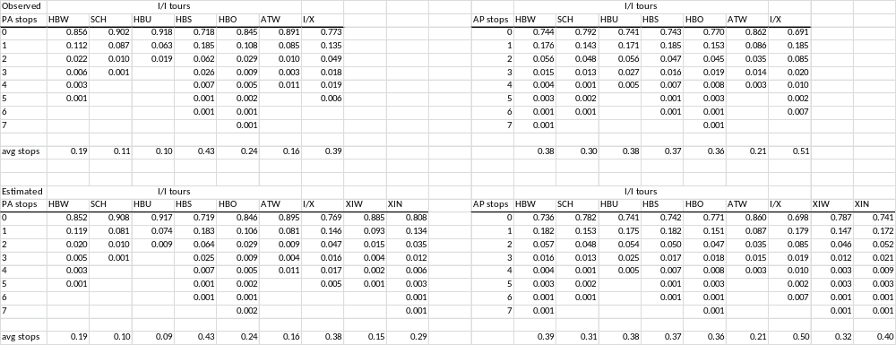

7 STOP LOCATION

7.1 Overview

The Stop Location (SL) model developed originally for the Brunswick, GA tour-based model was similar in organization to the Intermediate Stop model. Separate models were developed by purpose and direction. For Metrolina, the consultant undertook a more detailed analysis of intermediate stop behavior. This focused on detour time, which is the time that a traveller goes out of his way to make a stop, as shown in Figure 7-1.

Figure 7-1 Detour Time

origin
destination
stop
10
5
12
detour time = 10 + 5 – 12 = 3

The 12,788 surveyed tour records involved 7,305 stops. The average detour time by stop (both directions) was 14.1 minutes, as shown in Table 7-1. This table also indicates that Work tours have the longest average detour (18.2 min). The last row of this table shows the average detour time divided by the direct origin-destination (network) time. This shows that School trip detours are significant in that the detour time actually exceeds the direct time by 15%. This is probably a combination of parents taking children to relatively inconvenient school bus stop locations and/or picking up other children for a carpool. HBU trips go out of their way the least. The percent of tours by detour time and purpose is shown in Figure 7-2.
Table 7-1 Detour Time Analysis

detour tm | hbw | sch | hbu | hbs | hbo | atw | all
0 | 114 | 124 | 8 | 205 | 425 | 6 | 882
5 | 412 | 143 | 31 | 545 | 1174 | 28 | 2333
10 | 382 | 154 | 22 | 386 | 878 | 22 | 1844
15 | 242 | 61 | 14 | 164 | 450 | 13 | 944
20 | 152 | 56 | 6 | 79 | 199 | 5 | 497
25 | 84 | 33 | 2 | 50 | 118 | 2 | 289
30 | 64 | 20 | 5 | 13 | 52 |  | 154
35 | 40 | 14 |  | 13 | 39 |  | 106
40 | 29 | 8 |  | 13 | 17 |  | 67
45 | 14 | 3 |  | 7 | 14 |  | 38
50 | 23 | 3 |  | 11 | 17 |  | 54
55 | 8 | 2 | 1 | 3 | 8 |  | 22
60 | 8 | 2 |  |  | 8 |  | 18
65 | 6 | 1 |  |  | 3 |  | 10
70 | 6 | 1 |  |  | 5 |  | 12
75 | 2 |  |  |  | 2 |  | 4
80 | 5 |  |  |  | 2 |  | 7
85 | 9 |  |  |  |  |  | 9
90 | 4 | 1 |  |  |  |  | 5
95 | 1 |  |  |  |  |  | 1
100 | 2 |  |  |  |  |  | 2
105 | 1 |  |  |  |  |  | 1
110 | 1 |  |  |  |  |  | 1
115 | 1 |  |  |  |  |  | 1
120 |  |  |  | 2 |  |  | 2
140 | 1 |  |  |  |  |  | 1
145 | 1 |  |  |  |  |  | 1
 | 1612 | 626 | 89 | 1491 | 3411 | 76 | 7305
avg time | 18.2 | 14.4 | 13.3 | 12.4 | 13.0 | 11.7 | 14.1
detour % | 64% | 115% | 57% | 81% | 75% | 75% | 74%

Figure 7-2 Tours by Detour Time

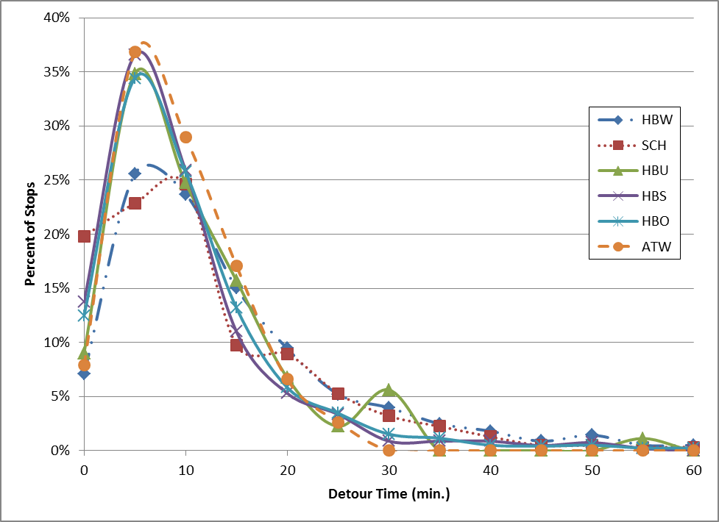

Figure 7-2 indicates that the non-work purposes are not very different from each other. This began to suggest that a model stratified by purpose might not be an efficient use of the data. It also opened the question of what attributes best describe intermediate stop location, as measured by detour time. Table 7-2 shows additional detour time tabulations by various characteristics.

Table 7-2 Detour Time Crosstabs

- average detour time by purpose and direction
 | Direction
Purpose | P-A | A-P
hbw | 16.2 | 19.2
sch | 10.4 | 15.8
hbu | 11.3 | 13.7
hbs | 12.6 | 12.1
hbo | 12.9 | 13.0
atw | 11.1 | 12.1

- average detour time by purpose and HH income
 | HH income group
Purpose | 1 | 2 | 3 | 4
hbw | 16.2 | 20.5 | 17.0 | 18.3
sch | 12.1 | 13.7 | 14.4 | 14.8
hbu | 16.3 | 14.1 | 13.5 | 12.2
hbs | 11.4 | 12.7 | 11.5 | 12.7
hbo | 10.3 | 13.3 | 12.9 | 13.3
atw | 18.8 | 11.6 | 11.2 | 11.4

- average detour time by purpose and HH size
 | HH size
Purpose | 1 | 2 | 3 | 4 | 5+
hbw | 18.5 | 18.2 | 19.2 | 17.1 | 17.7
sch | 8.6 | 11.2 | 15.0 | 14.6 | 14.1
hbu | 23.4 | 10.3 | 16.0 | 10.7 | 11.4
hbs | 12.5 | 13.8 | 12.0 | 10.8 | 11.1
hbo | 12.6 | 13.2 | 11.7 | 13.6 | 13.7
atw | 10.9 | 11.2 | 10.9 | 13.1 | 10.9

- average detour time by purpose and HH life cycle
 | HH Life Cycle
Purpose | Retired | Kids | Neither
hbw | 15.2 | 17.2 | 19.7
sch | 13.8 | 14.4 | 0.0
hbu | 11.7 | 11.5 | 15.9
hbs | 13.3 | 11.1 | 12.8
hbo | 11.4 | 13.0 | 13.4
atw | 11.2 | 11.6 | 11.8

- average detour time by purpose and workers
 | Workers
Purpose | 0 | 1 | 2 | 3+
hbw | 24.7 | 17.5 | 18.0 | 20.6
sch | 10.9 | 14.4 | 14.3 | 17.7
hbu | 16.9 | 13.1 | 13.9 | 9.3
hbs | 12.9 | 11.6 | 12.0 | 14.9
hbo | 12.3 | 13.3 | 13.1 | 15.4
atw |  | 11.7 | 11.7 | 11.7

- average detour time by purpose and stop sequence number
 | Stop Number
Purpose | 1 | 2 | 3 | 4 | 5 | 6 | 7
hbw | 17.2 | 19.2 | 23.3 | 21.3 | 21.5 | 27.7 | 27.5
sch | 13.9 | 14.3 | 21.4 | 15.8 | 11.4 | 21.8 | 20.8
hbu | 14.2 | 12.0 | 10.9 | 12.8 | 10.5 | 16.6
hbs | 11.9 | 13.2 | 13.5 | 13.3 | 15.4 | 11.8
hbo | 12.2 | 13.6 | 14.9 | 13.9 | 19.9 | 20.0 | 19.2
atw | 11.5 | 13.8 | 8.9 | 7.7

Several relevant observations:

- A-P stops have slightly longer detours than P-A stops, but the difference is significant only for HBW, SCH, and HBU.
- HBW detour time is significantly longer than for other purposes.
- Income 1 travellers have noticeably lower detours than other incomes.
- 1-person HHs have lower detours.
- Life cycle 1 HHs (retired) have lower detours.
- 0-worker HHs have lower detours and 3+ worker HHs have higher detours.
- Stop sequence number influences detour time: later stops have higher detours.

This analysis suggests that the differences between income 1 and income 2-4 is more important than the differences among the non-work purposes. The effect of stop sequence number is also noticeable. There are only a handful of tours that make 5-7 stops, but their average detour is about 50% higher than the overall average. The original concept for this model was to follow the Brunswick practice and not model stop sequence (i.e., treat all stops as separate and independent of each other). However, this data suggests that stop sequence is too important to ignore. Discussions with CDOT staff also supported the idea of specifically modelling the sequence of intermediate stops, so this was added to the model structure.

A related issue involves sample size. Stratifying the data simultaneously by purpose, HH income, and stop number stretches it too thinly. The number of observations in each group becomes too small to support model estimation. Based on the previous models, the consultant observed that with fewer than 300 observations, it is difficult to achieve statistical and logical confidence. Table 7-3 shows the number of surveyed tours in each category; the heavy boxes show one way to group the data that incorporates the effects of purpose, income, and stop sequence, while maintaining a sufficient sample size in each group.

Table 7-3 Sample Stratification

 | Stop Number
purpose | 1 | 2 | 3 | 4 | 5 | 6 | 7
 | income | 4
hbw | 821 | 221 | 64 | 21 | 7 | 2 | 1
sch | 292 | 71 | 21 | 7 | 6 | 3 | 3
hbu | 25 | 13 | 4 | 1
hbs | 521 | 191 | 68 | 22 | 5 | 3
hbo | 1220 | 390 | 158 | 73 | 29 | 11 | 5
atw | 40 | 8 | 4
 | income | 1-3
hbw | 320 | 89 | 34 | 15 | 9 | 5 | 3
sch | 173 | 42 | 6 | 1 | 1 | 0 | 0
hbu | 29 | 6 | 5 | 3 | 2 | 1 | 0
hbs | 488 | 134 | 45 | 9 | 3 | 2 | 0
hbo | 973 | 331 | 126 | 56 | 22 | 11 | 6
atw | 15 | 6 | 2 | 1 | 0 | 0 | 0
 | income | all
hbw | 1141 | 310 | 98 | 36 | 16 | 7 | 4
sch | 465 | 113 | 27 | 8 | 7 | 3 | 3
hbu | 54 | 19 | 9 | 4 | 2 | 1 | 0
hbs | 1009 | 325 | 113 | 31 | 8 | 5 | 0
hbo | 2193 | 721 | 284 | 129 | 51 | 22 | 11
atw | 55 | 14 | 6 | 1 | 0 | 0 | 0

This results in nine groups:
- HBW, stop 1, income 1-3
- HBW, stop 1, income 4
- HBW, stop 2, all incomes
- SCH/HBU, stop 1, all incomes
- HBS/HBO/ATW, stop 1, income 1-3
- HBS/HBO/ATW, stop 1, income 4
- SCH/HBU/HBS/HBO/ATW, stop 2, all incomes
- all purposes, stop 3, all incomes
- all purposes, stops 4-7, all incomes

This means there are nine SL models. Using different models for the first, second, third, and all subsequent stops allows the model to consider stop sequencing, which was not included in the Brunswick model. Although the SL model is applied separately by tour direction, the same model is used for both directions.

7.2 Choices

The SL model is similar to the Destination Choice model in that it is selecting a particular zone from a set of candidate zones. As with the DC model, in calibration and application, it is necessary as a practical matter to restrict the choice of stopping to zones that travellers would logically consider as a true candidate stop zone.

7.3 Calibration

Preparing the calibration file was done in a similar manner as for the DC model. Observed tour records that had a stop were extracted from the survey and a set of candidate independent variables was added, reflecting measurable attributes that the consultant considered would likely (and logically) affect stop location choice.

For calibration purposes, only 10 choices were used: the selected stop zone and nine other zones. Because the stop location is presumably constrained somewhat by the locations of the tour origin and destination zones, the consultant believed that the SL model could be developed by considering fewer zones than the 20 used in the DC model. As with the DC model, the nine alternative zones were selected at random. Candidate zones must have either non-zero population or non-zero employment and the maximum detour time for candidate zones was 45 minutes. As Figure 7-2 shows, the number of actual stops with detours greater than that was extremely small. This also prevents unusual stop choices with extreme detours (possibly representing geocoding errors) from unduly influencing the calibration.

From that point, the calibration file was created in the standard manner: several candidate variables were selected that should influence the choice of stop location and these were output on a calibration file for the selected zone and each of the nine candidate zones. Table 7-4 lists these variables.

These variables were used to estimate a logit model for each trip purpose, in a manner similar to that described in section 4.3. The tested utility functions are listed in Appendix A. The final models are shown in Table 7-5 and the variables are listed in Table 7-6. Some of the final model variables involve transformations of the basic input variables shown in Table 7-4.

Like the DC model, the SL model includes different types of variables:
- Travel time, which measures the separation between zones.
- Descriptors of the stop zones.
- “Size” variables: these are variables that represent the magnitude of the candidate stop zones, such as households or employment. By convention, these are entered in the utility equation in logarithmic form.

Table 7-4 SL Candidate Variables

Origin-stop time (1)
Origin-stop-destination time (1)
Area type (1-5)
Total employment
Retail employment (RTL + HWY)
Total population
K-12 enrollment (STU_K8 + STU_HS)
Zonal area
Accessibility to employment within 15 min. of composite time
Accessibility to HHs within 15 min. of composite time
CBD dummy (1 if zone in CBD, else 0)
Distance to CBD (TAZ 10002) (mi.)
Time from the previous stop (2)
Notes:
- In this case, “origin” is where the half-tour begins, which depends on the direction. For the PA direction, it is the tour’s main origin zone. For the AP direction, it is the tour’s main destination zone.
- Calculated only for stop numbers 2 and above.

Table 7-5 SL Models

Model | Description | Utility Equation
1 | HBW stop 1, inc 1-3 | -0.09805*DETOUR + 1.192*SHORTDUM – 0.2450*ATYPE  + ln(RETEMP + 0.16268*NRETEMP + 0.18637*POP  + 0.53741*K12ENR[1])
2 | HBW stop 1, inc 4 | -0.08703 *DETOUR + 0.8315*SHORTDUM – 0.2313*ATYPE  + 0.05425*DISTCBD + 1.240*STOPTMDUM +  ln(RETEMP + 0.20433*NRETEMP + 0.08821*POP + 0.35987*K12ENR)
3 | HBW stop 2 | -0.0402*DETOUR[2] + 1.308 *SHORTDUM – 0.1899*ATYPE [3]  - 0.1010*LASTTM  + ln(RETEMP + 0.11304*NRETEMP + 0.08094*POP + 0.33187*K12ENR)
4 | SCH/HBU, stop 1 | -0.1678*DETOUR + 1.114*SHORTDUM  + 0.7660*URBANDUM + 0.02703*DISTCBD + 1.0350*STOPTMDUM  - 3.257*10⁻⁸*EMPACC + ln(TOTEMP + 0.20867*POP)
5 | HBS/HBO/ATW, stop 1, inc 1-3 | -0.1800*DETOUR + 0.5415*SHORTDUM + 0.7166*URBANDUM  - 1.730*10⁻⁸*EMPACC  + ln(RETEMP + 0.12835*NRETEMP + 0.06367*POP + 0.14072*K12ENR)
6 | HBS/HBO/ATW, stop 1, inc 4 | -0.1665*DETOUR + 0.5221*SHORTDUM + 0.7392*URBANDUM  + 0.04428*DISTCBD + 0.9373*STOPTMDUM  + ln(RETEMP + 0.12051*NRETEMP + 0.06522*POP + 0.20577*K12ENR)
7 | All non-work, stop 2 | -0.01755*DETOUR[4] + 0.9071 *SHORTDUM + 0.7262*URBANDUM  - 0.1666*LASTTM - 1.526*10⁻⁸*EMPACC – 0.1298*STOPDEST  + ln(RETEMP + 0.08358*NRETEMP + 0.06734*POP + 0.08111*K12ENR)
8 | All purposes, stop 3 | 1.2410*SHORTDUM + 0.5373*URBANDUM – 0.1801*LASTTM  - 2.046*10⁻⁸*EMPACC – 0.09602*STOPDEST  + ln(RETEMP + 0.10540*NRETEMP + 0.05393*POP + 0.06620*K12ENR)
9 | All purposes, stops 4-7 | 1.2410*SHORTDUM + 0.4872*URBANDUM – 0.0636*LASTTM  - 9.770*10⁻⁹*EMPACC[4] – 0.13560*STOPDEST  + ln(RETEMP + 0.09720*NRETEMP + 0.11967*POP + 0.09575*K12ENR)
Note: All coefficients have absolute t values over 2.0, except as follows:
[1] t=1.9 [3] t=1.8
[2] t=1.2 [4] t=1.6
Variables shown in logarithmic form [ln()] are “Size” variables. The coefficients shown have already been transformed by taking the exponential of the value estimated by ALOGIT.
Additional validation adjustments for A-P direction only:
- HBU: multiply coefficients on DETOUR and LASTTM by 10.
- I/X: multiply coefficients on DETOUR and LASTTM by 0.75.

Table 7-6 SL Variables

Variable | Definition
ATYPE | Area type (1-5)
DETOUR | Detour time, min.
DISTCBD | Network distance to CBD (TAZ 10002), mi.
EMPACC | Accessibility to employment within 15 min. of composite time
K12ENR | K-12 enrollment (STU_K8 + STU_HS)
LASTTM | Time from the last stop, min. (only for stops 2+)
NRETEMP | Non-retail employment (TOTEMP – RETEMP)
POP | Total population
RETEMP | Retail employment (RTL + HWY)
SHORTDUM | 1 if detour time <= 10 min., else 0
STOPTMDUM | 1 if stop-destination time <= 5 min., else 0 (this is the half-tour’s destination)
STOPDEST | Stop-destination time, min. (this is the half-tour’s destination)
TOTEMP | Total employment
URBANDUM | 1 if zone is area type 1-2, else 0

A logical interpretation of these equations (in general) is as follows:

- Detour time is the most important variable and the sign is always negative, as it should logically be. The value is algebraically higher for non-work than work, meaning that non-work detours are shorter, which both reflects the survey and makes sense.
- Very short detours (10 min. or less) are especially important in stop zone selection. People really don’t like to go farther than that out of their way.
- Separate from the Size variables, the level of development is important. For Work, less developed zones are less likely to be stops. For Non-Work, Urban zones are more likely to be stops, but so are zones further from the CBD. Those two opposing factors must be moderating each other. However, zones with greater employment accessibility are less likely to be Non-Work stops. This illustrates the “competition” effect.
- The zone’s travel time to the end of each half-tour is significant for multi-stop tours and is negative, so that being closer to the end is associated with more stops. This is especially significant if the zone is within 5 min. of the half-tour’s end. (Note that the end of the first half-tour is the tour’s destination and the end of the second half-tour is the tour’s origin.)
- For multi-stop tours, the time from the last stop is important and negative, as it should be. This acts to minimize total tour time.
- All of the models but one use the same Size variables. Retail employment is the most important, as it should be since most intermediate stops are for shopping. K-12 enrollment is the next most important (student pick-up/drop-off), followed by non-retail employment and population. That seems logical.
- For models 8 and 9, representing the third stop and above, Detour Time dropped out and was replaced by the stop-destination time, time from the last stop, and the short detour dummy. So for those tours, it doesn’t matter exactly what the detour time is, all that matters is whether it’s within 10 min or not. The other implication is that stops 3, 4, etc. are not determined so much by the tour O and D zones, as by the location of the last stop and the destination zone. This suggests that stop location choice is a combination of pre-planned thinking (especially for 1-2 stop tours) and on-the-fly changes in behavior (for 3-7 stop tours). That makes sense.

7.4 Validation

Two primary measures of evaluation are used for the SL model:

- Total tour length frequency distribution, by direction: this is the true TLFD, including all stops, including both the average and the distribution (the TLFDs in Chapter 5 looked only at the direct origin-destination time)

- Average beginning-stop distance: this is the straight line distance between the half-tour starting point and each individual stop zone centroid; so for the home-nonhome (P-A) half-tour, it’s the distance from the tour origin to each stop, in turn; for the return half-tour (A-P), it’s the distance from the tour destination to each stop, in turn.

Although these two measures are related, the second one is included to try to measure the phenomenon of people travelling in unusual directions from the start of the half-tour (do people go backwards to go forwards? -- sometimes.).

Figures 7-3 through 7-9 show the true TLFDs. Table 7-7 shows the coincidence ratios for these graphs, which is a measure of how well the observed and estimated graphs correspond to each other. Table 7-8 shows the observed and estimated average true tour time by purpose, direction, and number of stops. Table 7-9 shows the observed and estimated straight line distance (mi.) from the start of each half-tour to each stop. These results show fairly close correspondence.
Figure 7-3 HBW True TLFD

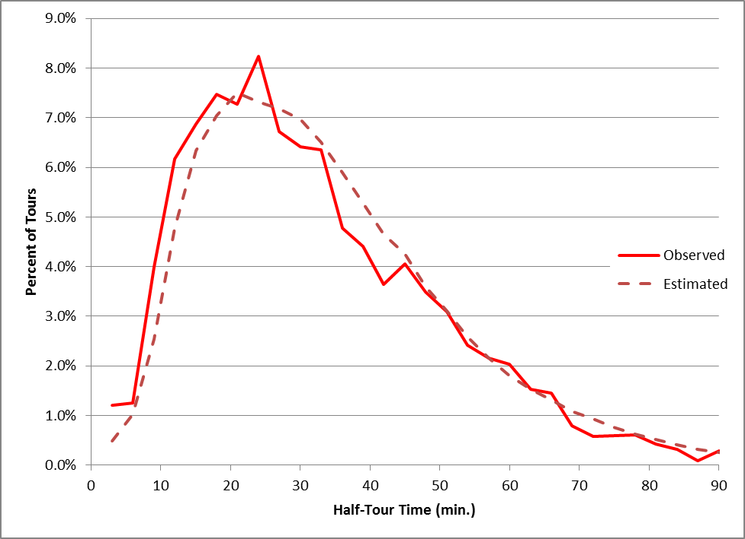

Figure 7-4 SCH True TLFD

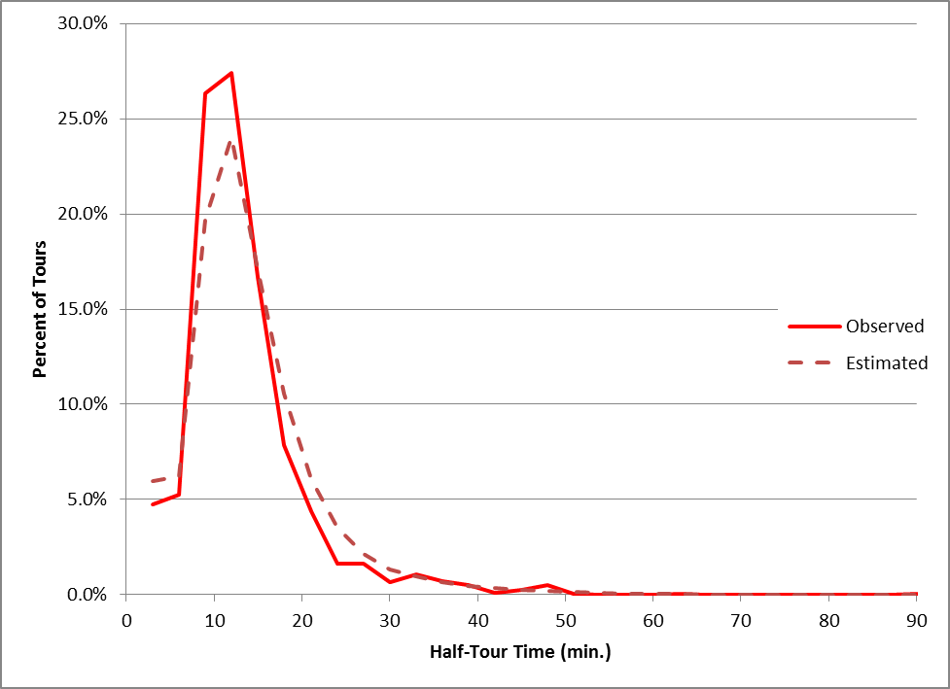
Figure 7-5 HBU True TLFD

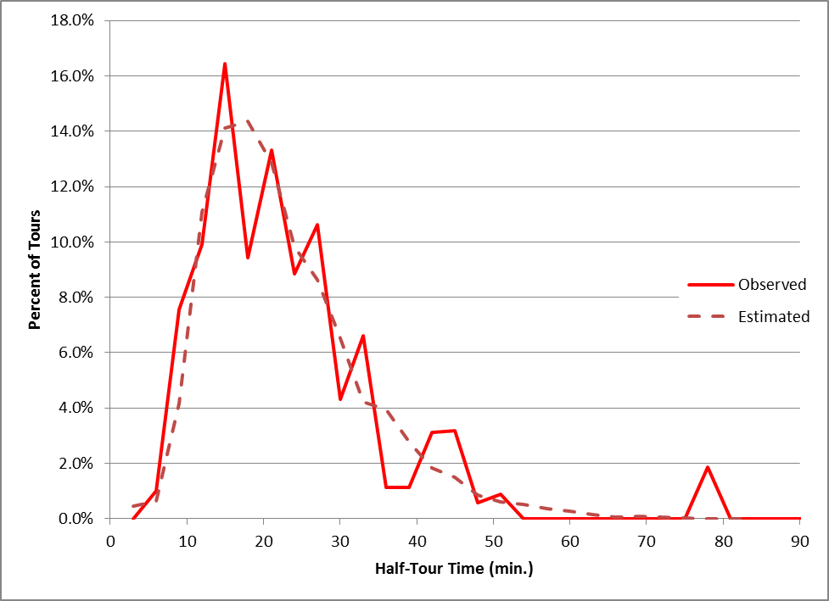

Figure 7-6 HBS True TLFD

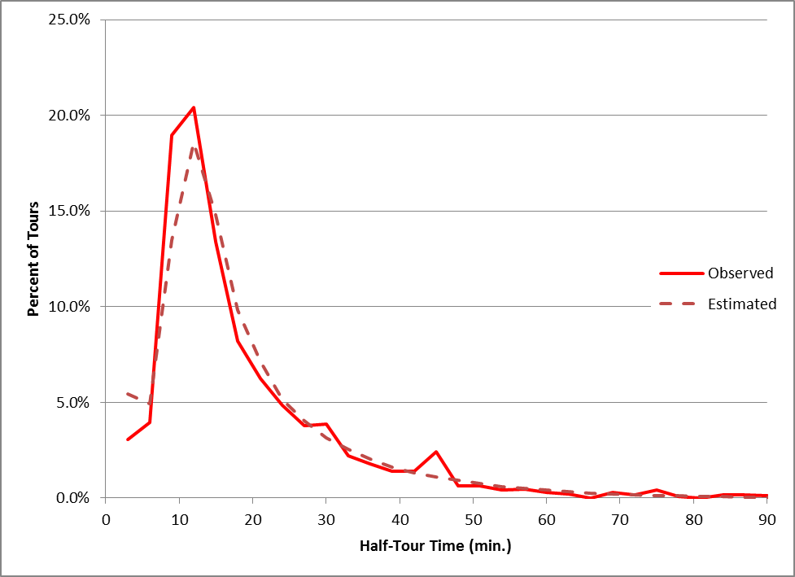
Figure 7-7 HBO True TLFD

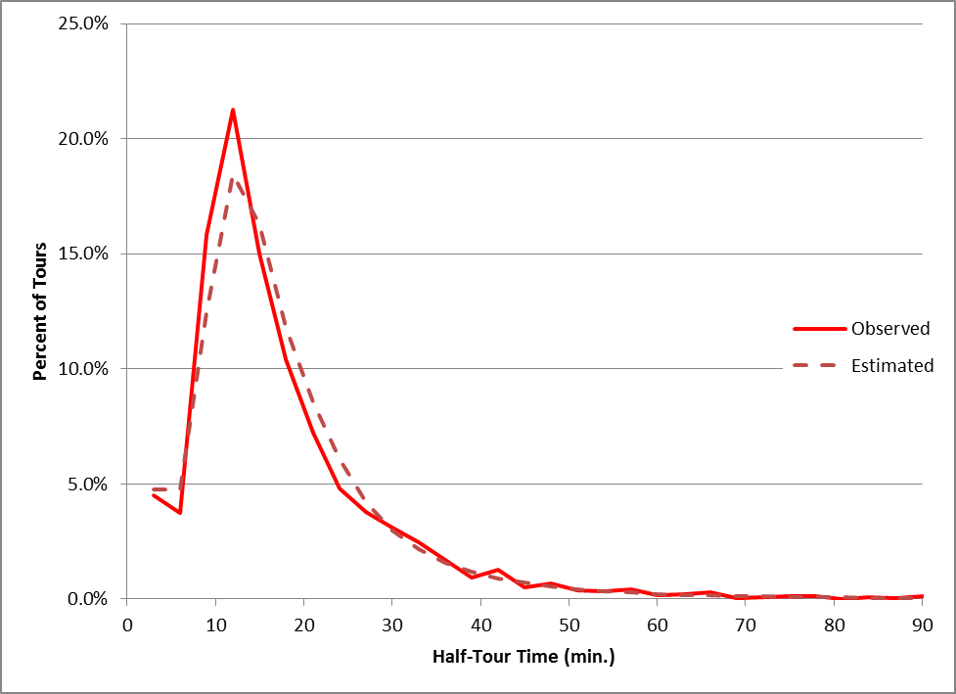

Figure 7-8 ATW True TLFD

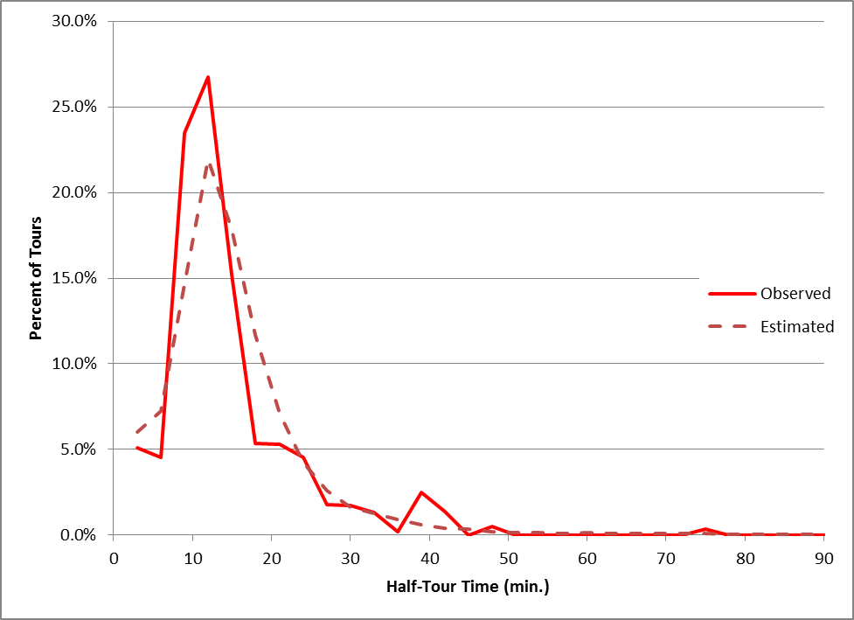
Figure 7-9 I/X True TLFD

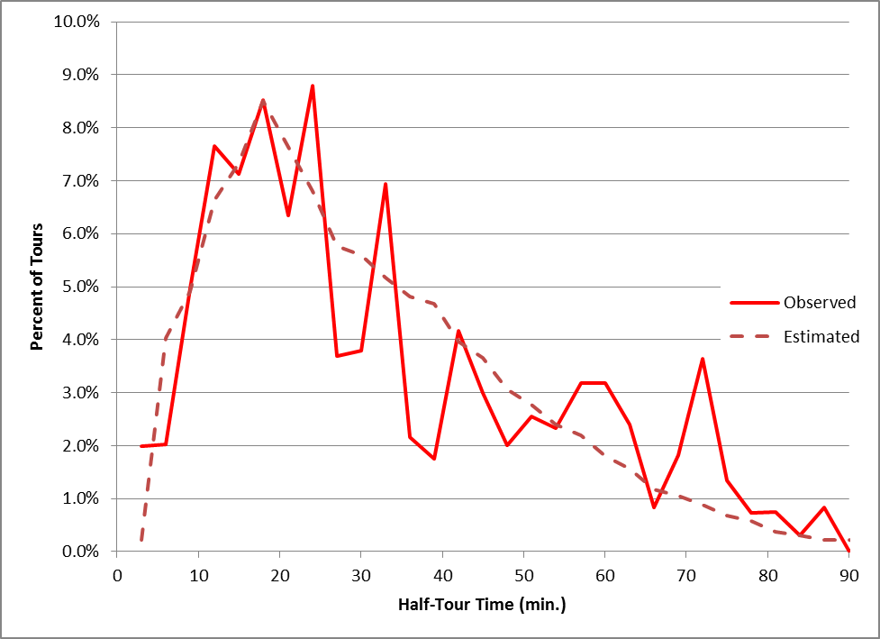

Table 7-7 Coincidence Index

Purpose | P-A Direction | A-P Direction
HBW | 0.878 | 0.873
SCH | 0.810 | 0.797
HBU | 0.736 | 0.715
HBS | 0.823 | 0.813
HBO | 0.854 | 0.861
ATW | 0.712 | 0.677
I/X | 0.727 | 0.719

Table 7-8 True Tour Time Comparison

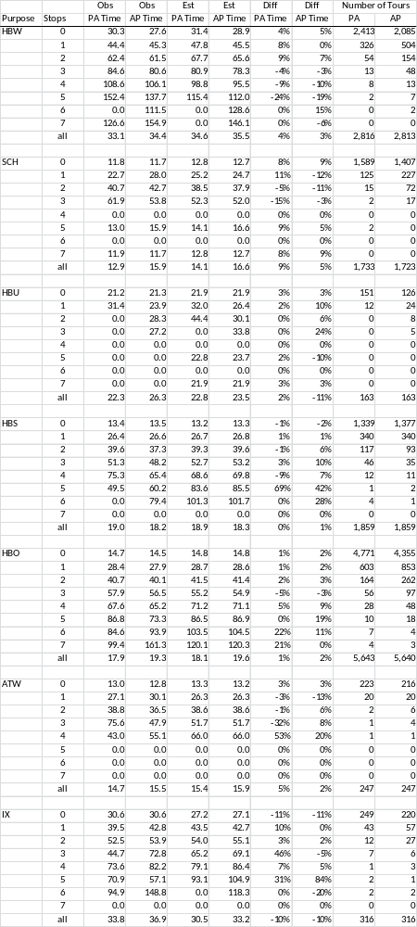

Table 7-9 Mean Start-Stop Distance

Purpose | Obs | Est | Diff
HBW | 6.7 | 6.8 | 0.9%
SCH | 4.1 | 4.1 | 0.0%
HBU | 5.9 | 6.5 | 10.5%
HBS | 4.1 | 4.5 | 8.9%
HBO | 4.8 | 5.1 | 6.7%
ATW | 4.1 | 4.3 | 3.5%
IX | 13.6 | 13.7 | 0.6%

These results indicate that overall, the modelled results match the observed data reasonably well. The true tour travel time (including all stops) is matched closely for most purposes and number of stops, but there are a few exceptions in cases where the number of observations is low. The direct straight line distance from the beginning of each half-tour to the stop locations is estimated with good accuracy. These findings suggest that the model is estimating intermediate stops in approximately the right locations, compared to the survey.

8 TIME OF DAY

8.1 Overview

The Metrolina trip-based time of day model consists of two components: 1) a pre-mode choice process to split daily person trips by peak and off-peak, and 2) a post-mode choice process to split vehicle trips by the four assignment periods. Since this version of the tour-based model does not include the mode choice model, only the first Time of Day (TOD) model was developed.

The Brunswick, GA model used a fixed table of percentages by purpose and direction. However, a more sophisticated approach was used for the Metrolina model. This is a logit model that estimates the time period for each half-tour. The first half-tour (P-A direction) is estimated first and that information is assumed to be available to influence the second half-tour (A-P direction).

8.2 Choices

Here, the choices are very simple: peak (6:30 – 9:30 AM and 3:30 – 6:30 PM) and off-peak (all other hours). Each direction of the tour is modelled separately. The time is based on the start of each half-tour.

8.3 Calibration

The calibration file was created in the same manner as for the other models. The period for each half-tour was determined based on the start time and a calibration file was assembled with the variables listed in Table 8-1. Peak travel time was used for HBW and off-peak time for all other purposes.
Table 8-1 TOD Candidate Variables

Tour origin and destination zones
HH income code (1-4)
HH size (1-5)
HH life cycle (1-3)
HH workers (0-3)
Tour main purpose
Actual period of start of first half-tour
Actual period of start of second half-tour
Origin area type (1-5)
Destination area type (1-5)
Actual number of P-A stops
Actual number of A-P stops
O/D direct network travel time, first half-tour (P-A direction)
O/D direct network travel time, second half-tour (A-P direction)
Origin zone accessibility to employment within 15 min. of composite time
Origin zone accessibility to HH within 15 min. of composite time
Destination zone accessibility to employment within 15 min. of composite time
Destination zone accessibility to HH within 15 min. of composite time
Origin zone distance to CBD (TAZ 10002) (mi.)
Destination zone distance to CBD (mi.)
Origin zone distance to cordon (mi.)
Destination zone distance to cordon (mi.)
Retail employment in the origin zone
Total employment in the origin zone
Population in the origin zone
Retail employment in the destination zone
Total employment in the destination zone
Population in the destination zone
Area in the origin zone
Area in the destination zone

The consultant hypothesized numerous utility functions for each purpose, as listed in Appendix A. In this model, the utility of the off-peak period was defined as zero. The candidate models are listed in Appendix A, the final models are shown in Table 8-2, and the variables are listed in Table 8-3. Some of the final model variables involve transformations of the basic input variables shown in Table 8-1.

The t scores for some variables are not as good as for most of the other models, suggesting the difficulty of modelling time period. For some purposes, the bias constants in Table 8-2 include validation adjustments to improve the observed/estimated comparison. Not all of the variables listed in Table 8-2 have an intuitively apparent logical relationship with the time period. It is likely that in some cases, the relationship is more one of mathematical association rather than cause and effect. The consultant’s interpretation of a logical interpretation of these equations (in general) is as follows:

Table 8-2 TOD Models

Purpose | Direction | Period | Utility Equation
HBW | PA | offpk | 0
 |  | peak | 0.4806 – 0.3482*INC1DUM[1] + 0.6237*INC4DUM + 0.2469*LC2DUM  – 0.1219*WORKERS – 0.01092*TIME + 0.1097*TOTSTOPS  + 0.0009691*DEMPDEN
 | AP | offpk | 0
 |  | peak | 0.2454[6] + 0.3675*INC4DUM – 0.2031*WORKERS + 0.02259*TIME  - 0.03577*PEAKDIFF - 0.1973*APSTOPS + 0.0004027*DEMPDEN[5]  - 0.6548*DPCTRET – 0.35*OFFPKDUM
SCH | PA | offpk | 0
 |  | peak | 2.9660 – 0.2595*SIZE5DUM[2] – 0.03374*TIME – 0.4423*PASTOPS
 | AP | offpk | 0
 |  | peak | -2.3500 + 0.9672*PAPERIOD + 0.4133*INC4DUM – 0.1361*SIZE  + 0.02534*TIME + 0.03184*OPOPDEN[5] – 0.02606*ODISTCBD
HBU | PA | offpk | 0
 |  | peak | 0.9827 – 0.4295*WORKERS + 1.9760*PASTOPS[3]  + 0.05470*DEMPDEN[4]
 | AP | offpk | 0
 |  | peak | -0.6062[7] – 0.6133*PAPERIOD[2] + 0.2871*WORKERS[8]  – 0.04278*TIME[3] + 0.02974*ODISTCBD[1]
HBS | PA | offpk | 0
 |  | peak | -0.9907 – 0.4362*LC1DUM + 0.3678*LC2DUM + 0.1262*WORKERS  + 0.1892*ORIGRUR[3]
 | AP | offpk | 0
 |  | peak | -3.5320 + 2.0430*PAPERIOD – 0.01276*TIME[2] – 0.3417*ORIGRUR
HBO | PA | offpk | 0
 |  | peak | -0.1635 + 0.1482*INC4DUM + 0.5276*LC2DUM – 0.1095*WKR0DUM[5]  -0.08573*TOTSTOPS – 0.1844*ORIGURB[1]
 | AP | offpk | 0
 |  | peak | -2.1210 + 0.9662*PAPERIOD + 0.2844*LC2DUM + 0.08146*NONWKR  - 0.04582*PEAKDIFF – 0.1122*TOTSTOPS + 1.4060*LONGDUM  - 0.3149*ORIGRUR – 0.0009187*DEMPDEN[1]
ATW | PA | offpk | 0
 |  | peak | -3.0000 + 0.05712*TIME + 0.4510*TOTSTOPS + 0.03542*ODISTCBD  - 1.3550*DPCTRET[5]
 | AP | offpk | 0
 |  | peak | -6.6120 + 2.7470*PAPERIOD – 0.7326*TOTSTOPS [5]  + 0.03834*DDISTCBD
I/X | PA | offpk | 0
 |  | peak | -1.5330 + 0.3444*OATYPE – 0.5838*SHOP[2]
 | AP | offpk | 0
 |  | peak | -0.2232[5] – 1.8860*ORIGURB – 0.5487*SHOP[8]
Note: in application, the HBW model is used for XIW and the HBO model is used for XIN.
All coefficients have absolute t values over 2.0, except as follows:
[1] t=1.8 [3] t=1.9 [5] t=1.6 [7] t=0.6
[2] t=1.5 [4] t=1.3 [6] t=1.2 [8] t=1.4
Table 8-3 TOD Variables

Variable | Definition
APSTOPS | Number of stops on second half-tour (AP direction)
DDISTCBD | Tour destination zone distance to CBD (TAZ 10002), mi.
DEMPDEN | Tour destination zone employees/acre
DPCTRET | Tour destination zone percent retail employment
INC1DUM | 1 if the HH is income 1 (low), else 0
INC4DUM | 1 if the HH is income 4 (high), else 0
LC1DUM | 1 if the HH is life cycle 1 (retired), else 0
LC2DUM | 1 if the HH is life cycle 2 (children), else 0
LONGDUM | 1 if O/D direct network travel time is more than 45 min., else 0
NONWKR | Non-workers in the HH (Size – Workers)
OATYPE | Tour origin zone area type (1-5)
ODISTCBD | Tour origin zone distance to CBD (TAZ 10002), mi.
OFFPKDUM | 1 if first half-tour (PA direction) was in the off-peak, else 0
OPOPDEN | Tour origin zone population/acre
ORIGRUR | 1 if tour origin zone is Rural (AT=5), else 0
ORIGURB | 1 if tour origin zone is CBD/Urban (AT=1,2), else 0
PAPERIOD | 2 if first half-tour (PA direction) was in the peak, else 1
PASTOPS | Number of stops on first half-tour (PA direction)
PEAKDIFF | O/D direct network travel time difference, peak minus off-peak
SHOP | 1 if tour is for shopping, else 0
SIZE5DUM | 1 if HH has 5 people, else 0
TIME | O/D direct network travel time (peak for HBW, off-peak for other purposes)
TOTSTOPS | Total number of stops on tour (both directions)
WKR0DUM | 1 if HH has no workers, else 0
WORKERS | Number of workers in HH

- The positive bias constants mean HBW, SCH, and HBU tours are more likely to start in the peak and HBW tours are more likely to end in the peak. ATW has especially large negative constants, meaning those tours are very unlikely to occur in the peak. These make sense.
- Higher income is associated with more peak travel and lower income is associated with less peak travel. Higher income is related to jobs that tend to have 9-to-5 hours, while lower income is more associated with retail jobs that begin and end at different hours. Also, lower income travellers may have more flexibility and thus be better able to avoid peak hours.
- The consultant specifically sought a relationship between peak/off-peak time differential and peak travel likelihood, in order to represent the phenomenon of peak spreading. In theory, greater congestion (measured here by the O/D direct peak time minus the off-peak time) should provide a higher disincentive to travel in the peak. A weak relationship of that type was found for HBW and HBO tours in the AP direction.
- Retired HHs (LC 1) travel less in the peak, while HHs with children (LC 2) travel more in the peak. Probably, LC 2 HHs have more activities to accomplish, forcing more of their travel to be in the peak.
- The effect of Workers is mixed. For HBW, more workers is associated with less peak travel. This makes sense if additional workers are more likely to work in retail or have part-time jobs. It is not clear why Workers should affect the time of non-work travel.
- Travel time generally has a negative coefficient: the longer the direct tour time (network time from origin to main destination), the less likely to be peak, which makes sense. The positive values for ATW PA and SCH AP are difficult to explain.
- The number of stops on the tour has an effect, but it is mixed. For HBW, HBU, and ATW, more stops means more peaking in the PA direction. More stops means a more complicated tour, which could be related to more peak travel. But for SCH and HBO (and HBW AP), more stops means less peaking. This relationship is less clear.
- Higher peaking is generally associated with greater destination zone employment density, with rural origin zones, and with origin zone population density. Lower peaking is associated with the origin zone being Urban and with greater percent retail employment at the destination. The last one of those makes sense, but the others are unclear.
- For HBU and ATW, the farther the tour origin and destination zones are from the CBD (TAZ 10002), the more likely to be peak. This is logical in the context of the “rolling peak”.
- The TOD model is applied sequentially, first for the first half-tour, then for the second half-tour. The second half-tour then has the advantage of “knowing” when the first half-tour was made and this was important for non-work tours. Except for HBU, if the first half-tour was in the peak, the second half-tour was more likely to be in the peak. This makes sense.
- For I/X tours, if the tour was for shopping, it was less likely to be in the peak, which is logical.
- The HBW PA model includes a special post-calibration adjustment added for validation. If the tour left home in the off-peak, a small factor was added to force it to be more likely to leave work in the off-peak.

8.4 Validation

The TOD model was validated by comparing observed and estimated shares by half-tour by period, as shown in Table 8-4. The “Abs Error” column is the sum of the absolute values of the four share differences by half-tour/half-tour combination. The estimated shares are very close to the observed shares from the survey.
Table 8-4 TOD Validation

 | Observed |  |  |  | Estimated |  |  | Abs
HBW |  |  |  |  |  |  |  | Error
 | AP peak | AP off-pk |  |  | AP peak | AP off-pk
PA peak | 36.5% | 26.2% | 62.7% |  | 36.5% | 26.9% | 63.3%
PA off-pk | 18.4% | 19.0% | 37.3% |  | 17.9% | 18.7% | 36.7%
 | 54.8% | 45.2% |  |  | 54.4% | 45.6% |  | 1.4%
SCH
PA peak | 29.3% | 62.1% | 91.4% |  | 28.9% | 62.5% | 91.5%
PA off-pk | 1.3% | 7.3% | 8.6% |  | 1.3% | 7.2% | 8.5%
 | 30.6% | 69.4% |  |  | 30.3% | 69.7% |  | 0.8%
HBU
PA peak | 9.1% | 58.1% | 67.2% |  | 10.4% | 56.6% | 67.1%
PA off-pk | 9.3% | 23.4% | 32.8% |  | 9.2% | 23.7% | 32.9%
 | 18.4% | 81.6% |  |  | 19.7% | 80.3% |  | 3.2%
HBS
PA peak | 17.9% | 15.3% | 33.2% |  | 18.1% | 15.1% | 33.2%
PA off-pk | 9.4% | 57.4% | 66.8% |  | 9.3% | 57.5% | 66.8%
 | 27.3% | 72.7% |  |  | 27.4% | 72.6% |  | 0.5%
HBO
PA peak | 21.9% | 29.3% | 51.2% |  | 21.9% | 30.3% | 52.2%
PA off-pk | 10.0% | 38.9% | 48.8% |  | 10.0% | 37.9% | 47.8%
 | 31.8% | 68.2% |  |  | 31.8% | 68.2% |  | 2.0%
ATW
PA peak | 4.2% | 10.9% | 15.0% |  | 4.8% | 10.5% | 15.4%
PA off-pk | 3.1% | 81.9% | 85.0% |  | 3.0% | 81.6% | 84.6%
 | 7.3% | 92.7% |  |  | 7.8% | 92.2% |  | 1.4%
I/X
PA peak | 19.8% | 25.9% | 45.7% |  | 19.6% | 26.2% | 45.9%
PA off-pk | 19.8% | 34.5% | 54.3% |  | 22.6% | 31.5% | 54.1%
 | 39.6% | 60.4% |  |  | 42.3% | 57.7% |  | 6.3%

9 TRIP ACCUMULATION

The preceding model steps – Tour Frequency, Destination Choice, Intermediate Stops, Stop Location, and Time of Day – have all dealt with individual round-trip tour records. In this step, called the Trip Accumulator, these tour records are converted into person trip records that can be built into conventional trip tables for input to the existing trip-based mode choice model. This step categorizes each segment of a tour by its origin zone, destination zone, income, time period, and purpose. The purposes are reclassified to align with those of the mode choice model, including Non-Home-Based (NHB) trips.

The tours are split into individual trip segments based on the intermediate stops and separate trip records are created for each segment. For example, a tour that had one stop in the first half and one stop in the second half would become four trip segments: origin-stop, stop-destination, destination-stop, stop-origin. The resulting trip segment records can be built into matrices as required by mode choice.

The trip tables resulting from these calculations are described as being in production/attraction (P/A) format. In this format, trips are stored in the trip table matrix in the row of the home end and the column of the non-home end. For home-based trips, this is not the same as the actual direction of movement. NHB trips are stored in O/D format, which is the same as the actual direction of movement. Normally, trip tables must be in P/A format in order to be input to mode choice.

This step is not a model, per se, but a logical process to convert the tour records into trips that are consistent with the person trips estimated by the Metrolina aggregate four-step trip-based model. This process includes the following rules:

- The Metrolina mode choice model uses four purposes: HBW, HBU, HBO, and NHB. The tour model’s SCH and HBS purposes are included with HBO.
- For I/I tours with stops, the intermediate stop legs have purposes that are redefined in a manner consistent with the trip-based model. For example, a HBW tour with one stop on each half-tour would be converted to four trips: an HBO trip (home-stop), a NHB trip (stop-work), a NHB trip (work-stop), and an HBO trip (stop-home).
- I/X tours are handled differently from I/I tours. In the Trip Accumulator step, I/X person tours are converted to vehicle tours by occupancy based on 0.7346 vehicle tours per person tour (an average vehicle occupancy [AVO] of 1.36, assuming no transit usage). The shares by occupancy derived from the 2011-12 survey are shown in Table 9-1. The first step is to apply Monte Carlo simulation using the percentages in Table 9-1. The second step is to convert person tours to vehicle tours. For single-occupant tours, a vehicle tour record is always output. For 2-occupant tours, there is a 50% chance of outputting a vehicle record. For 3+-occupant tours, there is a 31.25% chance (AVO = 3.20). Round-trip tours are converted to individual trip records in the same manner as for I/I tours. Note that since some of the I/X tours have intermediate stops, this results in some I/I trips being stored in the “I/X” trip table. These are the internal legs of I/X tours. These trips bypass the mode choice process and are subsequently split into four time periods prior to assignment.
- XIW tours (non-residents commuting to Metrolina jobs) are treated in a similar manner as I/X tours. The difference is that XIW tours were generated as vehicle tours in the first place. So the only conversion in the TA step is to split these by occupancy, using percentages derived from the 2014 external survey, as shown in Table 9-2. As with the I/X purpose, some of the XIW trips are actually I/I legs made on an XIW tour.
- XIN tours (non-work tours by non-residents to Metrolina attractions) are treated differently. The legs of these tours are split into two types: one type is the external legs (the inbound trip from the external station to the first internal stop and the outbound trip from the last internal stop to the external station), and these are considered vehicle trips that bypass mode choice. The TA calculation splits them by occupancy (see Table 9-3, also from the 2014 external survey, AVO = 1.519). The other type is the internal movements of the XIN tours. These records are multiplied by the vehicle occupancy and output as I/I NHB person trips, so that they can be input to mode choice. It is possible that some of these trips could use transit and this protocol permits that and results in a more complete description of NHB travel.

Table 9-1 I/X Occupancy Shares

Occupancy | Percentage | Cumulative Percentage
1 | 0.538 | 0.538
2 | 0.279 | 0.817
3+ | 0.183 | 1.000

Table 9-2 XIW Occupancy Shares

Occupancy | Percentage | Cumulative Percentage
1 | 0.8515 | 0.8515
2 | 0.1248 | 0.9763
3+ | 0.0237 | 1.0000

Table 9-3 XIN Occupancy Shares

Occupancy | Percentage | Cumulative Percentage
1 | 0.6018 | 0.6018
2 | 0.3109 | 0.9127
3+ | 0.0873 | 1.0000
10 EXTERNAL TRAVEL

As noted in Chapter 4, the Tour Frequency model estimates all tours made by Metrolina residents, whether I/I or I/X. The Destination Choice model for each purpose includes a function that allocates each tour to I/I or I/X, before the actual DC logit model is applied. This curve is a power function of the origin zone’s network distance to the nearest external cordon station (i.e., the border of the modelled region). This is the same function used in the trip-based model. The distance to the cordon indicates how close the zone is to the edge of the modelled area, and one expects the external share of trip ends to increase as one nears the cordon.

Analysis of the observed I/X share of productions from the home interview survey confirmed the hypothesis about productions, as shown in Figures 10-1 and 10-2. The points in these curves represent survey data aggregated to a district system, as developed for the trip-based model. As these curves show, there is a clear tendency for the I/X share to increase as distance to the cordon decreases. The dashed line is the best non-linear fit to the data, using the equation shown on the chart. The r² is 0.23 for work and 0.49 for non-work. These figures represent curves that were derived from the survey and then subsequently modified slightly so that the cordon counts would be matched. In application, the I/X share is capped at 50% for work and 30% for non-work. The curve in Figure 10-2 represents a generic average of the non-work purposes. Table 10-1 shows the curve parameters by purpose.

Table 10-1 I/X Share Parameters

Purpose | Exponent | Factor | Max. Share
HBW | -1.47 | 1.31 | 0.5
SCH | -1.33 | 0.21 | 0.3
HBU | -1.33 | 2.47 | 0.3
HBS | -1.33 | 0.44 | 0.3
HBO | -1.33 | 0.67 | 0.3
ATW | -1.33 | 1.04 | 0.3
Note: curve is % I/X = Factor * Dist^{Exponent}
Figure 10-1 I/X Share: Work

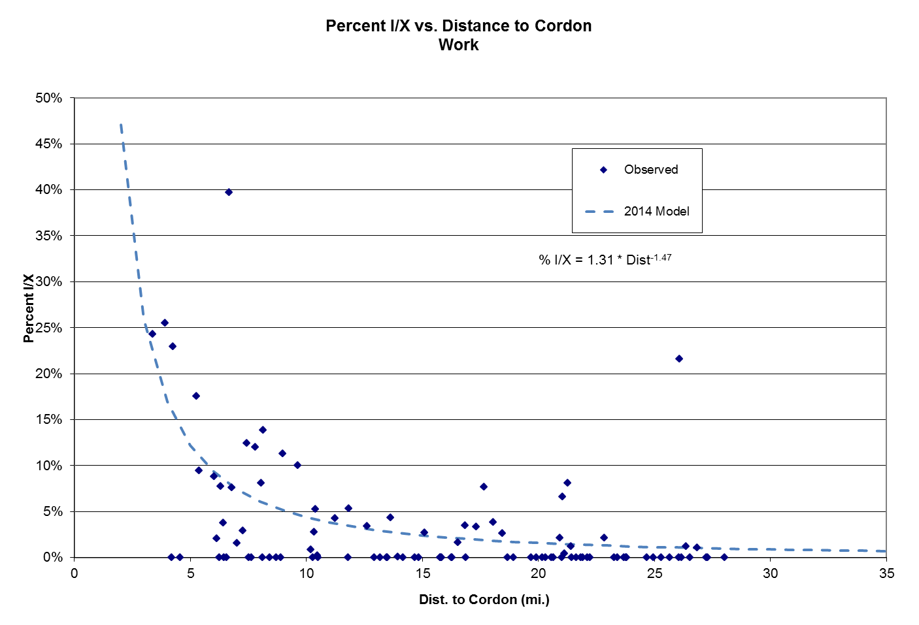
Figure 10-2 I/X Share: Non-Work
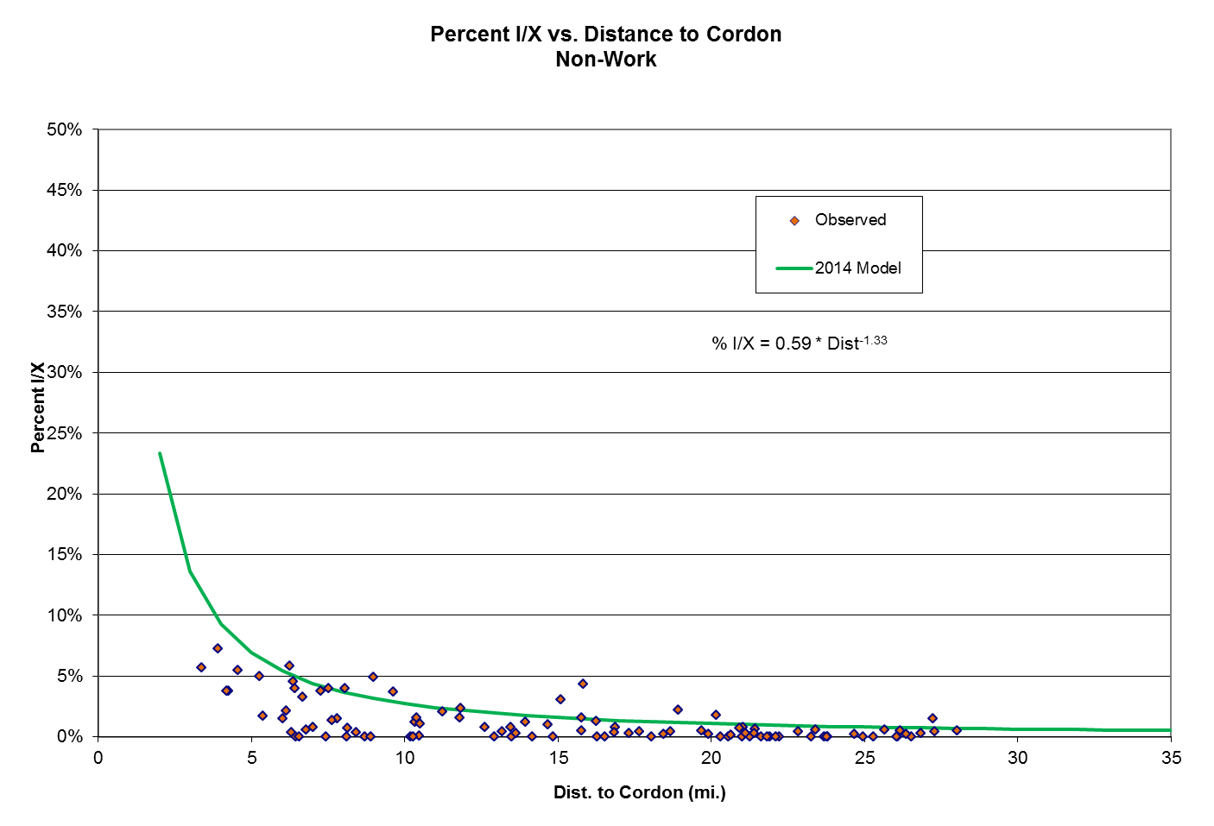

In each DC model, once a tour is identified as being I/X, it is written to a different file and does not go through the I/I destination choice process. After this is done for all six purposes, the I/X tour records are combined and input into an I/X DC model, as described in Table 5-3. This model allocates the I/X person tours to the external stations in a process that is similar to the I/I DC process, except that it is not doubly-constrained.

Next, the I/X tours are summarized by external station. The I/X tour ends are then multiplied by two to convert from tours to trips and divided by an AVO of 1.375 to convert from person travel to vehicle travel. Applying the following equation estimates X/I tours by external station:

X/I tours = (passenger car cordon station total – PC X/X trip ends
– 2*I/X trip ends/1.375) / 2

A factor of 2 is required to convert from trips (or tours) to trip ends. Very little is known about X/I travel, since these are non-residents who were obviously not included in the home interview survey. This procedure assumes that the X/I total must be what remains after subtracting the X/X and I/X trips from the cordon total. A key advantage of this protocol is that it guarantees consistency at the cordon. Analysis of the 2014 external survey data said that 44% of the X/I passenger car trips are for work. That share is used to split the X/I tours into work (XIW) and non-work (XIN). From this point forward in the model, the I/X tours are person tours and the X/I tours are vehicle tours.

Once the X/I tours (by work and non-work) are known at each station, a logit Destination Choice model can be applied to allocate them to the internal zones. A particular challenge is that nothing is known about the non-resident travellers or their HHs. Thus, some assumptions must be made. For XIW tours, the following is assumed:

- The HBW I/I DC model sufficiently describes the allocation of X/I workers to workplace zones and can be adapted for this use.
- The INTRACO term on the HBW DC model (see Table 5-3) is omitted, since it is probably inappropriate for X/I travel.
- All X/I workers are treated as being income 4 (upper 50%). This is probably more accurate than not.
- The HTIME coefficient can be adjusted to match the average XIW trip length from the 2014 external survey of 41.8 min.
- The XIW DC model is applied in singly-constrained fashion (it is not adjusted to match an attraction total).
For XIN tours, the following is assumed:

- The HBO I/I DC model sufficiently describes the allocation of X/I non-workers to internal zones and can be adapted for this use.
- The SAMEAT term on the HBO DC model (see Table 5-3) is omitted, since it cannot be calculated for X/I travel.
- All X/I non-workers are treated as being income 4 (upper 50%). This is probably more accurate than not.
- The HTIME coefficient can be adjusted to match the average XIN trip length from the 2014 external survey of 26.5 min.
- The XIN DC model is applied in singly-constrained fashion (it is not adjusted to match an attraction total).
This produces XIW and XIN vehicle tour records: tours with origins at the external stations and destinations at the internal zones.

At this point in the model, another key assumption is made. X/I workers are assumed to make ATW tours from/to their workplace. It seemed reasonable to assume that the ATW I/I Tour Frequency model can be applied to estimate these tours. So the ATW TF model is applied to the X/I workers, with the following assumptions:

- All X/I workers are treated as being income 4 (upper 50%), so INC4DUM=1.
- The workers/HH is unknown for non-residents. Use the average 2010 value for Metrolina, for HHs with at least one worker: 1.56.
- The home zone median HH income is unknown for non-residents. Use the average 2010 Metrolina value of $58,066.
Making these assumptions allows the ATW I/I TF model to be applied to non-resident workers, which creates a list of additional ATW tours. Those are then merged with the resident ATW tour records and the ATW DC model is re-applied to that file. In this run, I/X tours are not re-calculated. The non-resident workers are assumed to not make any ATW tours outside the region.

From this point on in the model, the remaining steps are all applied to both sets of external tours. For I/X tours, the Intermediate Stop, Stop Location, and Time of Day models were estimated from the survey. For X/I tours, the above process was repeated. The HBW I/I IS/SL/TOD models were used for XIW and the HBO I/I IS/SL/TOD models were used for XIN. As noted above, this requires certain assumptions to be made about the non-resident characteristics, for each model:

- Intermediate Stop
XIW:
All tours are inc 4 (INC4DUM=1), 50% of origin zones are rural (ORIGRUR=0.5), 28% of HHs are life cycle=2 (same as Metrolina; LC2DUM=0.28), average tours per HH is 3.56 (same as Metrolina). Add 0.6 to the bias constant for HBW 1 and 2+ stops in the PA direction and subtract 0.2 from the bias constant for HBW 1 and 2+ stops in the AP direction, for validation.
XIN:
No tours are inc 1 (INC1DUM=0) and the tour obviously cannot be intrazonal (INTRAZ = 0). Subtract 0.2 from the bias constant for HBO 1, 2, and 3+ stops in the AP direction, for validation.
- Stop Location
Treat XIW as HBW and XIN as HBO. The SL model doesn’t use any traveller characteristics, only the attributes of the tour origin and destination zones.
- Time of Day
Treat XIW as HBW and XIN as HBO. Assume inc 4, so INC1DUM=0 and INC4DUM=1. Assume HH size 2, so SIZE5DUM=0. Assume 1 worker, so WORKERS=1 and NONWKR=1. Assume life cycle 3, so LC1DUM=0 and LC2DUM=0.

As Chapter 9 noted, external tours are given special treatment in the Trip Accumulator step. I/X person tours are converted to vehicle tours by occupancy, for input to the second Time of Day model and traffic assignment. XIW vehicle tours are also split by occupancy, in similar fashion. XIN vehicle tours are also split by occupancy in similar fashion, but the internal legs of XIN tours are converted back to NHB person tours for input to mode choice.
11 TRUCK/COMMERCIAL TRAVEL

11.1 Approach

In almost all ABMs, the truck component is treated as a separate trip-based forecasting process. However, the consultant recently completed an applied research project to develop a tour-based truck model for Atlanta using GPS data. That work was successful enough to suggest that the tour-based structure is actually more important for trucks, due to the nature of commercial travel. CDOT staff agreed that it would make sense to transfer the Atlanta model to Charlotte and expand it to include three types of commercial vehicles: light-duty commercial (passenger cars, light trucks, and vans used for business and government travel), medium trucks (single-unit, FHWA class 5-7), and heavy trucks (semi-trailer, FHWA class 8-13). Those are the types of truck trips used in the existing Metrolina trip-based model. This chapter summarizes the model as applied for Metrolina.

The truck model is structurally similar to the rest of the CDOT tour-based model with a few exceptions. The vehicle types are treated as separate purposes: COM, MTK, and HTK. Instead of a logit tour frequency model, the number of tours is estimated by an aggregate zone-level trip generation model. That is followed by logit models for main destination choice, number of intermediate stops, stop location, and time of day. For trucks, the time of day model estimates tours by the four assignment time periods. The truck model includes its own trip accumulator step. I/I, I/X, and X/I are treated separately, in a manner similar to the person travel model. The Atlanta model included only one vehicle type; the consultant used experience from other areas to stratify the Atlanta models and parameters for the three vehicle types included here. Also, the Metrolina version has been modified slightly in order to work with its socioeconomic variables, which are slightly different from those available in Atlanta.

The only data available for true validation is new classification count data, which can be used to validate the assignment of medium and heavy trucks.

11.2 Tour Generation

The Tour Generation (TG) model is a straightforward zone-level linear regression model from which the constant term has been removed. This is one of the few components of the tour-based model that is not a logit model. Table 11-1 shows the models and Table 11-2 defines the variables.

Table 11-1 Truck TG Model

Vehicle Type | Equation
COM | 0.056*LOIND + 0.011*HIIND + 0.084*OFFGOV + 0.011*POP – 0.140*DISTCBD  + 0..062*RETAIL + 0.048*SERVICE
MTK | 0.110*LOIND + 0.022*HIIND + 0.017*OFFGOV + 0.008*POP – 0.550*DISTCBD  + 0.088*RETAIL + 0.050*SERVICE – 0.00006*ACCH15
HTK | 0.231*LOIND + 0.031*HIIND - 0.122*OFFGOV + 0.008*POP – 0.734*DISTCBD  + 0.035*RETAIL + 0.027*SERVICE – 0.00015*ACCH15
Note: All coefficients have absolute t values over 2.0, except as follows:

Table 11-2 Truck TG Variables

Variable | Definition
ACCH15 | Accessibility to HHs within 15 min. via off-peak highway time
DISTCBD | Distance to CBD (TAZ 10002), mi.
HIIND | High traffic industrial employment
LOIND | Low traffic industrial employment
OFFGOV | Office and government employment
POP | Total population (in households and group quarters)
RETAIL | Standard retail (RTL) + Highway retail (HWY) employment
SERVICE | Service employment (LOSVC + HISVC)

For zones that are “truck zones”, the result of the equations shown in Table 11-1 is multiplied by a “truck zone factor”. The truck zone flag is a binary (0/1) variable that takes the value of 1 for zones that have been designated as a “truck zone”. These are zones that contain land uses that are likely to generate a higher than average number of truck trips per employee. Examples include industrial parks, warehousing areas, truck stops, quarries, intermodal terminals, etc. The consultant identified these by examining satellite photos and submitting the list to CDOT for review. About 123 such zones were identified throughout the region, as shown in Table 11-4. The truck zone factors are shown in Table 11-3. These are based on similar values from other truck models and are subject to change during future assignment validation.

Table 11-3 Truck Zone Factor

Vehicle Type | Factor
COM | 1.0
MTK | 1.5
HTK | 2.0

Table 11-4 Truck Zones

19 | industrial | 3186 | industrial | 9255 | warehousing
90 | industrial | 3187 | industrial | 10031 | warehousing
94 | warehousing, commercial | 3196 | warehousing | 10035 | industrial
150 | warehousing | 3210 | huge warehouse | 10051 | industrial
151 | truck stop | 3213 | huge warehouse | 10052 | warehousing
160 | quarry | 3230 | industrial | 10061 | intermodal terminal
161 | Concord airport | 3247 | truck stop | 10202 | industrial
166 | quarry, industrial | 4110 | industrial | 10242 | industrial
167 | Speedway | 4122 | warehousing | 10243 | warehousing
176 | warehousing | 4123 | quarry | 10244 | warehousing
184 | industrial | 4126 | warehousing | 10245 | warehousing
188 | Speedway | 4133 | industrial | 10249 | warehousing
287 | lumberyard | 4134 | quarry | 10251 | warehousing
1005 | industrial ??? | 5012 | truck stop | 10271 | industrial
1024 | quarry | 5017 | industrial, warehousing ?? | 10272 | industrial
1064 | industrial | 5022 | warehousing | 10274 | industrial
1068 | auto auction ??? | 5051 | industrial | 10276 | industrial ???
1110 | manufacturing | 5057 | quarry, warehousing ??? | 10292 | quarry
1116 | industrial | 6010 | industrial | 10567 | industrial, warehousing
1119 | industrial | 6017 | industrial | 10568 | industrial, warehousing
1133 | warehousing | 6059 | warehousing | 10569 | industrial, warehousing
1136 | industrial | 8014 | industrial | 10570 | industrial, warehousing
1163 | industrial | 8015 | industrial | 10582 | warehousing
1166 | industrial, warehouse | 8135 | manufacturing | 10584 | warehousing
1168 | warehouse, auto auction | 8137 | Stanly Airport | 10596 | airport industrial
1174 | warehouse ??? | 8142 | warehousing | 10598 | airport industrial
1177 | Rockwell | 8147 | manufacturing | 10600 | CHL airport
1194 | warehouse | 8149 | warehousing | 10610 | industrial
1209 | power plant | 9045 | industrial | 10615 | distribution ctr
2066 | industrial | 9061 | industrial | 10645 | warehousing
2093 | distribution ctr | 9081 | warehousing | 10719 | warehousing
2133 | industrial | 9115 | industrial | 10720 | warehousing
2134 | warehousing | 9116 | industrial | 10721 | quarry
2135 | warehousing | 9122 | industrial | 10737 | warehousing
2236 | warehousing | 9123 | industrial | 10738 | warehousing
3056 | airport | 9127 | industrial | 10751 | warehousing
3077 | industrial | 9128 | industrial | 10760 | industrial
3098 | warehousing | 9130 | industrial | 10930 | landfill ???
3104 | warehousing | 9244 | Harris Teeter dist ctr | 10941 | industrial, warehousing
3106 | industrial | 9250 | quarry, industrial | 10944 | auto auction
3144 | warehousing | 9252 | industrial | 11033 | intermodal terminal

The equations in Table 11-1 estimate the total number of RT tours by vehicle type. A power model similar to the personal travel model is used to estimate the split of origins that are I/I vs. I/X and destinations that are I/I vs. X/I. Table 11-5 shows the coefficients of the external share models.

Table 11-5 External Share Models

Direction | Vehicle Type | Factor | Exponent | Maximum
I/X | COM | 0.078 | -0.158 | 0.90
 | MTK | 0.096 | -0.158 | 0.90
 | HTK | 0.176 | -0.158 | 0.90
X/I | COM | 0.116 | -0.158 | 0.90
 | MTK | 0.144 | -0.158 | 0.90
 | HTK | 0.290 | -0.158 | 0.90
Note: model is
external share = min(Factor * [DistanceToCordon^{Exponent}], Maximum)

The X/I tour total is estimated from the internal zone calculations. This total number of X/I tours is then allocated to the external stations on the basis of the external station volume by vehicle type. (Note that this is different from the personal travel model, in which the external share is estimated in the Destination Choice model.)

The coefficients in the TG model have been adjusted so as to produce approximately the same number of trips as the current Metrolina trip-based truck models. The tour and trip totals are subject to change as a result of future assignment validation.

11.3 Destination Choice

The tour main Destination Choice models are applied separately by vehicle type and internal vs. external movement. DC for I/I and X/I tours is applied together, since those models are similar. DC for I/X tours is applied separately, since the tour destinations are being allocated to the external stations. The truck DC models are shown in Table 11-6 and the variables defined in Table 11-7. These are logit models, very similar to the personal travel DC models.

The most significant variables (based on the t ratios) are travel time, truck zone flag, employment accessibility, and development density. Travel time has a negative coefficient, as it should. The coefficients on employment accessibility and development density are negative, which indicates a competitive effect. On the other hand, the Urban dummy is positive and the Rural dummy is negative, which works slightly in the opposite direction, suggesting an agglomerative effect. Distance to the cordon has a negative coefficient, meaning that zones close to the cordon are less likely to be truck destinations (which is consistent with the Rural coefficient).

Table 11-6 Truck DC Models

Type | Movement | Utility Equation
COM | I/I | -0.0550*TIME + 0.16*TZONE + 0.31*URBAN – 0.077*RURAL  – 0.003733*DISTCOR + ln(36*INDEMP + 15*POP + 10*OFFEMP)
 | X/I | -0.008*TIME + 0.24*TZONE + 1.18*URBAN – 0.32*RURAL  – 0.02834*DISTCBD + ln(NONEMP + 27*INDEMP + 15*POP + 10*OFFEMP)
MTK | I/I | -0.0500*TIME + 0.32*TZONE + 0.1547*URBAN – 0.03832*RURAL  – 0.003733*DISTCOR – 0.0002671*EMPACC – 0.0003853*DEVDENS  + ln(NONEMP + 36*INDEMP + 15*POP + 10*OFFEMP)
 | X/I | -0.008*TIME + 0.48*TZONE + 0.5914*URBAN – 0.1604*RURAL  – 0.02834 *DISTCBD – 0.0002819*EMPACC – 0.0005027*DEVDENS  + ln(NONEMP + 34.8481*INDEMP + 9.1798*POP)
HTK | I/I | -0.0020*TIME + 0.6466*TZONE + 0.1547*URBAN – 0.03832*RURAL  – 0.003733 *DISTCOR – 0.0002671*EMPACC – 0.0003853*DEVDENS  + ln(NONEMP + 48.3758*INDEMP + 10.6122*POP)
 | X/I | -0.001*TIME + 0.9380*TZONE + 0.5914*URBAN – 0.1604*RURAL  – 0.02834 *DISTCBD – 0.0002819*EMPACC – 0.0005027*DEVDENS  + ln(NONEMP + 34.8481*INDEMP + 9.1798*POP)
All | I/X | -0.006*TIME + 0.79*ln(EXTVOL)
Note: Note: All HTK coefficients have absolute t values over 2.0. T scores are unavailable for the other trip types.
Variables shown in logarithmic form [ln()] are “Size” variables. The coefficients shown have already been transformed by taking the exponential of the value estimated by ALOGIT.

Table 11-7 Truck DC Variables

Variable | Definition
DEVDENS | Development density function = (800*total pop + 300*total emp)/acres
DISTCBD | Distance to the CBD (TAZ 10002), mi.
DISTCOR | Distance to the nearest external station, mi.
EMPACC | Accessibility to employment, calculated as row sum of emp_{j}/tt_{ij}²
EXTVOL | External station volume for this vehicle type
INDEMP | Industrial employment (LOIND + HIIND)
NONEMP | Non-industrial employment
OFFEMP | Office/government employment
POP | Total population
RURAL | 1 if area type is 4 or 5, else 0
TIME | Off-peak O/D highway time, min.
TZONE | 1 if zone is a truck zone, else 0
URBAN | 1 if area type is 1 or 2, else 0
Distance to the CBD also has a negative coefficient, so that zones close to the CBD are less likely to be truck destinations, which is generally logical in Charlotte. Unlike the personal travel models, the truck DC models are applied in singly-constrained fashion (no adjustment to match estimated zonal attraction totals).

Although no observed truck data was available for Metrolina, the Triangle region (Raleigh/Durham/Chapel Hill) conducted a commercial vehicle survey in 2011. That survey calculated average trip lengths in minutes by vehicle type: COM = 23.0, MTK = 25.0, HTK = 44.8. These values must be viewed in the context of the mean HBW trip length in the Triangle region of 20.2 min, which presumably does not include terminal time. The Metrolina mean HBW trip time is 29.5 min, which does include terminal time (assumed to average around 3 min/trip). Thus it is concluded that trip lengths are about 31% longer in Metrolina: (29.5 – 3)/20.2, due to a larger modelled region and somewhat higher congestion. If the Triangle surveyed truck trip times are increased by 31%, this produces the following values: COM = 30.1, MTK = 32.8, HTK = 58.7 minutes. The estimated tour times are COM = 31.2, MTK = 35.1, HTK = 44.1. The consultant believes that these estimated values are not unreasonable and that it would be wise to wait until a truck assignment has been performed to consider further adjustments.

11.4 Intermediate Stops

The personal travel Intermediate Stops model includes eight choices: 0 to 7 stops. Three or four of those choices are modelled specifically and the rest are estimated using fixed probabilities. The truck IS model includes seven choices: 0 to 6 stops, all of which are modelled specifically. For trucks, the same IS model is applied to all tours equally, whether I/I, I/X, or X/I. The IS models are shown in Table 11-8 and the variables in Table 11-9. The utility of making no stops is defined as zero.

Table 11-8 Truck IS Models

Utility Equation
System Variables
Bias + 0.0042*TIME – 0.0605*ORIGAT – 0.0852*DESTAT + 0.00866*ORIGIND3
– 0.05848*DESTIND – 0.4471*SHORTDUM + 0.1239*LONGDUM

Bias Constants | 1 stop | 2 stops | 3 stops | 4 stops | 5 stops | 6 stops
I/I
COM | -0.6393 | -0.7175 | -0.6425 | 0.2200 | 0.2880 | 1.3211
MTK | -0.0486 | -0.4251 | -0.7250 | -0.8290 | -1.0740 | 0.1623
HTK | 0.4014 | -0.1051 | -0.5250 | -1.0790 | -1.5240 | -0.8377
I/X and X/I
COM | -0.9393 | -1.0275 | -1.2025 | -0.6000 | -0.7520 | -0.6989
MTK | -0.3486 | -0.7351 | -1.2850 | -1.6490 | -2.1140 | -1.8577
HTK | 0.1014 | -0.4151 | -1.0850 | -1.8990 | -2.5640 | -2.8577

A logical interpretation of this model is as follows: the number of stops increases as the tour O-D time increases and even more if that time exceeds 45 min (the LONGDUM dummy variable), which is very logical. The number of stops also increases with increasing industrial employment within 3 miles of the origin zone, but the logic of this is less clear. The number of stops decreases with reduced density at either end of the tour (i.e., increasing values of ORIGAT and DESTAT). The number of stops decreases if the tour O-D distance is very short (under 15 min) and with increasing industrial employment in the tour destination zone, both of which make sense. The bias constants indicate that COM tours have more stops than MTK, which have more stops than HTK and that seems logical. I/I tours have more stops than external tours.

Table 11-9 Truck IS Variables

Variable | Definition
DESTAT | Destination zone area type (1-5)
DESTIND | Industrial employment (LOIND + HIIND) in the destination zone, in thousands
LONGDUM | 1 if TIME is 45 min. or more, else 0
ORIGAT | Origin zone area type (1-5)
ORIGIND3 | Industrial employment (LOIND + HIIND) in zones whose centroid is within 3 mi. straight line distance from the tour origin zone, in thousands
SHORTDUM | 1 if TIME is 15 min. or less, else 0
TIME | Off-peak O/D direct highway travel time, min.

11.5 Stop Location

The truck Stop Location models are similar by vehicle type and do not vary by internal vs. external movement. See Tables 11-10 and 11-11.

Table 11-10 Truck SL Models

Type | Utility Equation
COM | -0.007887*DETOUR + 0.5358*TZONE + 0.3254*ATYPE – 0.00108*ACCEMP45  + 1.742*SHORTDUM + ln(NONEMP + 0.7*INDEMP + 1.0*POP)
MTK | -0.007887*DETOUR + 0.5358*TZONE + 0.3254*ATYPE – 0.00108*ACCEMP45  + 1.742*SHORTDUM + ln(NONEMP + 5.068272*INDEMP + 0.756918*POP)
HTK | -0.007887*DETOUR + 0.5358*TZONE + 0.3254*ATYPE – 0.00108*ACCEMP45  + 1.742*SHORTDUM + ln(NONEMP + 5.068272*INDEMP + 0.756918*POP)
Note: Note: All HTK coefficients have absolute t values over 2.0. T scores are unavailable for the other trip types.
Variables shown in logarithmic form [ln()] are “Size” variables. The coefficients shown have already been transformed by taking the exponential of the value estimated by ALOGIT.

Table 11-11 Truck SL Variables

Variable | Definition
ACCEMP45 | Employment accessible within 45 min. off-peak highway time, in thousands
ATYPE | Area type (1-5)
DETOUR | Detour time (min.)
INDEMP | Industrial employment (LOIND + HIIND)
NONEMP | Non-industrial employment
POP | Total population
SHORTDUM | 1 if detour time is 5 min. or less, else 0
TZONE | 1 if zone is a truck zone, else 0

The coefficients seem reasonable:
- The DETOUR variable is very strong and the negative coefficient means that truck drivers try to minimize their detour time, which seems reasonable. In addition, the positive SHORTDUM variable (1 if the detour time is 5 min or less) gives an additional boost to stops with a very short detour time. However, it must be noted that truck drivers often do not have much flexibility in selecting their intermediate stops. Some companies, such as UPS, use routing software that tries to select an efficient route, but ultimately the stop locations are determined by where the pickups and deliveries are located, which is outside of the driver’s control.
- The positive TZONE coefficient means that truck zones are more likely to be stops.
- The positive ATYPE coefficient means that less developed zones (higher numerical area type) are more likely to be stops. This may seem counterintuitive, but it could mean that highly developed areas are too congested to be considered as intermediate stops, or it could be the “competitive” effect mentioned above (a zone in a developed area is itself less likely to be selected because it is competing with other nearby developed zones). This effect is supported by the negative coefficient on the number of jobs accessible within 45 min (ACCEMP45).
- The size variables are non-industrial employment, industrial employment (more important), and population (not too important).

The application of the SL model is limited to those zones that are within the “O/D circle”. This is a circle whose radius is the straight line distance between the tour origin and destination centroids, centered on the midpoint between those centroids. See the “circle” diagram in Figure 6-1. Zones whose centroid is outside this circle or which do not have any jobs are not considered as candidate intermediate stop zones. In all other respects, the truck SL models are applied in the same manner as the personal travel SL models.

11.6 Time of Day

Unlike the personal travel TOD models, the truck TOD models stratify the truck tours by the four time periods used in traffic assignment:
- AM = 6:30 – 9:30
- MD = 9:30 a – 3:30 p
- PM = 3:30 – 6:30
- NT = 6:30 p – 6:30 a

These values obviously do not go through the mode choice process but instead go directly into the traffic assignment step.

The TOD model does not currently vary by vehicle type or by internal vs. external, although vehicle type variations might be introduced later, during assignment validation. The model is shown in Table 11-12 and the variables in Table 11-13. The model’s choices are the four time periods described above. The utility of the AM peak period is defined as zero and the model includes utility equations for the other three periods.

Table 11-12 Truck TOD Models

Period | Utility Equation
MD | 0.2861 + 0.01514*TIME – 0.07226*ORIGRUR – 0.00003543*OACCEMP  + 0.0001246*DACCEMP – 0.01947*ODISTCBD + 0.04504*DPOPDEN
PM | -0.4516 + 0.01514*TIME – 0.07226*ORIGRUR – 0.00003543*OACCEMP  + 0.0000945*DACCEMP – 0.00803*ODISTCBD + 0.03828*DPOPDEN
NT | 0.4878 + 0.01514*TIME – 0.07226*ORIGRUR – 0.00003543*OACCEMP  + 0.0001194*DACCEMP – 0.01432*ODISTCBD + 0.03828*DPOPDEN
Note: Note: All HTK coefficients have absolute t values over 2.0. T scores are unavailable for the other trip types.

Table 11-13 Truck TOD Variables

Variable | Definition
DACCEMP | Employment accessible to tour destination zone within 45 min. off-peak highway time, in thousands
DPOPDEN | Destination zone total population per acre
OACCEMP | Employment accessible to tour origin zone within 45 min. off-peak highway time, in thousands
ODISTCBD | Origin zone distance to CBD (TAZ 10002), mi.
ORIGRUR | 1 if origin zone is Rural (AT=4,5), else 0
TIME | Off-peak O/D direct highway travel time, min.

The findings include:
- Somewhat surprisingly, tour O-D direct travel time turned out to be an especially significant variable. Longer travel time tends to push tours out of the AM peak.
- If the tour origin is rural (area type = 4 or 5) or is farther from the CBD, the tour is more likely to start in the AM peak. This makes sense in the context of such tours being longer and thus having to start earlier.
- If the origin is more accessible to employment, the tour is more likely to start in the AM peak. If the tour main destination is more accessible to employment or has a higher population density, the tour is less likely to start in the AM peak. The logic of these effects is less clear.

11.7 Trip Accumulation

Like the personal travel models, the truck models include a Trip Accumulator step, which works in the same manner. This step decomposes each truck tour by vehicle type and time period into the legs that comprise each tour, which are now treated as vehicle trips. COM trips are assigned along with SOV trips, while MTK and HTK trips are assigned, tracked, and output as separate volumes on each link.
12 MODEL APPLICATION

As of this writing, the consultant has transmitted the calibrated models to CDOT and is assisting CDOT staff to write the code to apply the models in GISDK, the native scripting language of the TransCAD software package. As noted above, the tour-based model described in this report is not a complete model system. As per agreement with CDOT, the tour-based model is currently designed to estimate person trips by purpose, income, and peak/off-peak, for input to the existing trip-based mode choice model. From that point on, the existing trip-based model would be applied to split the vehicle and transit trips by assignment period and perform assignment. Future work will include the development of a new mode choice model that operates on tours.

Once the GISDK code to apply the models is completed, the full “hybrid” (tour/trip) model will be applied and the assigned volumes compared to link traffic counts and transit boardings. That comparison may suggest the need for further adjustments to the tour-based model parameters. That work is expected to be completed by mid-2015.
13 FUTURE ENHANCEMENTS

Every travel forecasting model ever created needs improvement. As noted above, this simplified tour-based model structure lacks some of the features of more sophisticated ABMs. Adding some of those features is an obvious strategy for enhancing the tour-based model, but the challenge is to do so in a manner that does not render the tour-based model excessively complex or difficult to run. As the opportunity arises to improve the model, here is a list of features that should be considered (listed in no particular order):

- Mode Choice: As already noted, the tour-based model excludes the mode choice step. This is a logical element to include. Since the existing MC model already is a logit model, it should not be difficult to modify it to operate on tour records instead of aggregate zone-zone totals. However, using a tour-based structure provides an excellent opportunity to improve the MC process. At the very least, a new MC model that incorporates household characteristics could be calibrated from the 2011-12 survey data. It should also be possible to integrate the MC calculation with other models, such as Destination Choice or Stop Location.
- X/I Drive-Transit Trips: Neither the current trip-based model nor the tour-based model properly estimates trips from non-residents who drive into the region and then immediately switch to transit to complete their trip. This should be incorporated into future models.
- HH Synthesis: A variety of improvements could be considered in this step:
-- Incorporate advanced demographic forecasting techniques to improve the forecasting of HH life cycle.
-- Include additional HH characteristics, such as the number of vehicles, worker status, driver status, or persons by age group.
-- Forecast characteristics by HHs and persons simultaneously (which could also be used to enhance the estimation of life cycle).
-- Investigate alternative income groupings.
-- Examine off-campus university student housing more closely. This may need to be a separate category of housing.
- Tour Frequency: If individual people are also modelled, include their attributes in the TF model. Also: explicitly model group travel, such as travel by families or parents escorting children to school. Also: specifically incorporate travel by group quarters population.
- Destination Choice: Modelling tours by groups would affect this model as well. Also: for tours 2 through N, consider the (increased?) probability of a traveller returning to the tour 1 destination. That is, once a traveller goes to a destination, is there a greater chance that he’ll return to that same place on subsequent tours in the same day?
- Stop Location: Future models should consider a more sophisticated process of stop sequencing.
- Visitors: The current tour-based model treats X/I non-work tours in two ways: the leg entering/exiting the region is a vehicle trip and any other legs (caused by intermediate stops) are treated as person trips which are input to mode choice. This concept could be extended further to provide more explicit consideration of travel by tourists to/from hotel rooms and specific recreational attractions, including sports, cultural, and retail venues.
- Air Passengers: The current tour-based model includes no special treatment of Charlotte Douglas International Airport. An increasing number of urban area models are including a separate model set to estimate generation, distribution, mode choice, and time of day for air passengers. Air passenger models that use the tour-based construct are still largely experimental, but it may be feasible to fashion such a model from the 2011-12 home interview survey and CLT passenger survey data.
- X/X Tours: X/X travel is the only component of travel not included in the current tour-based model. The 2014 external survey provides data that could be used to develop a separate model of X/X tours. This would include trips that pass entirely through the region without stopping, as well as those that pass through the region (within a day) but do make some stops.

APPENDIX A Candidate Logit Models

Tour Frequency Models

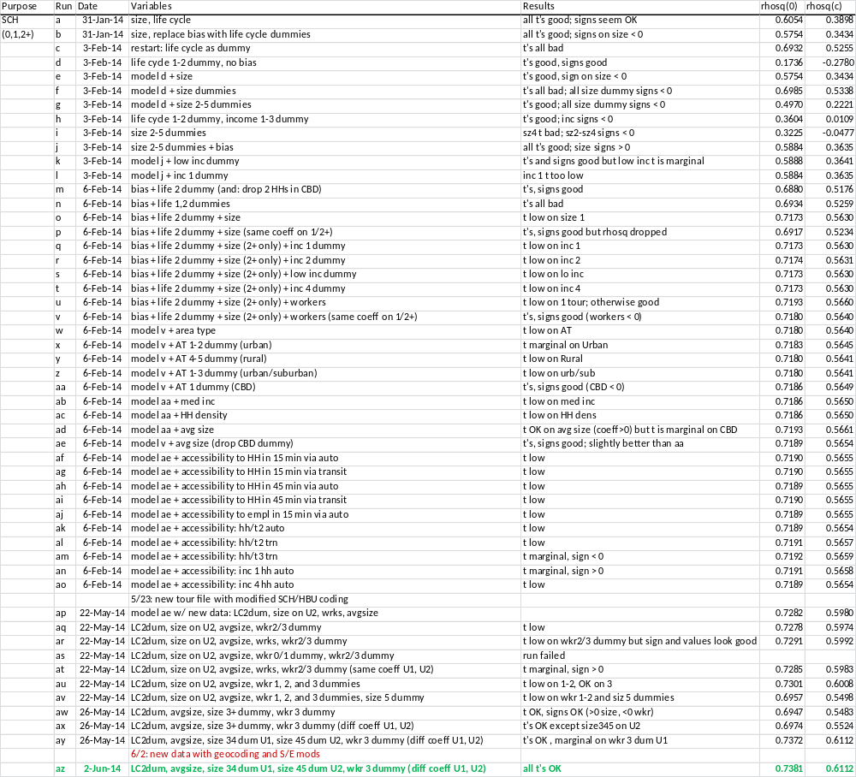
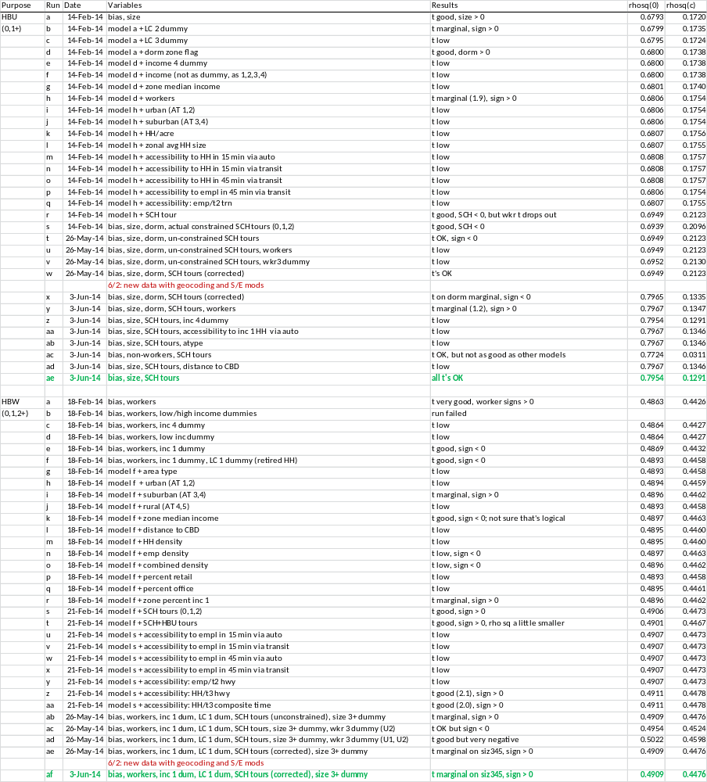
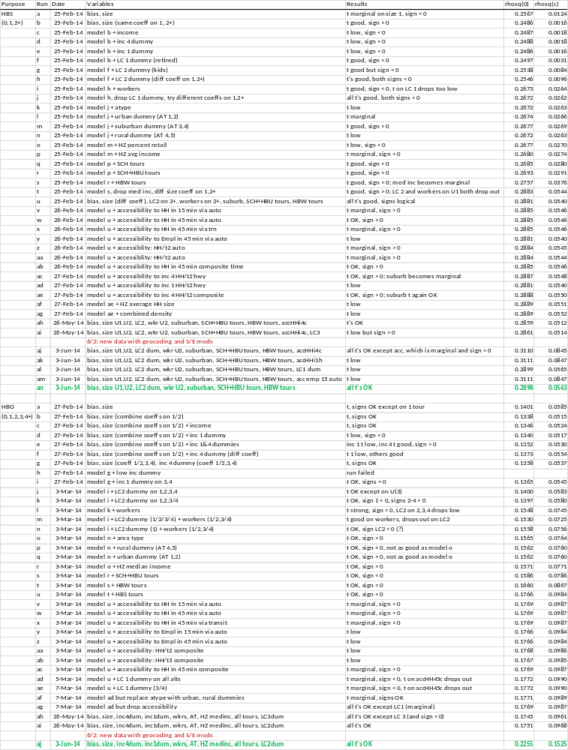
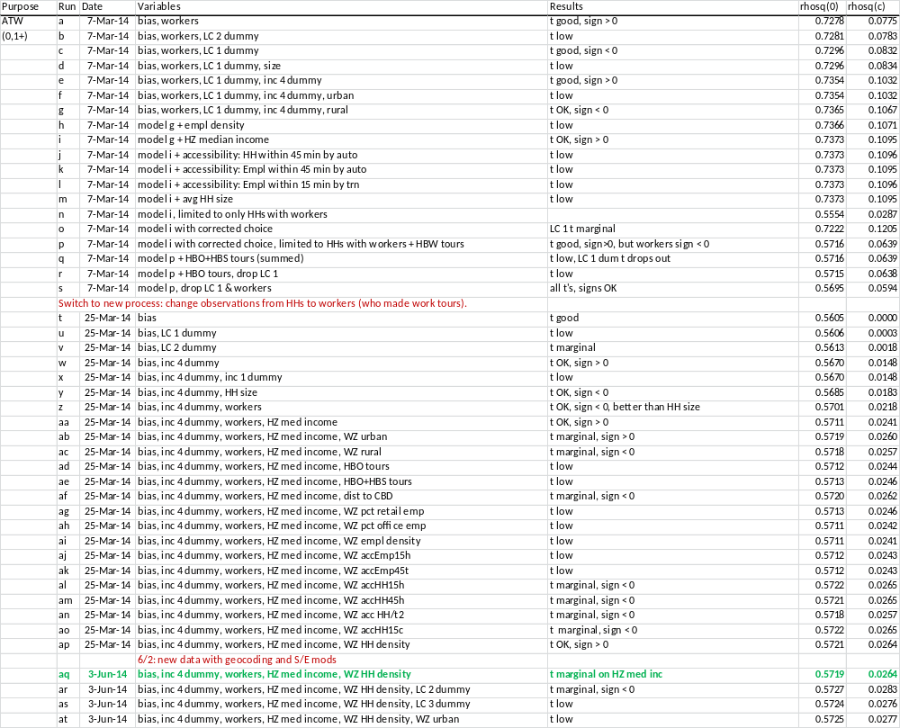
Tour Destination Choice Models

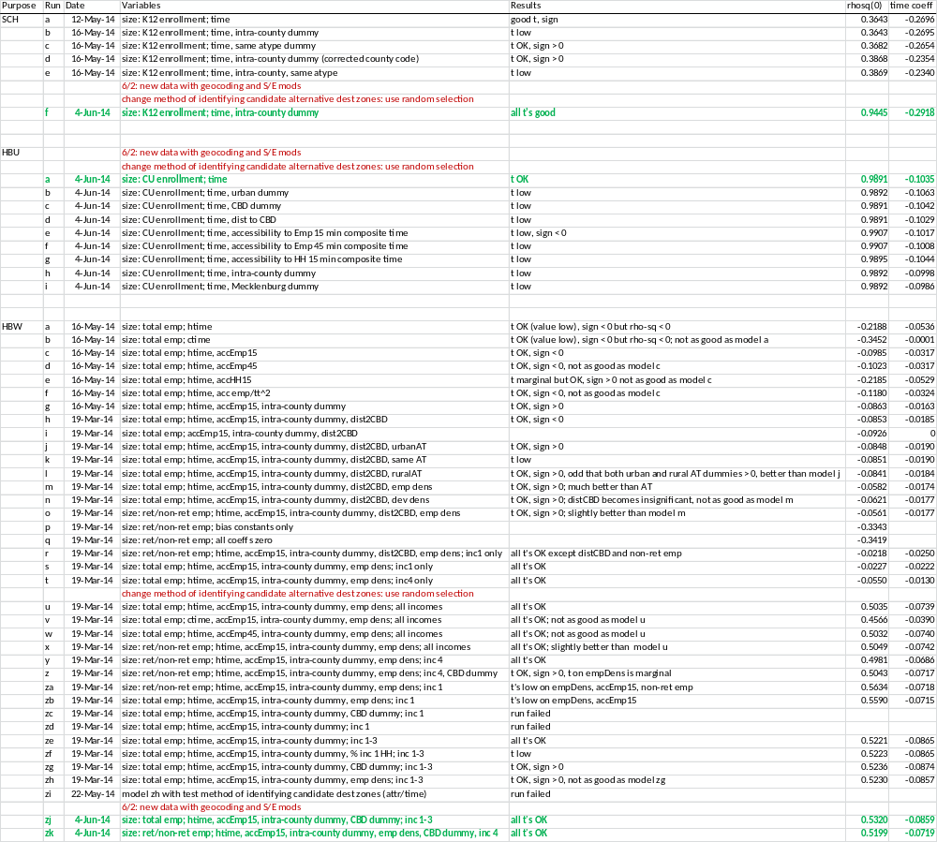
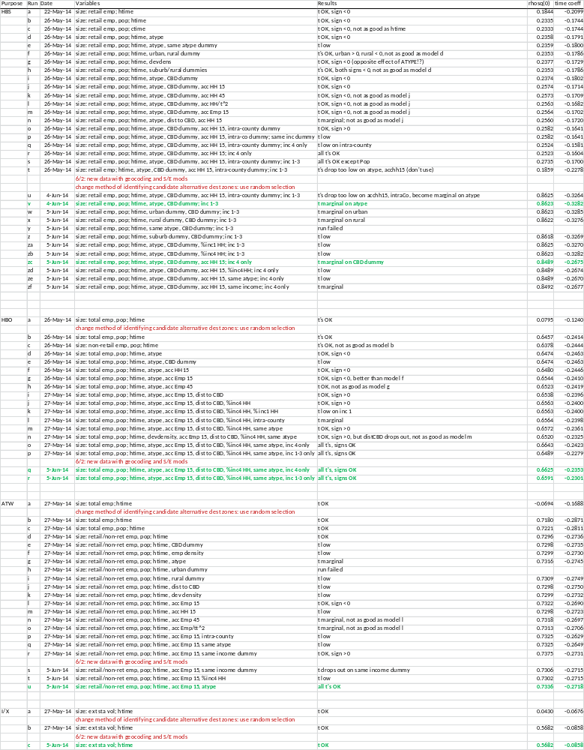
Intermediate Stop Models

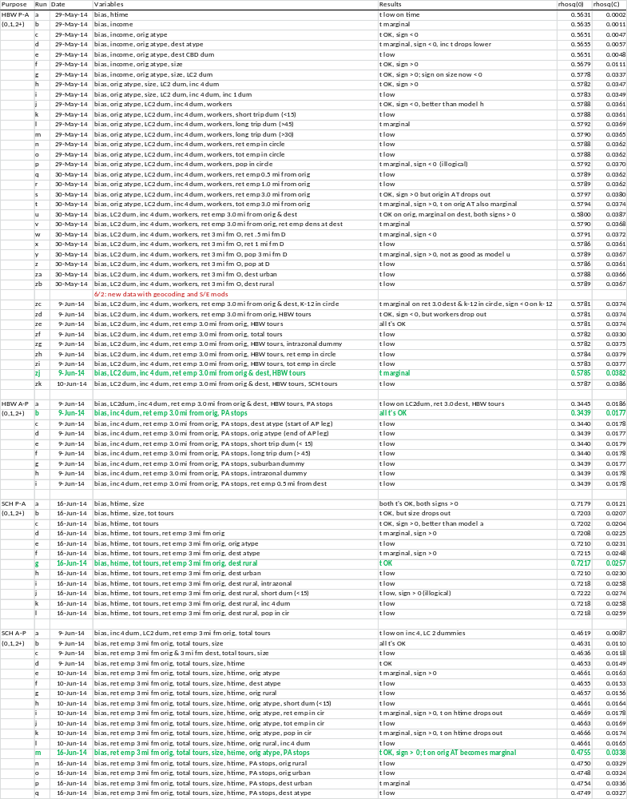

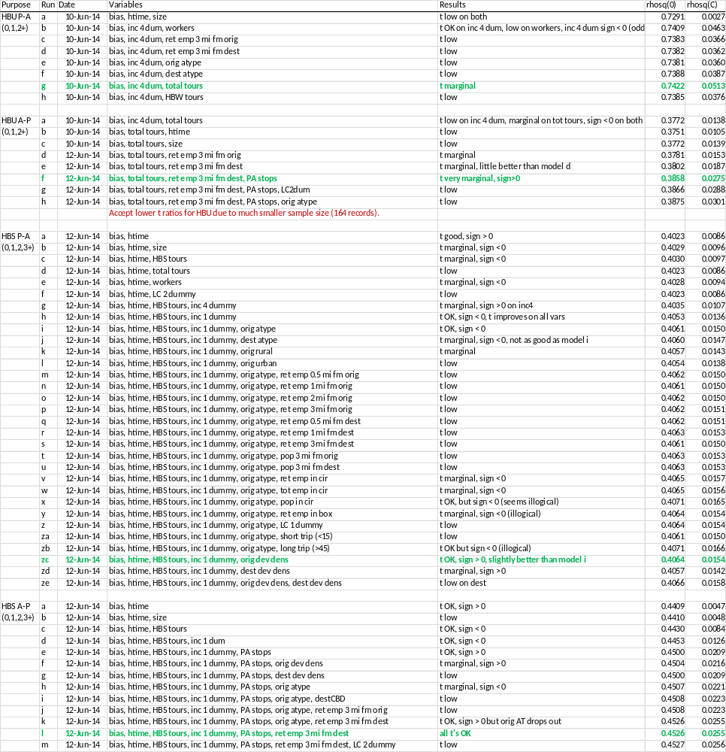

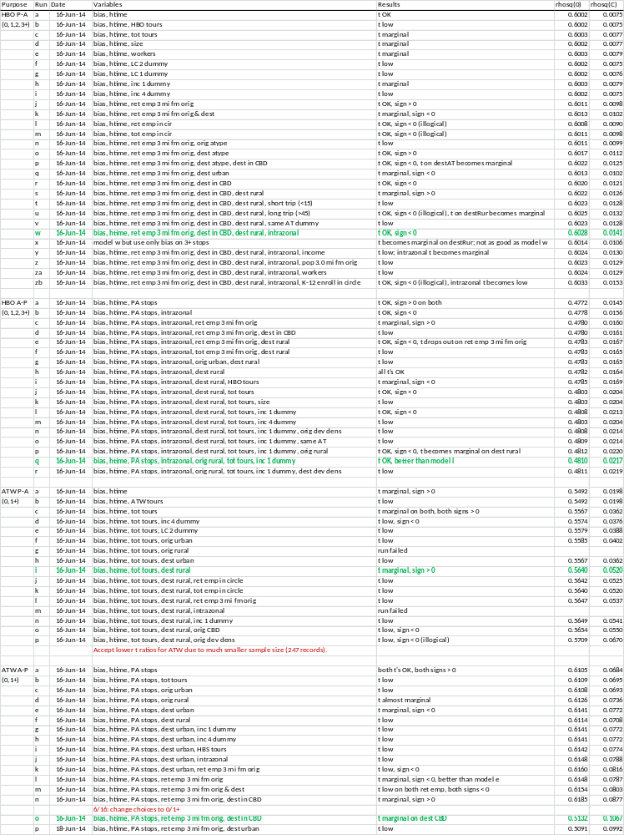
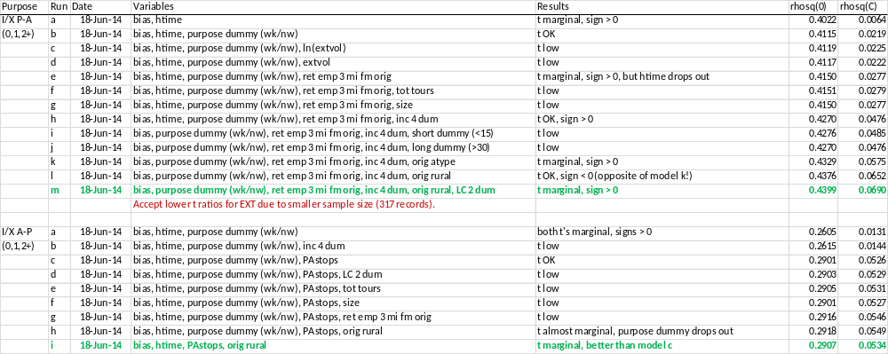
Stop Location Models

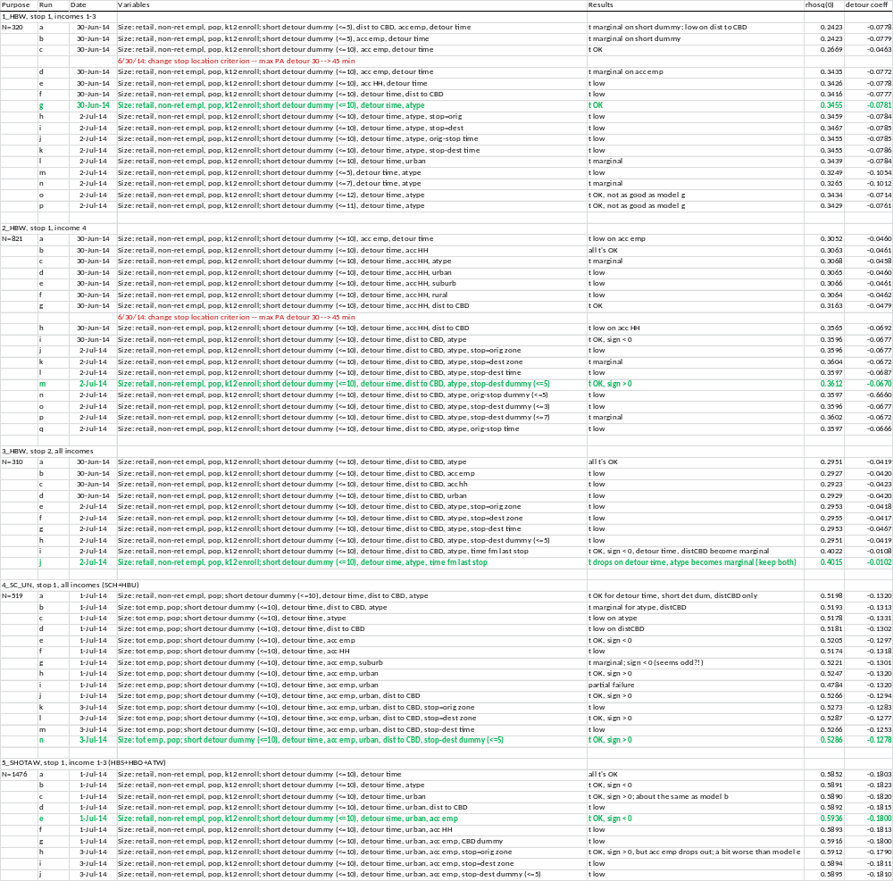
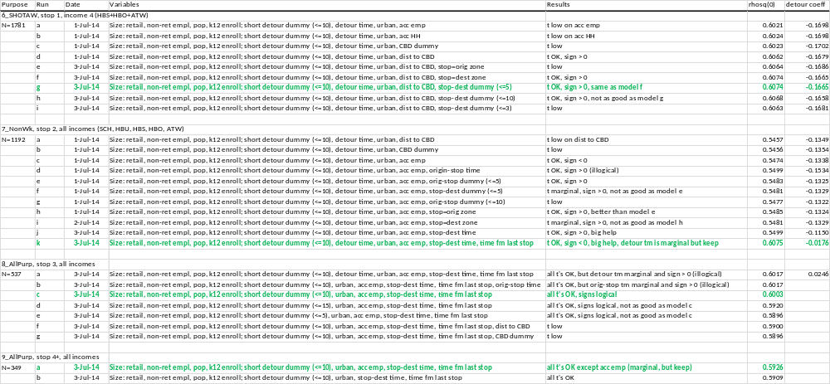
Time of Day Models

